GENETICS DOMAIN | LESSON 20 OF 20 | WHOLE TEAM (HEAD MEDICAL GENETICIST AND ALL SPECIALIST SEATS)

What Is Mateo's Complete Genetic Story?
Can your team assemble every piece of evidence into one clear, well-supported genetic story for Mateo?
CARRY FORWARD  An ethical decision weighs benefit, harm, autonomy, heritability, access, and alternatives before technical possibility. | 10-YEAR TAKEAWAY  Mateo's strongest genetic story is multifactorial and evidence-bounded: IRF6 explains a pathway, not a proven individual cause.

Cells differentiate | Development sculpts | Cells move | Development can go wrong

1. Observe the analogy before naming the biology
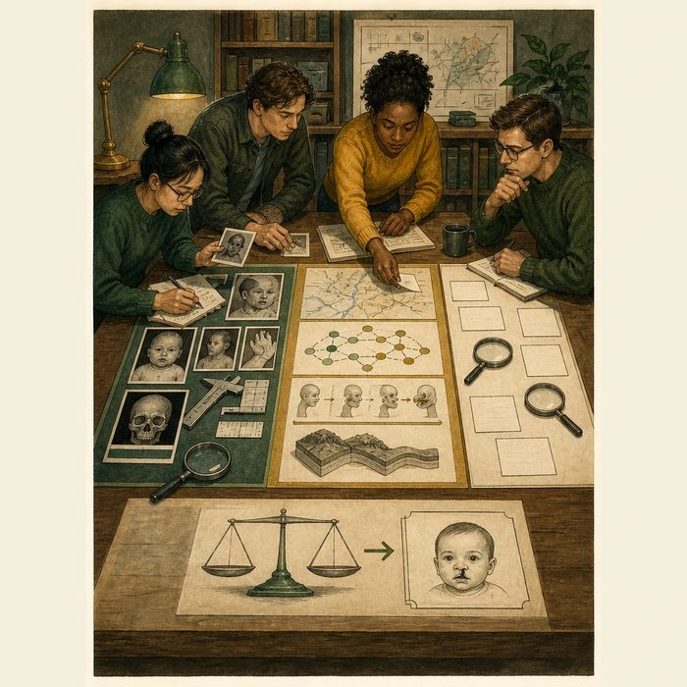
Illustration: A courtroom file separates facts, expert models, and unresolved claims
1. Which items are direct case facts?
________________________________________________________________________________
2. Which items come from research models?
________________________________________________________________________________
3. Which claim remains unresolved without a molecular result?
________________________________________________________________________________

GENETICS LESSON 20 | RULES AND BIOLOGY MAPPING
2. Turn observations into rules

1. Rule 1: Separate patient evidence from exemplar-gene evidence. Explain it in your own words.
________________________________________________________________________________
2. Rule 2: Link variant to molecule to cell to tissue when supported. Explain it in your own words.
________________________________________________________________________________
3. Rule 3: End at the claim ceiling, not the most dramatic story. Explain it in your own words.
________________________________________________________________________________
Where the analogy stops: A medical case conference is collaborative care, not an adversarial trial.

3. Map the rules onto the biomedical example
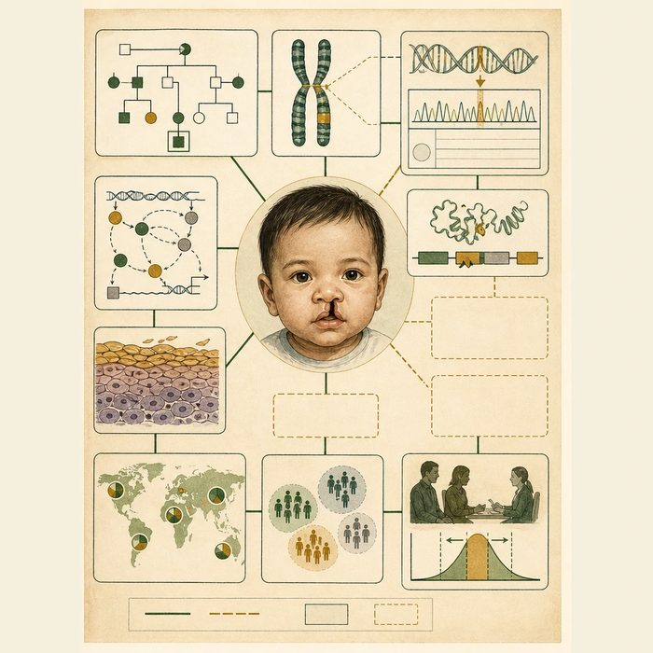
Biomedical teaching illustration: Assemble Mateo's complete genetic evidence chain
Analogy step | Biology step | How the relationship stays the same
Confirmed facts | Mateo's pedigree and phenotype | ________________________________
Expert model | IRF6 pathway and multifactorial research | ________________________________
Unresolved claim | Mateo's individual causal variant or exposure | ________________________________

GENETICS LESSON 20 | CASE FILE AND DECISION
4. Use the case evidence

ID | Finding supplied in the case | Why it matters
GEN20-E1 | Mateo has an isolated-appearing cleft and no strong family pattern in the composite file. | The case fits a multifactorial model better than a proven dominant syndrome.
GEN20-E2 | IRF6 coding and regulatory studies explain how epithelial differentiation and cleft risk can change. | IRF6 is a strong pathway exemplar.
GEN20-E3 | No pathogenic IRF6 result or single causal exposure is supplied for Mateo. | The individual cause remains open.

5. Make the clinical decision
You are the lead geneticist at the final conference. The team must approve one conclusion that will be shared with every other domain.
A. Use a multifactorial, IRF6-informed model while stating that Mateo's cause is unproven.
B. Declare a pathogenic IRF6 variant that was never tested.
C. Say genetics contributes no useful information.
Decision. Choose the conclusion and cite case evidence plus the molecular limit.
________________________________________________________________________________
________________________________________________________________________________
Claim ceiling: You may synthesize the best-supported model. You may not add a molecular diagnosis absent from the case file.
Claim. State the choice you can defend.
________________________________________________________________________________
Evidence. Use these labeled IDs: GEN20-E1 + GEN20-E2.
________________________________________________________________________________
Reasoning. Explain why the evidence supports the claim and stays inside the claim ceiling.
________________________________________________________________________________
________________________________________________________________________________

GENETICS LESSON 20 | REDUCE, REFLECT, AND PREPARE
6. Reduce the lesson to one lasting idea

Take-home. Mateo's strongest genetic story is multifactorial and evidence-bounded: IRF6 explains a pathway, not a proven individual cause.
________________________________________________________________________________
________________________________________________________________________________
1. What is direct evidence about Mateo?
________________________________________________________________________________
2. What useful IRF6 claim remains below the ceiling?
________________________________________________________________________________

Glossary
Term | Plain-English definition
synthesis | Building a molecule in the cell, as in protein synthesis (making a protein from mRNA).
domain report | A focused summary of the current research and evidence within one specific topic area, used to organize knowledge before drawing conclusions.
gene regulatory network | The web of genes that turn each other on and off to control a process such as palate fusion.
haploinsufficiency | When one working copy of a gene cannot make enough product on its own, so losing the second copy causes the trait.
multifactorial inheritance | A trait caused by many small genetic and environmental factors adding up together, rather than by a single gene alone.

Next lesson unlock
The genetics team has now assembled Mateo's complete molecular story, from first clue to ethics. But genetics cannot finish his care alone. We hand the story across to the developmental, anatomical, clinical, and experimental-design teams, so each domain can do its part on how this gene shapes the embryo, the face, the surgery, and the care plan.
The journal links on the lesson page are optional. Everything required for this guided-notes set is already supplied here and in the case file.

