GENETICS DOMAIN | LESSON 18 OF 20 | GENE THERAPIST

Can We Fix the Code?
Can we fix the genetic code behind a cleft, and if so, how far along is that work, really?
CARRY FORWARD  Recurrence counseling uses empiric family data and uncertainty; it gives a range, not a promise. | 10-YEAR TAKEAWAY  Gene editing, pathway rescue, and gene-dosage modulation are different strategies with different targets and risks.

Cells differentiate | Development sculpts | Cells move | Development can go wrong

1. Observe the analogy before naming the biology

Illustration: Repair a program by editing code, changing settings, or adding a patch
1. Which repair changes the original code?
________________________________________________________________________________
2. Which repair changes output without rewriting?
________________________________________________________________________________
3. Which repair may work only during one window?
________________________________________________________________________________

GENETICS LESSON 18 | RULES AND BIOLOGY MAPPING
2. Turn observations into rules

1. Rule 1: Name the molecular target and cell type. Explain it in your own words.
________________________________________________________________________________
2. Rule 2: Separate permanent editing from temporary pathway modulation. Explain it in your own words.
________________________________________________________________________________
3. Rule 3: Require delivery, timing, safety, and off-target evidence. Explain it in your own words.
________________________________________________________________________________
Where the analogy stops: Embryos and genes are not software, and biological repairs can affect many tissues.

3. Map the rules onto the biomedical example
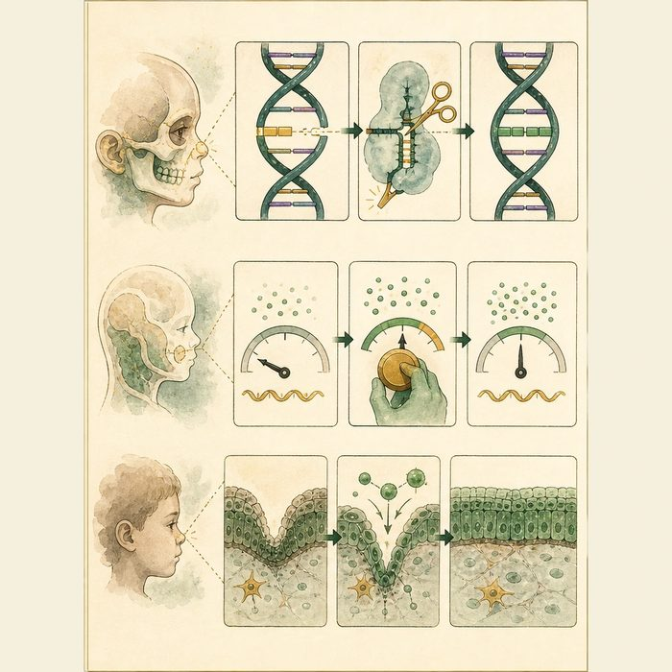
Biomedical teaching illustration: Compare three preclinical intervention strategies
Analogy step | Biology step | How the relationship stays the same
Code edit | CRISPR sequence change | ________________________________
Output setting | Gene-dosage modulation | ________________________________
Temporary patch | Timed pathway rescue | ________________________________

GENETICS LESSON 18 | CASE FILE AND DECISION
4. Use the case evidence

ID | Finding supplied in the case | Why it matters
GEN18-E1 | Animal studies have rescued some cleft-related model phenotypes through pathway or gene restoration. | Preclinical proof of mechanism exists.
GEN18-E2 | The face forms during early, short developmental windows. | Delivery would need precise timing and tissue targeting.
GEN18-E3 | No established prenatal gene-editing treatment prevents common human cleft lip and palate. | Clinical readiness is not established.

5. Make the clinical decision
You are evaluating a startup claim. The company says animal rescue results mean fetal CRISPR for clefts is clinic-ready.
A. Reject clinic-ready language and list delivery, timing, safety, and evidence gaps.
B. Approve the claim from animal rescue alone.
C. Say all preclinical work is meaningless.
Decision. Choose the evaluation and cite mechanism evidence plus readiness limits.
________________________________________________________________________________
________________________________________________________________________________
Claim ceiling: You may compare preclinical strategies. You may not claim an available or proven human prenatal treatment.
Claim. State the choice you can defend.
________________________________________________________________________________
Evidence. Use these labeled IDs: GEN18-E1 + GEN18-E2.
________________________________________________________________________________
Reasoning. Explain why the evidence supports the claim and stays inside the claim ceiling.
________________________________________________________________________________
________________________________________________________________________________

GENETICS LESSON 18 | REDUCE, REFLECT, AND PREPARE
6. Reduce the lesson to one lasting idea

Take-home. Gene editing, pathway rescue, and gene-dosage modulation are different strategies with different targets and risks.
________________________________________________________________________________
________________________________________________________________________________
1. How do the three strategies differ?
________________________________________________________________________________
2. What four gaps block a clinic-ready claim?
________________________________________________________________________________

Glossary
Term | Plain-English definition
gene therapy | Treating disease by adding, silencing, or correcting a gene in a patient's cells.
CRISPR | A gene-editing tool that uses a guide RNA to bring the Cas9 protein to a chosen DNA site and cut it so the sequence can be changed.
gene-dosage modulation | Tuning how much product a gene makes, raising or lowering it, as a possible way to treat or prevent a condition.
preclinical | Research done in cells and animals to test safety and effect before a treatment is ever tried in people.
somatic | Relating to the ordinary body cells other than egg and sperm; changes in these cells affect only the individual and are not inherited.
germline | The egg, sperm, and the cells that make them; changes in these cells can be passed to a person's children.

Next lesson unlock
These fixes work in animals today, and the science is moving. That raises a question no experiment can answer: if correcting a cleft gene in a human embryo ever became possible, should we do it, and who gets to decide? We chase that next.
The journal links on the lesson page are optional. Everything required for this guided-notes set is already supplied here and in the case file.

