GENETICS DOMAIN | LESSON 17 OF 20 | GENETIC COUNSELOR

What Is the Family's Recurrence Risk?
What is the recurrence risk for Mateo's family, and how do you communicate it honestly?
CARRY FORWARD  Population differences reflect allele frequencies, effect sizes, environments, and sampling, not biological ranking of groups. | 10-YEAR TAKEAWAY  Recurrence counseling uses empiric family data and uncertainty; it gives a range, not a promise.

Cells differentiate | Development sculpts | Cells move | Development can go wrong

1. Observe the analogy before naming the biology

Illustration: A weather forecast guides planning without guaranteeing rain
1. How does a forecast help if it is not certain?
________________________________________________________________________________
2. What information changes the forecast?
________________________________________________________________________________
3. How should uncertainty be communicated?
________________________________________________________________________________

GENETICS LESSON 17 | RULES AND BIOLOGY MAPPING
2. Turn observations into rules

1. Rule 1: Use the best-matched family and phenotype data. Explain it in your own words.
________________________________________________________________________________
2. Rule 2: State a range and the source of uncertainty. Explain it in your own words.
________________________________________________________________________________
3. Rule 3: Support family autonomy without blame. Explain it in your own words.
________________________________________________________________________________
Where the analogy stops: Recurrence risk is based on genetic and family data, not weather systems.

3. Map the rules onto the biomedical example
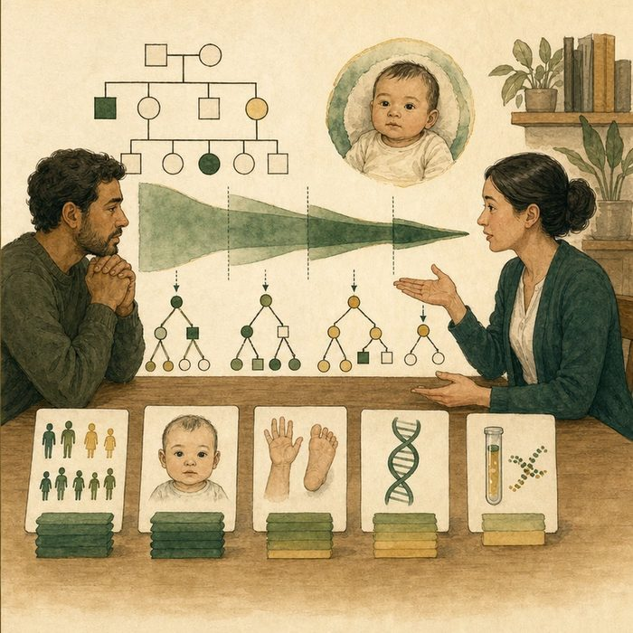
Biomedical teaching illustration: Build a recurrence-risk conversation for Mateo's family
Analogy step | Biology step | How the relationship stays the same
Forecast | Empiric recurrence estimate | ________________________________
Location and season | Family history, phenotype, and molecular result | ________________________________
Planning choice | Informed family decision | ________________________________

GENETICS LESSON 17 | CASE FILE AND DECISION
4. Use the case evidence

ID | Finding supplied in the case | Why it matters
GEN17-E1 | Mateo's case is isolated-appearing with unaffected parents. | Syndrome-specific dominant risk is not established.
GEN17-E2 | Empiric recurrence estimates come from outcomes in similar families. | The number is evidence-based but population-level.
GEN17-E3 | A confirmed pathogenic familial variant would change the counseling model. | Molecular results can refine recurrence risk.

5. Make the clinical decision
You are the genetic counselor meeting Mateo's parents. They ask for one guaranteed percentage before deciding about future pregnancy.
A. Give a sourced empiric range and explain what could refine it.
B. Promise an exact outcome.
C. Refuse to discuss uncertainty.
Decision. Choose the counseling approach and cite case fit plus uncertainty.
________________________________________________________________________________
________________________________________________________________________________
Claim ceiling: You may provide an educational empiric range from the supplied source. You may not personalize medical advice beyond the composite evidence.
Claim. State the choice you can defend.
________________________________________________________________________________
Evidence. Use these labeled IDs: GEN17-E1 + GEN17-E2.
________________________________________________________________________________
Reasoning. Explain why the evidence supports the claim and stays inside the claim ceiling.
________________________________________________________________________________
________________________________________________________________________________

GENETICS LESSON 17 | REDUCE, REFLECT, AND PREPARE
6. Reduce the lesson to one lasting idea

Take-home. Recurrence counseling uses empiric family data and uncertainty; it gives a range, not a promise.
________________________________________________________________________________
________________________________________________________________________________
1. What evidence could refine recurrence risk?
________________________________________________________________________________
2. Why is an empiric estimate not a guarantee?
________________________________________________________________________________

Glossary
Term | Plain-English definition
recurrence risk | The chance that a future child in the same family will also be affected by a given condition.
empiric risk | A recurrence risk estimated from observed family and population data rather than from a single-gene inheritance calculation.
multifactorial inheritance | A trait caused by many small genetic and environmental factors adding up together, rather than by a single gene alone.
nonpenetrance | When a person carries a disease-linked variant but never shows the associated trait or condition.
genetic counselor | A specialist who explains genetic test results and recurrence risk to families and supports them in making their own decisions.
informed consent | Agreeing to a treatment or study only after truly understanding its purpose, risks, benefits, and alternatives; the understanding, not the signature, is the ethics.

Next lesson unlock
We can now counsel the family honestly about the odds, but giving a number does not change the gene. Sooner or later a family asks the bolder question: instead of measuring the risk, could we repair the underlying genetic problem itself? Can we fix the code? We chase that next.
The journal links on the lesson page are optional. Everything required for this guided-notes set is already supplied here and in the case file.

