GENETICS DOMAIN | LESSON 16 OF 20 | POPULATION GENETICIST

Why Is CL/P More Common in Some Groups?
Why is cleft lip and/or palate far more common in some human populations than in others?
CARRY FORWARD  Knockout and rescue experiments strengthen causation when loss creates a defect and restoration reverses part of it. | 10-YEAR TAKEAWAY  Population differences reflect allele frequencies, effect sizes, environments, and sampling, not biological ranking of groups.

Cells differentiate | Development sculpts | Cells move | Development can go wrong

1. Observe the analogy before naming the biology
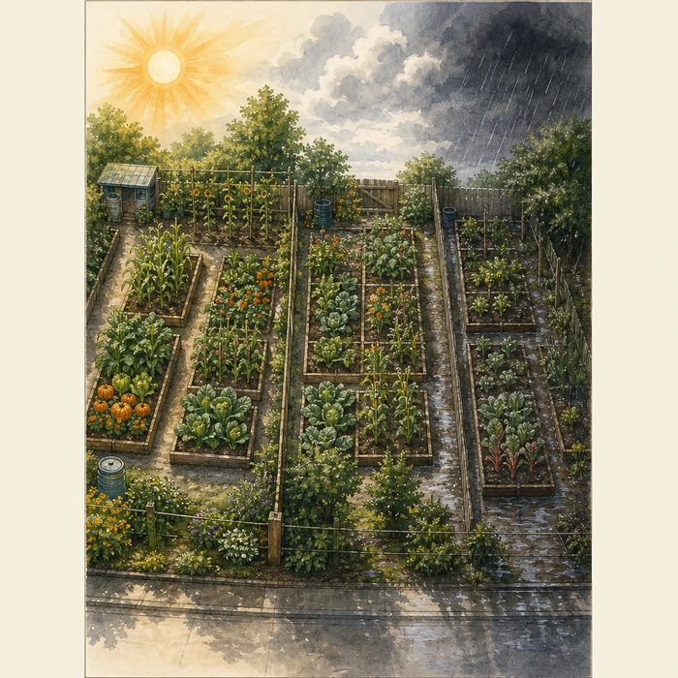
Illustration: Different gardens contain different seed mixes and weather
1. Which factors differ between gardens?
________________________________________________________________________________
2. Why can the same seed behave differently?
________________________________________________________________________________
3. What would replication across gardens test?
________________________________________________________________________________

GENETICS LESSON 16 | RULES AND BIOLOGY MAPPING
2. Turn observations into rules

1. Rule 1: Separate ancestry from race labels. Explain it in your own words.
________________________________________________________________________________
2. Rule 2: Compare allele frequency and effect size. Explain it in your own words.
________________________________________________________________________________
3. Rule 3: Require replication and consider environment and sampling. Explain it in your own words.
________________________________________________________________________________
Where the analogy stops: Human populations are not isolated gardens, and ancestry is continuous and shared.

3. Map the rules onto the biomedical example
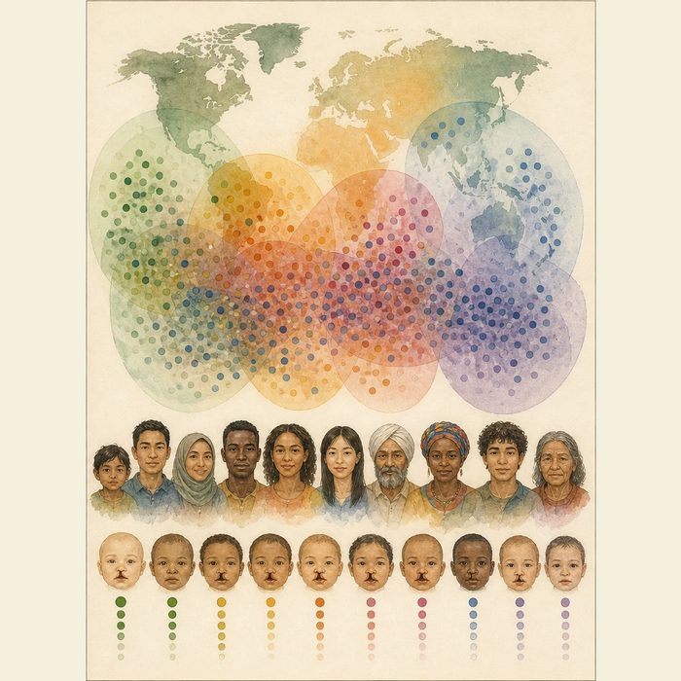
Biomedical teaching illustration: Interpret cleft prevalence and IRF6 risk across populations
Analogy step | Biology step | How the relationship stays the same
Seed mix | Allele frequencies | ________________________________
Weather | Environmental and social context | ________________________________
Flower count | Population prevalence | ________________________________

GENETICS LESSON 16 | CASE FILE AND DECISION
4. Use the case evidence

ID | Finding supplied in the case | Why it matters
GEN16-E1 | Cleft prevalence differs among studied populations. | Population pattern is real but descriptive.
GEN16-E2 | Risk-allele frequencies and effect estimates can differ by ancestry and study. | Genetic contribution is population-context dependent.
GEN16-E3 | Within-group variation is large and ancestry groups overlap. | Population averages do not determine an individual outcome.

5. Make the clinical decision
You are reviewing a public-health infographic. The draft says one ancestry group is genetically destined to have more clefts.
A. Replace it with frequency, context, overlap, and replication language.
B. Keep the destiny claim.
C. Erase population data entirely.
Decision. Choose the correction and cite both difference and overlap evidence.
________________________________________________________________________________
________________________________________________________________________________
Claim ceiling: You may discuss population statistics. You may not rank groups biologically or predict an individual from ancestry alone.
Claim. State the choice you can defend.
________________________________________________________________________________
Evidence. Use these labeled IDs: GEN16-E1 + GEN16-E2.
________________________________________________________________________________
Reasoning. Explain why the evidence supports the claim and stays inside the claim ceiling.
________________________________________________________________________________
________________________________________________________________________________

GENETICS LESSON 16 | REDUCE, REFLECT, AND PREPARE
6. Reduce the lesson to one lasting idea

Take-home. Population differences reflect allele frequencies, effect sizes, environments, and sampling, not biological ranking of groups.
________________________________________________________________________________
________________________________________________________________________________
1. Why is ancestry not destiny?
________________________________________________________________________________
2. What evidence should accompany a population difference?
________________________________________________________________________________

Glossary
Term | Plain-English definition
allele frequency | How common a particular version of a gene is in a population, written as the share of all copies that are that version.
ancestry | A person's population background inherited from earlier generations, which can affect how common certain DNA variants are.
odds ratio | A number comparing the odds of having a factor in affected versus unaffected people; above 1 suggests the factor is associated.
liability threshold | The point on a scale of combined genetic and environmental risk above which a trait such as a cleft actually appears.
gene-environment interaction | When a genetic risk and an environmental factor such as smoking or low folate combine to raise risk more than either alone.
replication | Repeating a study to see if the result holds; a key test of whether a finding is real.

Next lesson unlock
We found why CL/P differs across whole populations, but population averages are not a family. Mateo's parents now ask the practical question: if they have another child, what is the chance that child also has a cleft? That family recurrence risk is what we chase next.
The journal links on the lesson page are optional. Everything required for this guided-notes set is already supplied here and in the case file.

