GENETICS DOMAIN | LESSON 15 OF 20 | MODEL RESEARCHER

How Do We Prove the Gene Causes It?
How can a scientist prove that losing IRF6 causes clefting, instead of just appearing alongside it?
CARRY FORWARD  The IRF6 network helps oral epithelial cells form periderm, preventing wrong adhesions before correct fusion. | 10-YEAR TAKEAWAY  Knockout and rescue experiments strengthen causation when loss creates a defect and restoration reverses part of it.

Cells differentiate | Development sculpts | Cells move | Development can go wrong

1. Observe the analogy before naming the biology
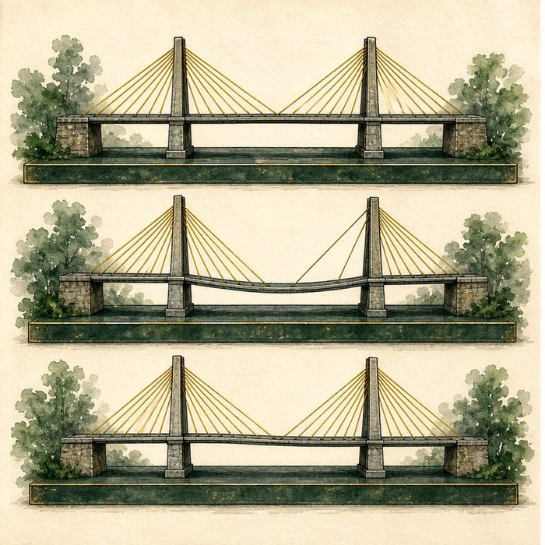
Illustration: Remove one bridge cable, then restore it
1. Which comparison shows necessity?
________________________________________________________________________________
2. Which comparison tests sufficiency or rescue?
________________________________________________________________________________
3. Why might a partial rescue still teach mechanism?
________________________________________________________________________________

GENETICS LESSON 15 | RULES AND BIOLOGY MAPPING
2. Turn observations into rules

1. Rule 1: Compare matched control and knockout groups. Explain it in your own words.
________________________________________________________________________________
2. Rule 2: Restore the suspected function in a defined tissue or time. Explain it in your own words.
________________________________________________________________________________
3. Rule 3: Measure both rescue and remaining defects. Explain it in your own words.
________________________________________________________________________________
Where the analogy stops: Genes act in networks and tissues, so restoration can be incomplete.

3. Map the rules onto the biomedical example
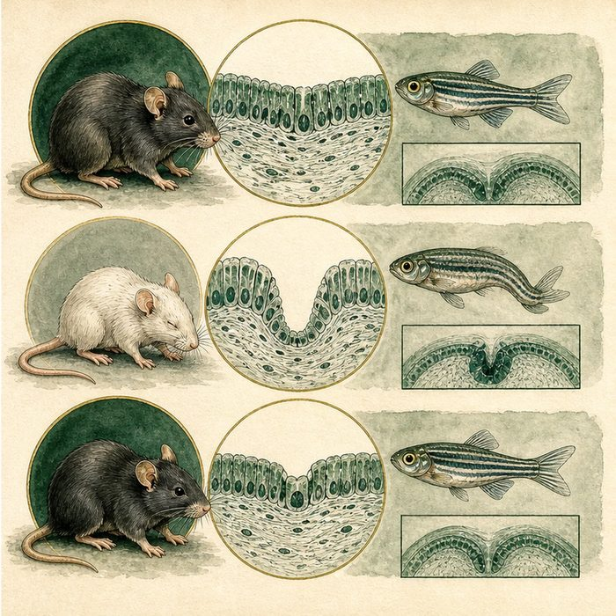
Biomedical teaching illustration: Read IRF6 knockout and partial-rescue evidence
Analogy step | Biology step | How the relationship stays the same
Intact bridge | Wild-type control | ________________________________
Cable removed | Irf6 knockout | ________________________________
Cable restored | Tissue-specific or mRNA rescue | ________________________________

GENETICS LESSON 15 | CASE FILE AND DECISION
4. Use the case evidence

ID | Finding supplied in the case | Why it matters
GEN15-E1 | Irf6 knockout models develop abnormal epithelium, oral adhesions, and cleft palate. | Loss of function produces the predicted phenotype.
GEN15-E2 | Restoring epithelial IRF6 reduces some adhesions but does not fully rescue every defect. | The rescue supports an epithelial role and reveals limits.
GEN15-E3 | Zebrafish rescue experiments add evidence in a second model. | Cross-model replication strengthens the mechanism while remaining preclinical.

5. Make the clinical decision
You are judging whether the rescue proves complete correction. The rescue group has fewer adhesions but still has cleft palate in several regions.
A. Call it a partial mechanistic rescue.
B. Call it a complete cure.
C. Ignore the improvement because it was incomplete.
Decision. Choose the verdict and cite both improvement and remaining phenotype.
________________________________________________________________________________
________________________________________________________________________________
Claim ceiling: You may support causation and a tissue role. You may not claim complete rescue or human treatment.
Claim. State the choice you can defend.
________________________________________________________________________________
Evidence. Use these labeled IDs: GEN15-E1 + GEN15-E2.
________________________________________________________________________________
Reasoning. Explain why the evidence supports the claim and stays inside the claim ceiling.
________________________________________________________________________________
________________________________________________________________________________

GENETICS LESSON 15 | REDUCE, REFLECT, AND PREPARE
6. Reduce the lesson to one lasting idea

Take-home. Knockout and rescue experiments strengthen causation when loss creates a defect and restoration reverses part of it.
________________________________________________________________________________
________________________________________________________________________________
1. What does knockout test?
________________________________________________________________________________
2. Why is a partial rescue still informative?
________________________________________________________________________________

Glossary
Term | Plain-English definition
model organism | A species, such as zebrafish or mouse, studied because its biology is similar enough to ours to teach us about human development and disease.
knockout | An organism or cell engineered to have a specific gene switched off, used to reveal what that gene normally does.
rescue experiment | Adding a working gene back into a mutant to see if it restores the normal trait, which proves that gene was responsible.
causation | When one factor actually brings about another, shown by controlled evidence rather than by the two simply appearing together.
correlation | Two things tending to occur together, which does not by itself prove that one causes the other.

Next lesson unlock
We proved IRF6 loss causes clefting using knockout and rescue in mouse and zebrafish, so we now understand how the cleft happens in one embryo. But why is cleft lip and palate far more common in some human populations than in others? We chase that next, when the population geneticist takes the seat.
The journal links on the lesson page are optional. Everything required for this guided-notes set is already supplied here and in the case file.

