GENETICS DOMAIN | LESSON 14 OF 20 | DEVELOPMENTAL-BIOLOGY LIAISON

What Does IRF6 Actually Do in the Embryo?
What job do the cells controlled by IRF6 perform, and how does losing that job cause the shelves to fail to fuse?
CARRY FORWARD  IRF6 works in a regulatory network, so similar phenotypes can arise when different connected genes fail. | 10-YEAR TAKEAWAY  The IRF6 network helps oral epithelial cells form periderm, preventing wrong adhesions before correct fusion.

Cells differentiate | Development sculpts | Cells move | Development can go wrong

1. Observe the analogy before naming the biology
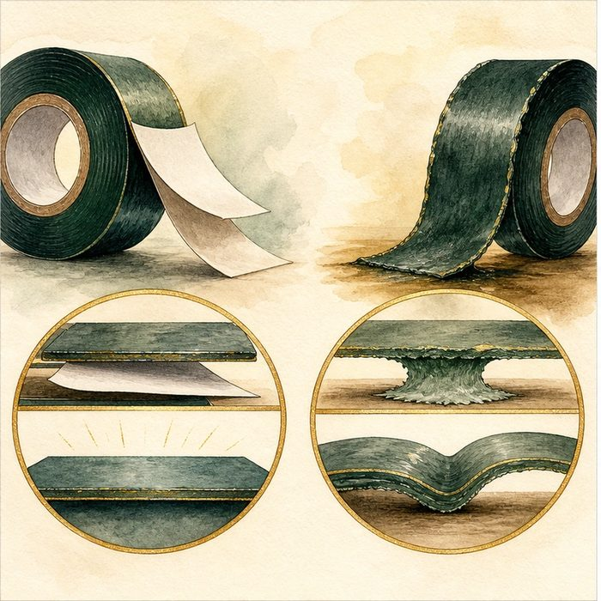
Illustration: Temporary release paper protects adhesive surfaces
1. Why must the protection exist before contact?
________________________________________________________________________________
2. What happens if the wrong surfaces stick first?
________________________________________________________________________________
3. When can the protective layer safely change?
________________________________________________________________________________

GENETICS LESSON 14 | RULES AND BIOLOGY MAPPING
2. Turn observations into rules

1. Rule 1: Differentiate a temporary protective surface. Explain it in your own words.
________________________________________________________________________________
2. Rule 2: Prevent wrong adhesion before enabling correct fusion. Explain it in your own words.
________________________________________________________________________________
3. Rule 3: A cell-autonomous defect can create a tissue-level block. Explain it in your own words.
________________________________________________________________________________
Where the analogy stops: Periderm is living tissue controlled by a network, not manufactured paper.

3. Map the rules onto the biomedical example
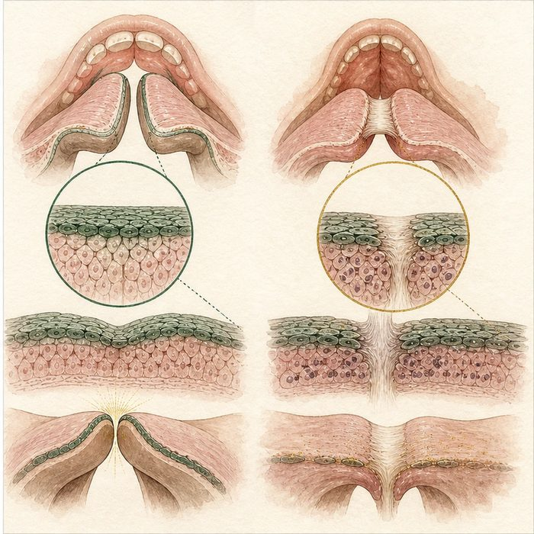
Biomedical teaching illustration: Connect IRF6 genotype to periderm cell behavior
Analogy step | Biology step | How the relationship stays the same
Release paper | Periderm | ________________________________
Manufacturing instruction | IRF6 regulatory network | ________________________________
Wrong early sticking | Abnormal oral epithelial adhesion | ________________________________

GENETICS LESSON 14 | CASE FILE AND DECISION
4. Use the case evidence

ID | Finding supplied in the case | Why it matters
GEN14-E1 | IRF6 is active in oral epithelium and periderm differentiation. | The gene acts in a relevant cell type.
GEN14-E2 | Irf6-deficient models lose normal periderm and develop abnormal oral adhesions. | Gene loss changes a specific cell behavior.
GEN14-E3 | Those adhesions can block palatal elevation and closure. | The cell defect connects to the tissue phenotype.

5. Make the clinical decision
You are building the molecular-to-anatomy chain for the case board. The board requires one sequence from gene to cell to tissue outcome.
A. IRF6 network failure, periderm defect, wrong adhesion, blocked closure.
B. IRF6 instantly creates a hole in the palate.
C. Periderm has no relationship to fusion.
Decision. Choose the sequence and cite cell plus tissue evidence.
________________________________________________________________________________
________________________________________________________________________________
Claim ceiling: You may explain an established model mechanism. You may not claim Mateo has IRF6 loss without a result.
Claim. State the choice you can defend.
________________________________________________________________________________
Evidence. Use these labeled IDs: GEN14-E1 + GEN14-E2.
________________________________________________________________________________
Reasoning. Explain why the evidence supports the claim and stays inside the claim ceiling.
________________________________________________________________________________
________________________________________________________________________________

GENETICS LESSON 14 | REDUCE, REFLECT, AND PREPARE
6. Reduce the lesson to one lasting idea

Take-home. The IRF6 network helps oral epithelial cells form periderm, preventing wrong adhesions before correct fusion.
________________________________________________________________________________
________________________________________________________________________________
1. What cell behavior links IRF6 to palate closure?
________________________________________________________________________________
2. Which claim about Mateo remains unsupported?
________________________________________________________________________________

Glossary
Term | Plain-English definition
periderm | A thin temporary outer cell layer of the embryo; if it sticks where it should not, the growing edges cannot fuse.
epithelium | A sheet of tightly joined surface cells, such as the lining whose edges must clear away for the palatal shelves to fuse.
differentiation | The process by which an unspecialized cell turns on specific genes and becomes a specialized cell type with a defined job.
fusion | When two growing tissue edges meet at the midline and join into one continuous structure, as the lip and palate do during development.
cell-autonomous | Describing an effect that plays out inside the very cell carrying the change, rather than in its neighbors.

Next lesson unlock
We found that IRF6 makes periderm cells differentiate so the shelves can fuse, and without it they stick wrongly and stay open. But a strong story is not proof. How do scientists actually prove that losing IRF6 causes the cleft, rather than just appearing alongside it? We chase that next.
The journal links on the lesson page are optional. Everything required for this guided-notes set is already supplied here and in the case file.

