GENETICS DOMAIN | LESSON 13 OF 20 | SYSTEMS GENETICIST

Does IRF6 Work Alone?
Is IRF6 a lone actor, or one link in a chain of genes, and how would we tell from the patterns in patients?
CARRY FORWARD  A missense variant matters when its side-chain change disrupts a specific protein interaction or fold. | 10-YEAR TAKEAWAY  IRF6 works in a regulatory network, so similar phenotypes can arise when different connected genes fail.

Cells differentiate | Development sculpts | Cells move | Development can go wrong

1. Observe the analogy before naming the biology
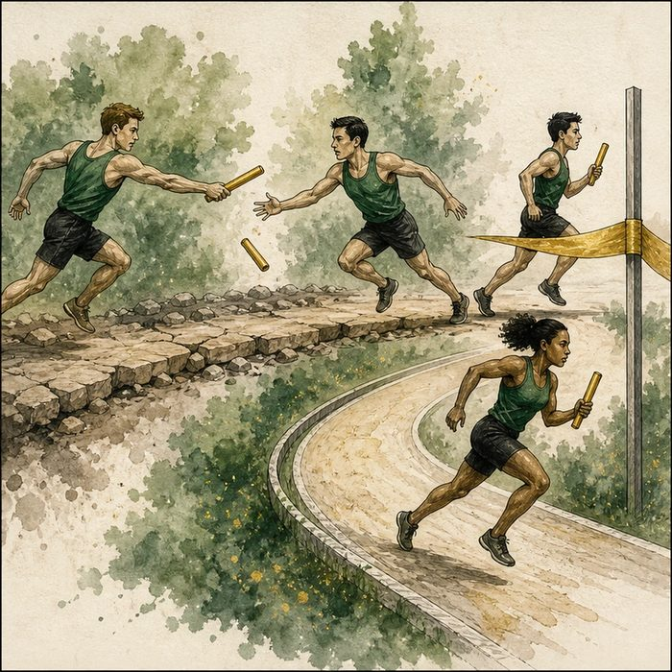
Illustration: A relay team passes one signal through several runners
1. Who acts before the middle runner?
________________________________________________________________________________
2. Which handoff could stop the same finish?
________________________________________________________________________________
3. Why would two different failed runners create similar outcomes?
________________________________________________________________________________

GENETICS LESSON 13 | RULES AND BIOLOGY MAPPING
2. Turn observations into rules

1. Rule 1: Name upstream and downstream relationships. Explain it in your own words.
________________________________________________________________________________
2. Rule 2: Different nodes can converge on one cell behavior. Explain it in your own words.
________________________________________________________________________________
3. Rule 3: Network redundancy can soften or redirect a failure. Explain it in your own words.
________________________________________________________________________________
Where the analogy stops: Gene networks branch, feed back, and vary by tissue, unlike a straight relay.

3. Map the rules onto the biomedical example
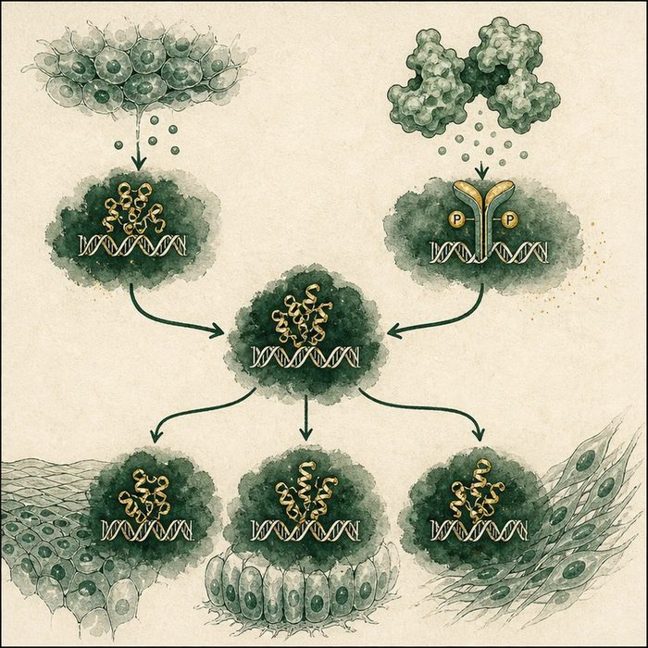
Biomedical teaching illustration: Place p63, IRF6, GRHL3, and KLF genes in a network
Analogy step | Biology step | How the relationship stays the same
Earlier runner | Upstream regulator | ________________________________
Baton handoff | Transcriptional regulation | ________________________________
Finish-line action | Epithelial differentiation and safe fusion | ________________________________

GENETICS LESSON 13 | CASE FILE AND DECISION
4. Use the case evidence

ID | Finding supplied in the case | Why it matters
GEN13-E1 | p63 and TGF-beta signaling influence IRF6 expression or activity in oral epithelium. | IRF6 has upstream regulators.
GEN13-E2 | IRF6 promotes GRHL3, KLF4, and KLF17-related differentiation programs. | IRF6 connects to downstream targets.
GEN13-E3 | GRHL3 variants can also cause Van der Woude-like phenotypes. | Different network nodes can converge on similar outcomes.

5. Make the clinical decision
You are explaining a negative IRF6 test in a family with lip pits and clefting. IRF6 sequencing is negative, but the phenotype remains strongly suggestive of the network.
A. Consider other connected genes and broader testing.
B. Conclude the phenotype is impossible.
C. Invent an IRF6 variant.
Decision. Choose the next genetic strategy and cite network convergence.
________________________________________________________________________________
________________________________________________________________________________
Claim ceiling: You may broaden the candidate network. You may not diagnose a specific second gene without evidence.
Claim. State the choice you can defend.
________________________________________________________________________________
Evidence. Use these labeled IDs: GEN13-E1 + GEN13-E2.
________________________________________________________________________________
Reasoning. Explain why the evidence supports the claim and stays inside the claim ceiling.
________________________________________________________________________________
________________________________________________________________________________

GENETICS LESSON 13 | REDUCE, REFLECT, AND PREPARE
6. Reduce the lesson to one lasting idea

Take-home. IRF6 works in a regulatory network, so similar phenotypes can arise when different connected genes fail.
________________________________________________________________________________
________________________________________________________________________________
1. What do upstream and downstream mean?
________________________________________________________________________________
2. Why can different genes produce similar phenotypes?
________________________________________________________________________________

Glossary
Term | Plain-English definition
gene regulatory network | The web of genes that turn each other on and off to control a process such as palate fusion.
transcription factor | A protein that binds DNA and turns specific genes on or off, controlling what a cell becomes and does.
upstream | Genes or events that come earlier in a pathway and control what happens later, downstream.
downstream | Describing genes or events that come later in a pathway, controlled by something acting earlier, or upstream, of them.
redundancy | When more than one gene can perform the same job, so losing one is partly covered by another and the effect is softened.

Next lesson unlock
We placed IRF6 in a network with p63 above it and GRHL3 and the KLFs alongside and below. But a network of genes is just instructions. What does this network actually make the cells of the embryo do so the lip and palate can physically close? We chase that next.
The journal links on the lesson page are optional. Everything required for this guided-notes set is already supplied here and in the case file.

