GENETICS DOMAIN | LESSON 12 OF 20 | STRUCTURAL BIOLOGIST

How Does One Wrong Amino Acid Break the Protein?
How can changing one single amino acid in a 467-amino-acid protein stop the whole protein from doing its job?
CARRY FORWARD  Evolutionary conservation marks positions that tolerated little change, adding evidence that a new change may matter. | 10-YEAR TAKEAWAY  A missense variant matters when its side-chain change disrupts a specific protein interaction or fold.

Cells differentiate | Development sculpts | Cells move | Development can go wrong

1. Observe the analogy before naming the biology

Illustration: One replacement key no longer fits the lock
1. Which tiny shape difference prevents fitting?
________________________________________________________________________________
2. Why might another key change still work?
________________________________________________________________________________
3. What direct test would show loss of grip?
________________________________________________________________________________

GENETICS LESSON 12 | RULES AND BIOLOGY MAPPING
2. Turn observations into rules

1. Rule 1: Amino-acid side chains have different size, charge, and chemistry. Explain it in your own words.
________________________________________________________________________________
2. Rule 2: Local structure determines the effect. Explain it in your own words.
________________________________________________________________________________
3. Rule 3: A model predicts; a binding assay tests. Explain it in your own words.
________________________________________________________________________________
Where the analogy stops: Proteins are flexible molecular structures, not rigid metal keys.

3. Map the rules onto the biomedical example
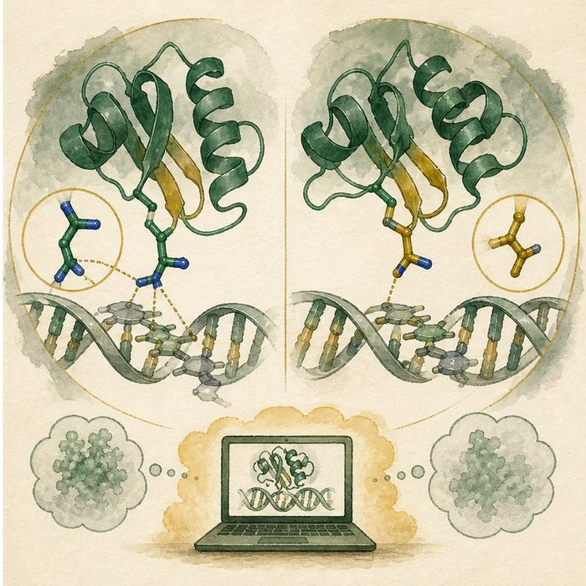
Biomedical teaching illustration: Model an Arg84 substitution in IRF6
Analogy step | Biology step | How the relationship stays the same
Key tooth | Amino-acid side chain | ________________________________
Lock surface | DNA-binding interface | ________________________________
Fit test | Functional DNA-binding assay | ________________________________

GENETICS LESSON 12 | CASE FILE AND DECISION
4. Use the case evidence

ID | Finding supplied in the case | Why it matters
GEN12-E1 | Arg84 lies in the conserved IRF6 DNA-binding domain. | The position is functionally plausible.
GEN12-E2 | Replacing arginine changes side-chain chemistry and may alter DNA contact or local folding. | A structural mechanism can be proposed.
GEN12-E3 | AlphaFold predicts structure but does not measure variant function. | Experimental validation remains necessary.

5. Make the clinical decision
You are deciding whether a structure image completes a variant report. The model predicts an altered DNA-contact surface, but no binding experiment has been run.
A. Report a supported hypothesis and request functional testing.
B. Call the prediction direct proof.
C. Ignore position and chemistry.
Decision. Choose the report language and cite prediction versus experiment.
________________________________________________________________________________
________________________________________________________________________________
Claim ceiling: You may propose a structure-function mechanism. You may not present a prediction as measured protein behavior.
Claim. State the choice you can defend.
________________________________________________________________________________
Evidence. Use these labeled IDs: GEN12-E1 + GEN12-E2.
________________________________________________________________________________
Reasoning. Explain why the evidence supports the claim and stays inside the claim ceiling.
________________________________________________________________________________
________________________________________________________________________________

GENETICS LESSON 12 | REDUCE, REFLECT, AND PREPARE
6. Reduce the lesson to one lasting idea

Take-home. A missense variant matters when its side-chain change disrupts a specific protein interaction or fold.
________________________________________________________________________________
________________________________________________________________________________
1. What chemical features can change in a missense variant?
________________________________________________________________________________
2. What can a model not measure?
________________________________________________________________________________

Glossary
Term | Plain-English definition
AlphaFold | An artificial intelligence system from DeepMind that predicts a protein's three-dimensional folded shape directly from its amino acid sequence.
missense variant | A DNA change that swaps one amino acid for another in the protein, such as the IRF6 R84C change.
protein folding | How a chain of amino acids settles into its specific three-dimensional shape, which determines what the protein can do.
side chain | The variable part of an amino acid that gives it its chemistry, so changing it can alter how a protein folds or works.
structure-function | The principle that a molecule's three-dimensional shape determines what it can do, so breaking the shape breaks the job.

Next lesson unlock
We found that one wrong amino acid in the conserved domain can stop IRF6 from gripping DNA. But a transcription factor never works alone. Who switches IRF6 on, and who carries the signal once IRF6 has done its part? We chase that next.
The journal links on the lesson page are optional. Everything required for this guided-notes set is already supplied here and in the case file.

