GENETICS DOMAIN | LESSON 11 OF 20 | BIOINFORMATICIAN

Is This Gene Important Across Species?
If we line up the IRF6 protein from many animals, which parts stay the same, and what does staying the same tell us about importance?
CARRY FORWARD  Protein domains are specialized working regions, so a variant's position helps predict which function may fail. | 10-YEAR TAKEAWAY  Evolutionary conservation marks positions that tolerated little change, adding evidence that a new change may matter.

Cells differentiate | Development sculpts | Cells move | Development can go wrong

1. Observe the analogy before naming the biology

Illustration: Compare many editions to find the words no editor changes
1. Which parts remain unchanged across every edition?
________________________________________________________________________________
2. What does repeated preservation suggest?
________________________________________________________________________________
3. Can preservation alone prove a new edit is harmful?
________________________________________________________________________________

GENETICS LESSON 11 | RULES AND BIOLOGY MAPPING
2. Turn observations into rules

1. Rule 1: Align orthologous sequences. Explain it in your own words.
________________________________________________________________________________
2. Rule 2: High conservation suggests functional constraint. Explain it in your own words.
________________________________________________________________________________
3. Rule 3: Conservation supports, but does not settle, variant classification. Explain it in your own words.
________________________________________________________________________________
Where the analogy stops: Evolution selects organisms and populations, not words in a book.

3. Map the rules onto the biomedical example
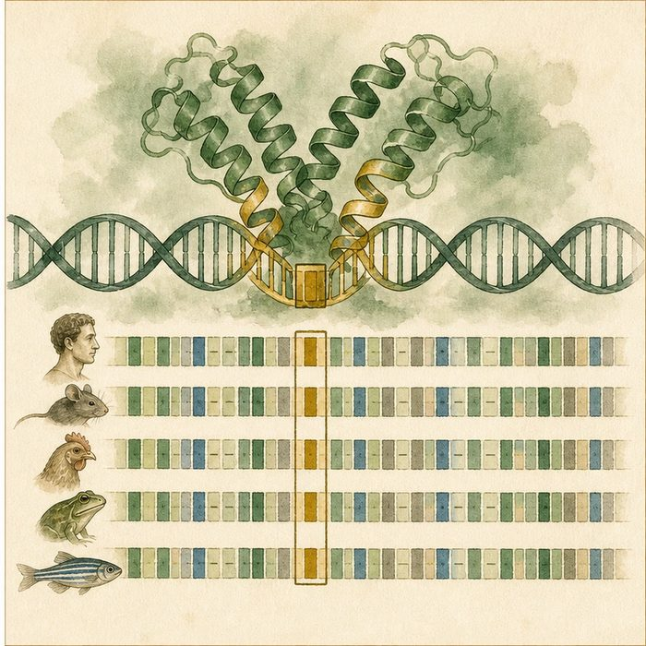
Biomedical teaching illustration: Read an IRF6 multispecies alignment
Analogy step | Biology step | How the relationship stays the same
Edition | Species ortholog | ________________________________
Unchanged phrase | Conserved amino-acid stretch | ________________________________
Editorial constraint | Purifying selection | ________________________________

GENETICS LESSON 11 | CASE FILE AND DECISION
4. Use the case evidence

ID | Finding supplied in the case | Why it matters
GEN11-E1 | IRF6 orthologs occur across many vertebrate species. | The gene is evolutionarily shared.
GEN11-E2 | The DNA-binding domain has highly conserved residues, including Arg84. | Those positions tolerated little change.
GEN11-E3 | Some conserved-position variants have different clinical effects. | Conservation is one evidence line, not a complete verdict.

5. Make the clinical decision
You are reviewing a new missense variant at a conserved IRF6 residue. The residue is identical in five vertebrates, but no patient or functional data exist.
A. Use conservation as supporting evidence and keep classification uncertain.
B. Call it pathogenic from conservation alone.
C. Call it benign because only one amino acid changed.
Decision. Choose the classification stance and cite both support and limit.
________________________________________________________________________________
________________________________________________________________________________
Claim ceiling: You may say the site is constrained. You may not make conservation the only pathogenicity criterion.
Claim. State the choice you can defend.
________________________________________________________________________________
Evidence. Use these labeled IDs: GEN11-E1 + GEN11-E2.
________________________________________________________________________________
Reasoning. Explain why the evidence supports the claim and stays inside the claim ceiling.
________________________________________________________________________________
________________________________________________________________________________

GENETICS LESSON 11 | REDUCE, REFLECT, AND PREPARE
6. Reduce the lesson to one lasting idea

Take-home. Evolutionary conservation marks positions that tolerated little change, adding evidence that a new change may matter.
________________________________________________________________________________
________________________________________________________________________________
1. What does conservation suggest?
________________________________________________________________________________
2. Why does it not finish classification?
________________________________________________________________________________

Glossary
Term | Plain-English definition
BLAST | A search tool (Basic Local Alignment Search Tool) that compares a DNA or protein sequence against a database to find similar sequences and likely relatives.
ortholog | The matching version of a gene found in a different species, descended from the same gene in a common ancestor.
conservation | When a DNA or protein sequence stays similar across many species, a strong sign that it does an essential biological job.
percent identity | In a sequence comparison, the share of positions that exactly match between two DNA or protein sequences; a higher value means they are more alike.
purifying selection | Natural selection that removes harmful mutations over time, which is why important DNA and protein sequences stay highly conserved across species.

Next lesson unlock
We found that the DNA-binding domain is conserved across species, so it must be essential. But if those exact amino acids are protected across hundreds of millions of years, what actually happens to the protein when one of them, like position 84, is swapped for the wrong letter? We chase that next.
The journal links on the lesson page are optional. Everything required for this guided-notes set is already supplied here and in the case file.

