GENETICS DOMAIN | LESSON 10 OF 20 | PROTEIN SCIENTIST

What the IRF6 Protein Looks Like
What does the IRF6 protein actually look like?
CARRY FORWARD  A regulatory variant changes when or how much a gene is used without changing the protein sequence. | 10-YEAR TAKEAWAY  Protein domains are specialized working regions, so a variant's position helps predict which function may fail.

Cells differentiate | Development sculpts | Cells move | Development can go wrong

1. Observe the analogy before naming the biology

Illustration: A multi-tool has separate working sections
1. Which part performs each job?
________________________________________________________________________________
2. Would damage to the handle equal damage to the gripping tip?
________________________________________________________________________________
3. Why map a defect before testing function?
________________________________________________________________________________

GENETICS LESSON 10 | RULES AND BIOLOGY MAPPING
2. Turn observations into rules

1. Rule 1: Proteins contain functional domains. Explain it in your own words.
________________________________________________________________________________
2. Rule 2: Domain position narrows the likely disrupted job. Explain it in your own words.
________________________________________________________________________________
3. Rule 3: Unstructured regions can still matter even when less conserved. Explain it in your own words.
________________________________________________________________________________
Where the analogy stops: Protein domains fold in three dimensions and interact dynamically, unlike a simple tool.

3. Map the rules onto the biomedical example
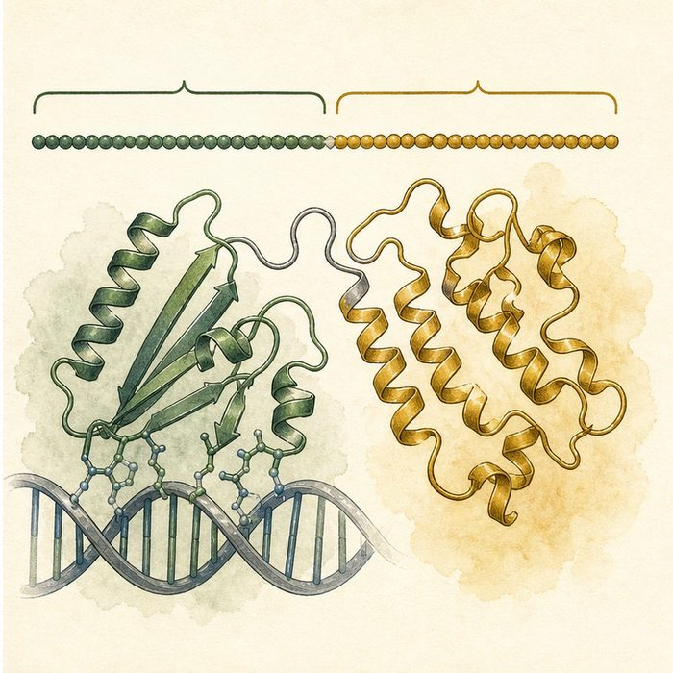
Biomedical teaching illustration: Place variants on the IRF6 domain map
Analogy step | Biology step | How the relationship stays the same
Gripping tip | DNA-binding domain | ________________________________
Joining section | Protein-interaction domain | ________________________________
Tool layout | IRF6 amino-acid domain map | ________________________________

GENETICS LESSON 10 | CASE FILE AND DECISION
4. Use the case evidence

ID | Finding supplied in the case | Why it matters
GEN10-E1 | IRF6 is 467 amino acids long. | Variant position can be recorded precisely.
GEN10-E2 | The N-terminal DNA-binding domain spans roughly residues 7 to 115. | Variants there may alter DNA recognition.
GEN10-E3 | The C-terminal SMIR/IAD region supports protein interactions. | Different domains support different molecular jobs.

5. Make the clinical decision
You are choosing a functional assay for an IRF6 variant. Variant A lies in the DNA-binding domain; variant B lies in the C-terminal interaction region.
A. Test DNA binding for A and partner interaction for B.
B. Use the same unrelated assay for both.
C. Classify both from location alone.
Decision. Choose the assay plan and cite the domain-function evidence.
________________________________________________________________________________
________________________________________________________________________________
Claim ceiling: You may select assays from domain location. You may not classify a variant without results and other evidence.
Claim. State the choice you can defend.
________________________________________________________________________________
Evidence. Use these labeled IDs: GEN10-E1 + GEN10-E2.
________________________________________________________________________________
Reasoning. Explain why the evidence supports the claim and stays inside the claim ceiling.
________________________________________________________________________________
________________________________________________________________________________

GENETICS LESSON 10 | REDUCE, REFLECT, AND PREPARE
6. Reduce the lesson to one lasting idea

Take-home. Protein domains are specialized working regions, so a variant's position helps predict which function may fail.
________________________________________________________________________________
________________________________________________________________________________
1. Which IRF6 domain binds DNA?
________________________________________________________________________________
2. What does a domain map help researchers choose?
________________________________________________________________________________

Glossary
Term | Plain-English definition
protein domain | A distinct part of a protein that folds and works on its own, such as the DNA-binding domain of IRF6.
DNA-binding domain | The part of a transcription factor that grips DNA so it can switch target genes on or off.
protein-binding domain | The part of a protein that attaches to other proteins to do its job.
SMIR / IAD domain | A lesson term defined by the surrounding model and case evidence.
structure-function | The principle that a molecule's three-dimensional shape determines what it can do, so breaking the shape breaks the job.

Next lesson unlock
Our protein has critical domains. How can we tell which parts are so important that evolution never lets them change?
The journal links on the lesson page are optional. Everything required for this guided-notes set is already supplied here and in the case file.

