GENETICS DOMAIN | LESSON 9 OF 20 | VARIANT ANALYST

The Hidden Regulatory Variant
Where is the common, hidden variant?
CARRY FORWARD  Variant location can change mechanism: reduced dosage and altered DNA binding can produce different IRF6-related outcomes. | 10-YEAR TAKEAWAY  A regulatory variant changes when or how much a gene is used without changing the protein sequence.

Cells differentiate | Development sculpts | Cells move | Development can go wrong

1. Observe the analogy before naming the biology

Illustration: The machine is intact, but its dimmer switch changes output
1. What stays identical in both machines?
________________________________________________________________________________
2. Which control changes the amount produced?
________________________________________________________________________________
3. Why would output depend on the room and time?
________________________________________________________________________________

GENETICS LESSON 9 | RULES AND BIOLOGY MAPPING
2. Turn observations into rules

1. Rule 1: Coding sequence and regulation are separate. Explain it in your own words.
________________________________________________________________________________
2. Rule 2: Enhancers control context-specific expression. Explain it in your own words.
________________________________________________________________________________
3. Rule 3: A risk allele changes probability rather than guaranteeing disease. Explain it in your own words.
________________________________________________________________________________
Where the analogy stops: Enhancers integrate many factors and are not single household dimmers.

3. Map the rules onto the biomedical example
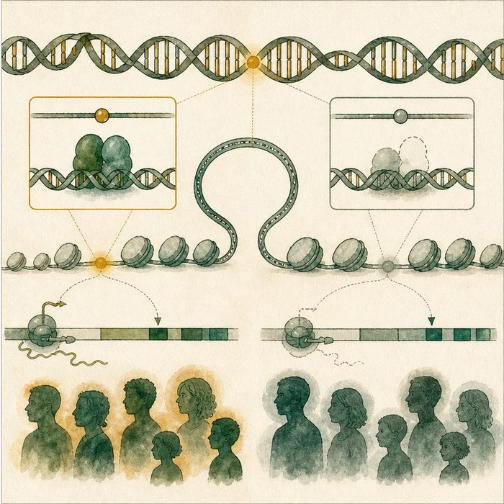
Biomedical teaching illustration: Map rs642961 to an IRF6 enhancer
Analogy step | Biology step | How the relationship stays the same
Machine | IRF6 protein coding sequence | ________________________________
Dimmer | IRF6 enhancer | ________________________________
Lower output | Changed gene expression during facial development | ________________________________

GENETICS LESSON 9 | CASE FILE AND DECISION
4. Use the case evidence

ID | Finding supplied in the case | Why it matters
GEN09-E1 | rs642961 lies in an IRF6 enhancer rather than a protein-coding exon. | The variant does not change an IRF6 amino acid.
GEN09-E2 | The risk allele disrupts an AP-2alpha binding site in laboratory assays. | A molecular regulatory mechanism is supported.
GEN09-E3 | The allele is associated with increased cleft-lip risk but is found in unaffected people. | It is a risk allele, not a deterministic syndrome mutation.

5. Make the clinical decision
You are reviewing an isolated-cleft research result. A report finds one rs642961 risk allele and no pathogenic coding variant.
A. Describe a modest regulatory risk contribution, not a diagnosis.
B. Call it a guaranteed cause.
C. Dismiss it because the protein sequence is unchanged.
Decision. Choose the interpretation and cite regulatory mechanism plus penetrance.
________________________________________________________________________________
________________________________________________________________________________
Claim ceiling: You may describe association and mechanism. You may not claim the allele alone caused Mateo's cleft.
Claim. State the choice you can defend.
________________________________________________________________________________
Evidence. Use these labeled IDs: GEN09-E1 + GEN09-E2.
________________________________________________________________________________
Reasoning. Explain why the evidence supports the claim and stays inside the claim ceiling.
________________________________________________________________________________
________________________________________________________________________________

GENETICS LESSON 9 | REDUCE, REFLECT, AND PREPARE
6. Reduce the lesson to one lasting idea

Take-home. A regulatory variant changes when or how much a gene is used without changing the protein sequence.
________________________________________________________________________________
________________________________________________________________________________
1. What changes in a regulatory variant?
________________________________________________________________________________
2. Why is risk allele more accurate than causal mutation here?
________________________________________________________________________________

Glossary
Term | Plain-English definition
coding variant | A DNA change located inside the protein-coding part of a gene, which can alter the protein the gene builds.
regulatory variant | A DNA change outside a gene's coding region that alters when or how strongly the gene is switched on.
enhancer | A stretch of regulatory DNA that boosts how strongly a nearby gene is transcribed, even from some distance away.
transcription factor | A protein that binds DNA and turns specific genes on or off, controlling what a cell becomes and does.
risk allele | A common version of a gene that nudges the chance of a trait up a little, without causing the trait by itself.

Next lesson unlock
A regulatory variant lowers how MUCH IRF6 is made, while syndromic variants damage specific protein parts. To understand both, we need to see the protein itself. What does the IRF6 protein actually look like?
The journal links on the lesson page are optional. Everything required for this guided-notes set is already supplied here and in the case file.

