GENETICS DOMAIN | LESSON 8 OF 20 | VARIANT ANALYST

One Gene, Two Diseases
Why does one gene cause two different diseases?
CARRY FORWARD  DNA variants change proteins in different ways, so variant type is evidence about mechanism, not a verdict by itself. | 10-YEAR TAKEAWAY  Variant location can change mechanism: reduced dosage and altered DNA binding can produce different IRF6-related outcomes.

Cells differentiate | Development sculpts | Cells move | Development can go wrong

1. Observe the analogy before naming the biology
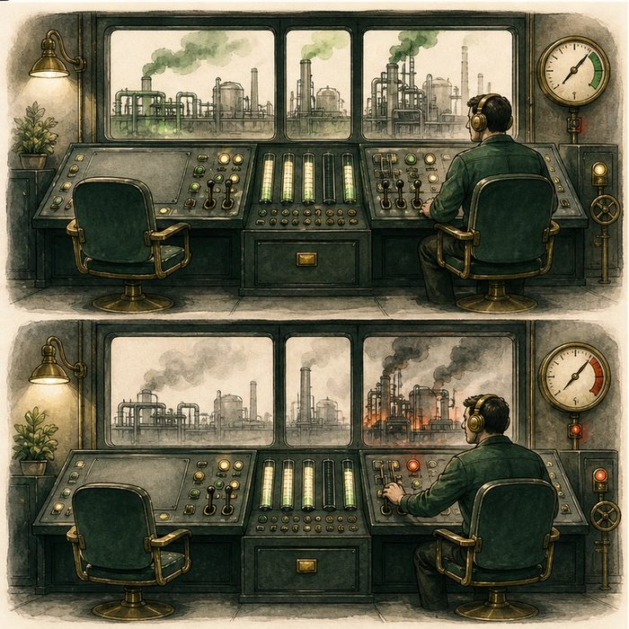
Illustration: A two-person control room can fail in two ways
1. What happens when one station is empty?
________________________________________________________________________________
2. How is a wrong command different from no command?
________________________________________________________________________________
3. Which failure could disrupt the working operator too?
________________________________________________________________________________

GENETICS LESSON 8 | RULES AND BIOLOGY MAPPING
2. Turn observations into rules

1. Rule 1: One missing functional copy can reduce dosage. Explain it in your own words.
________________________________________________________________________________
2. Rule 2: A changed protein can interfere with normal complexes. Explain it in your own words.
________________________________________________________________________________
3. Rule 3: Domain location helps predict the mechanism. Explain it in your own words.
________________________________________________________________________________
Where the analogy stops: IRF6 molecular effects vary by variant and are more complex than two operators.

3. Map the rules onto the biomedical example
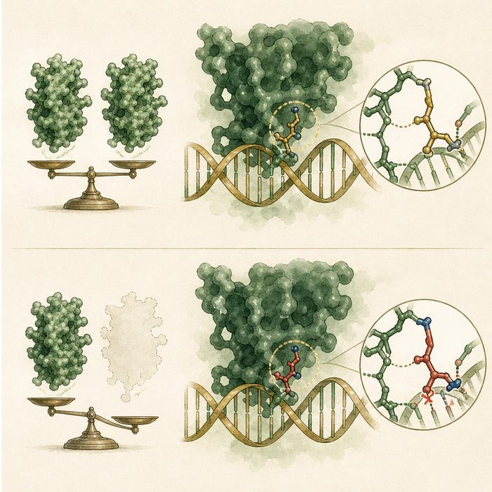
Biomedical teaching illustration: Compare IRF6 haploinsufficiency and domain-specific disruption
Analogy step | Biology step | How the relationship stays the same
Empty station | Haploinsufficiency or loss of function | ________________________________
Wrong commands | Altered DNA-binding protein | ________________________________
Control panel location | Protein domain | ________________________________

GENETICS LESSON 8 | CASE FILE AND DECISION
4. Use the case evidence

ID | Finding supplied in the case | Why it matters
GEN08-E1 | Many Van der Woude variants reduce the amount of functional IRF6. | Haploinsufficiency is a supported disease mechanism.
GEN08-E2 | Some severe PPS-associated variants cluster at Arg84 in the DNA-binding domain. | Location can alter protein behavior and phenotype.
GEN08-E3 | Different substitutions at Arg84 do not always produce the same phenotype. | Position alone does not erase the exact amino-acid effect.

5. Make the clinical decision
You are comparing two IRF6 variant reports. One creates an early stop. The other changes Arg84 in the DNA-binding domain.
A. Discuss dosage loss versus domain-specific altered function.
B. Call both mechanisms identical without evidence.
C. Predict Mateo's phenotype from the gene name alone.
Decision. Choose the comparison and cite dosage plus domain evidence.
________________________________________________________________________________
________________________________________________________________________________
Claim ceiling: You may compare supported mechanisms. You may not guarantee syndrome severity from variant position alone.
Claim. State the choice you can defend.
________________________________________________________________________________
Evidence. Use these labeled IDs: GEN08-E1 + GEN08-E2.
________________________________________________________________________________
Reasoning. Explain why the evidence supports the claim and stays inside the claim ceiling.
________________________________________________________________________________
________________________________________________________________________________

GENETICS LESSON 8 | REDUCE, REFLECT, AND PREPARE
6. Reduce the lesson to one lasting idea

Take-home. Variant location can change mechanism: reduced dosage and altered DNA binding can produce different IRF6-related outcomes.
________________________________________________________________________________
________________________________________________________________________________
1. How is reduced dosage different from an interfering protein?
________________________________________________________________________________
2. Why can two changes at the same position have different outcomes?
________________________________________________________________________________

Glossary
Term | Plain-English definition
haploinsufficiency | When one working copy of a gene cannot make enough product on its own, so losing the second copy causes the trait.
dominant-negative | A faulty protein that not only fails at its own job but also blocks the working protein made from the normal gene copy.
DNA-binding domain | The part of a transcription factor that grips DNA so it can switch target genes on or off.
loss of function | A genetic change that reduces or removes a protein's normal activity, so the cell loses what that protein usually does.
genotype-phenotype correlation | A link between which gene variant a person carries and which features or how severe a condition they show.

Next lesson unlock
The harmful IRF6 changes we studied are rare and cause syndromes. Most clefts are isolated and common. Where is the common, hidden variant, and why have we not seen it in the protein code?
The journal links on the lesson page are optional. Everything required for this guided-notes set is already supplied here and in the case file.

