GENETICS DOMAIN | LESSON 7 OF 20 | VARIANT ANALYST

Kinds of Typos in DNA
What kinds of typos can occur in DNA?
CARRY FORWARD  Variant interpretation combines clinical assertions, population frequency, molecular consequence, and evidence quality. | 10-YEAR TAKEAWAY  DNA variants change proteins in different ways, so variant type is evidence about mechanism, not a verdict by itself.

Cells differentiate | Development sculpts | Cells move | Development can go wrong

1. Observe the analogy before naming the biology
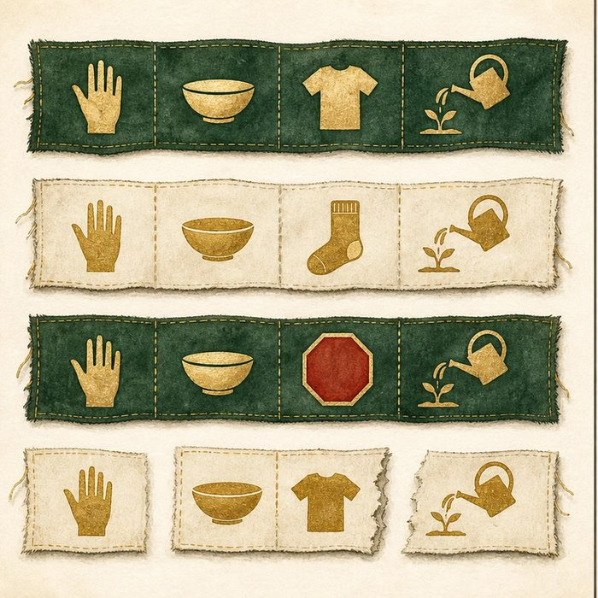
Illustration: Edit one instruction manual four different ways
1. Which edit changes one item but keeps the rest?
________________________________________________________________________________
2. Which edit stops the message early?
________________________________________________________________________________
3. Which edit shifts every group after it?
________________________________________________________________________________

GENETICS LESSON 7 | RULES AND BIOLOGY MAPPING
2. Turn observations into rules

1. Rule 1: Missense swaps one amino acid. Explain it in your own words.
________________________________________________________________________________
2. Rule 2: Nonsense and frameshift variants can truncate protein. Explain it in your own words.
________________________________________________________________________________
3. Rule 3: Splice variants can change which RNA sections remain. Explain it in your own words.
________________________________________________________________________________
Where the analogy stops: Protein consequences depend on location and biology, not only the editing label.

3. Map the rules onto the biomedical example
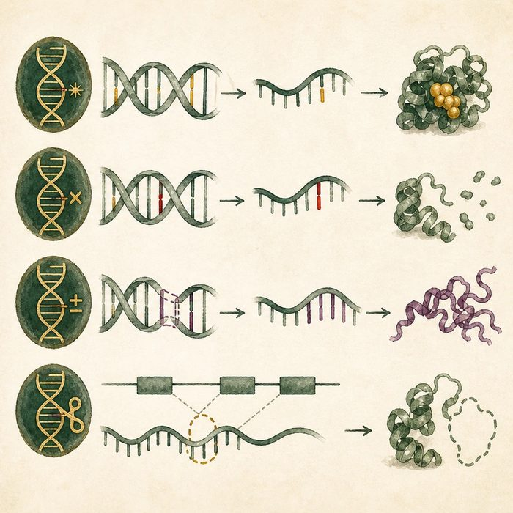
Biomedical teaching illustration: Translate four IRF6 variant types
Analogy step | Biology step | How the relationship stays the same
Swapped word | Missense variant | ________________________________
Early period | Nonsense variant | ________________________________
Shifted spacing or page join | Frameshift or splice-site variant | ________________________________

GENETICS LESSON 7 | CASE FILE AND DECISION
4. Use the case evidence

ID | Finding supplied in the case | Why it matters
GEN07-E1 | A missense variant replaces one amino acid. | The rest of the reading frame can remain intact.
GEN07-E2 | A nonsense or frameshift variant can create a premature stop. | The protein may be shortened or its RNA degraded.
GEN07-E3 | A splice-site variant can alter exon joining. | The mature mRNA can lose or gain sequence.

5. Make the clinical decision
You are annotating three IRF6 lab reports. Report A is missense, B is an early nonsense, and C is a splice-site change near an exon boundary.
A. Predict different possible consequences and request location-specific evidence.
B. Call all three identical.
C. Call every missense benign.
Decision. Choose the annotation strategy and cite two distinct mechanisms.
________________________________________________________________________________
________________________________________________________________________________
Claim ceiling: You may predict molecular consequences. You may not classify pathogenicity from variant type alone.
Claim. State the choice you can defend.
________________________________________________________________________________
Evidence. Use these labeled IDs: GEN07-E1 + GEN07-E2.
________________________________________________________________________________
Reasoning. Explain why the evidence supports the claim and stays inside the claim ceiling.
________________________________________________________________________________
________________________________________________________________________________

GENETICS LESSON 7 | REDUCE, REFLECT, AND PREPARE
6. Reduce the lesson to one lasting idea

Take-home. DNA variants change proteins in different ways, so variant type is evidence about mechanism, not a verdict by itself.
________________________________________________________________________________
________________________________________________________________________________
1. Which variant type shifts later codons?
________________________________________________________________________________
2. Why is variant type not a final classification?
________________________________________________________________________________

Glossary
Term | Plain-English definition
missense | A DNA change that swaps one amino acid in a protein, leaving it full length but possibly altering how it works.
nonsense | A DNA change that creates an early stop codon, halting translation so the protein is cut short and usually nonfunctional.
frameshift | An insertion or deletion not a multiple of three that re-groups every codon after it, scrambling the rest of the protein.
splice-site variant | A change at an intron and exon boundary that disrupts mRNA splicing, so the wrong pieces are joined and the protein is altered.
reading frame | The set of three-letter codons the ribosome reads in order along messenger RNA; a frameshift mutation throws this grouping off.

Next lesson unlock
We can sort IRF6 typos by type. But IRF6 causes two different diseases, a milder one and a more severe one. Why would one gene cause two diseases?
The journal links on the lesson page are optional. Everything required for this guided-notes set is already supplied here and in the case file.

