GENETICS DOMAIN | LESSON 5 OF 20 | MOLECULAR GENETICIST

The Gene at 1q32 Has a Name: IRF6, From DNA to Protein
What is the gene at 1q32, and what does it make?
CARRY FORWARD  Linkage follows inherited chromosome markers to narrow a gene's address before sequencing names the gene. | 10-YEAR TAKEAWAY  IRF6 encodes a transcription factor that changes cell behavior by controlling other genes.

Cells differentiate | Development sculpts | Cells move | Development can go wrong

1. Observe the analogy before naming the biology
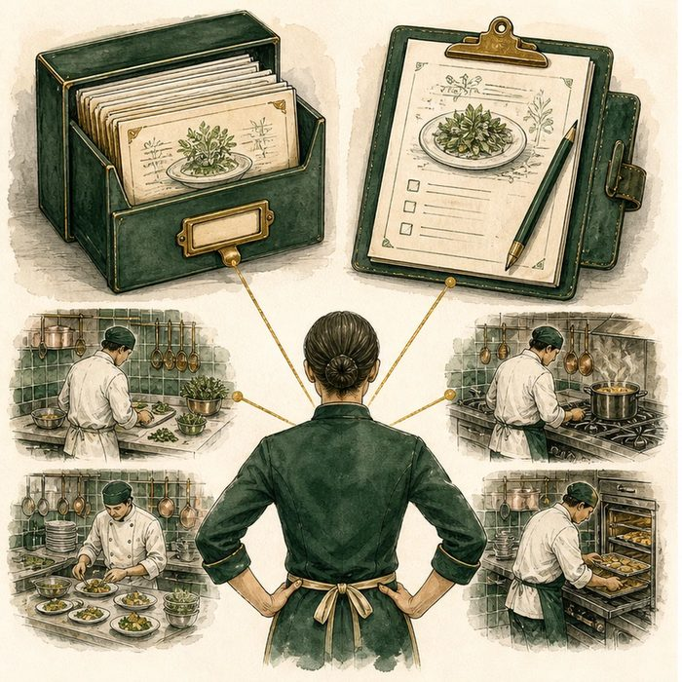
Illustration: A recipe card becomes a kitchen supervisor
1. Which object stores the lasting instructions?
________________________________________________________________________________
2. What copy leaves the archive?
________________________________________________________________________________
3. How can one supervisor change many stations?
________________________________________________________________________________

GENETICS LESSON 5 | RULES AND BIOLOGY MAPPING
2. Turn observations into rules

1. Rule 1: DNA is transcribed into an RNA copy. Explain it in your own words.
________________________________________________________________________________
2. Rule 2: RNA is translated into protein. Explain it in your own words.
________________________________________________________________________________
3. Rule 3: A transcription factor regulates other genes rather than building tissue directly. Explain it in your own words.
________________________________________________________________________________
Where the analogy stops: Genes do not contain recipes in words, and proteins do not make conscious decisions.

3. Map the rules onto the biomedical example
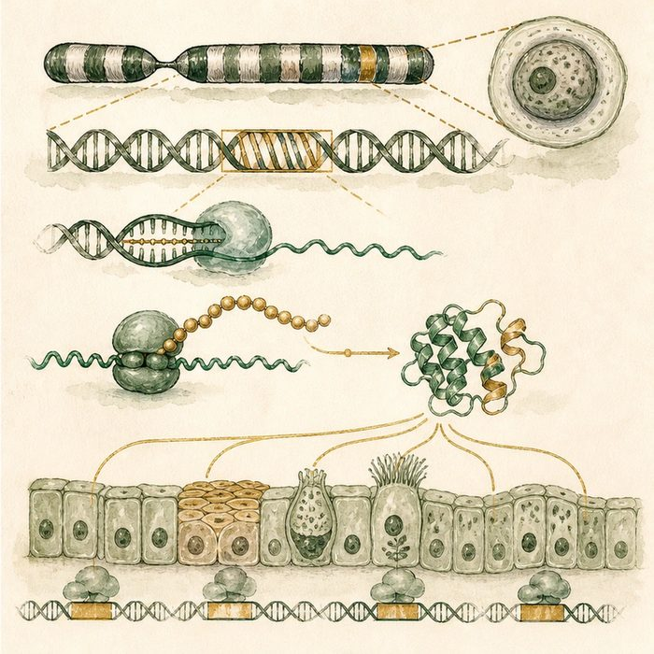
Biomedical teaching illustration: Trace IRF6 from gene to regulatory protein
Analogy step | Biology step | How the relationship stays the same
Recipe archive | IRF6 DNA | ________________________________
Work order | IRF6 mRNA | ________________________________
Supervisor | IRF6 transcription-factor protein | ________________________________

GENETICS LESSON 5 | CASE FILE AND DECISION
4. Use the case evidence

ID | Finding supplied in the case | Why it matters
GEN05-E1 | Sequencing the linked 1q32 interval identified damaging variants in IRF6. | IRF6 was the gene supported by molecular evidence.
GEN05-E2 | IRF6 is transcribed into mRNA and translated into a 467-amino-acid protein. | The gene produces a specific protein product.
GEN05-E3 | IRF6 contains a DNA-binding domain and regulates epithelial differentiation genes. | Its main job is control of gene activity.

5. Make the clinical decision
You are explaining the gene discovery to a molecular team. A new intern says IRF6 is a piece of lip tissue made directly from DNA.
A. Correct the path to DNA, RNA, transcription factor, target genes, and cell behavior.
B. Agree that DNA becomes lip tissue directly.
C. Say IRF6 is only a chromosome marker.
Decision. Choose the correction and cite gene-product and protein-job evidence.
________________________________________________________________________________
________________________________________________________________________________
Claim ceiling: You may describe IRF6's molecular role. You may not say one IRF6 result explains Mateo without a case test.
Claim. State the choice you can defend.
________________________________________________________________________________
Evidence. Use these labeled IDs: GEN05-E1 + GEN05-E2.
________________________________________________________________________________
Reasoning. Explain why the evidence supports the claim and stays inside the claim ceiling.
________________________________________________________________________________
________________________________________________________________________________

GENETICS LESSON 5 | REDUCE, REFLECT, AND PREPARE
6. Reduce the lesson to one lasting idea

Take-home. IRF6 encodes a transcription factor that changes cell behavior by controlling other genes.
________________________________________________________________________________
________________________________________________________________________________
1. What molecule is translated?
________________________________________________________________________________
2. Why is transcription factor more accurate than structural lip protein?
________________________________________________________________________________

Glossary
Term | Plain-English definition
transcription | The first step of making a protein: copying a DNA gene into messenger RNA.
mRNA (messenger RNA) | The working copy of a gene that carries its instructions out of the nucleus to the ribosome to be read into protein.
translation | The second step of making a protein: the ribosome reads the mRNA and builds a chain of amino acids.
transcription factor | A protein that binds DNA and turns specific genes on or off, controlling what a cell becomes and does.
IRF6 | Interferon Regulatory Factor 6, a transcription factor needed by the skin-like cells that let the lip and palate fuse; a leading cleft gene.

Next lesson unlock
Now that we have the exemplar gene IRF6, where do we look up whether a given variant in it is already known, and whether it is harmful?
The journal links on the lesson page are optional. Everything required for this guided-notes set is already supplied here and in the case file.

