GENETICS DOMAIN | LESSON 4 OF 20 | GENE MAPPER

Hunting the Exemplar Cleft Gene: Linkage to 1q32
How do you hunt a gene when you have no address for it?
CARRY FORWARD  Most isolated clefts fit a multifactorial threshold model in which many small influences add to risk. | 10-YEAR TAKEAWAY  Linkage follows inherited chromosome markers to narrow a gene's address before sequencing names the gene.

Cells differentiate | Development sculpts | Cells move | Development can go wrong

1. Observe the analogy before naming the biology
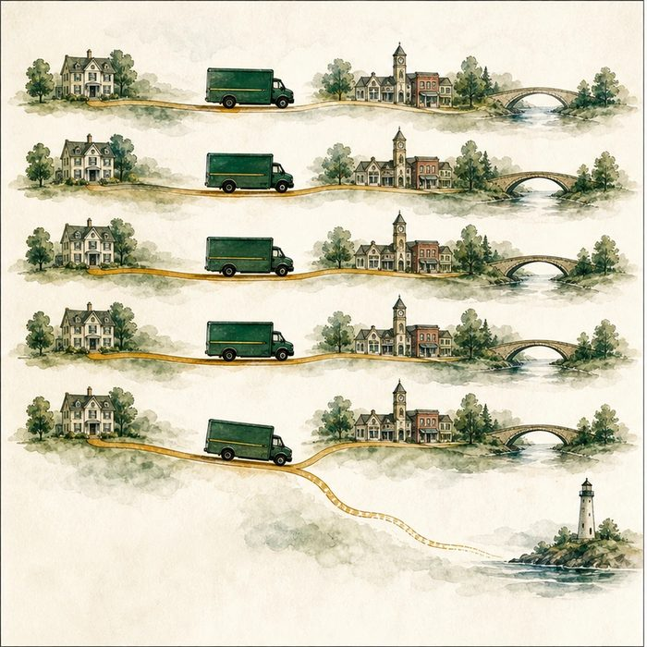
Illustration: Track a delivery truck by the landmarks it passes
1. Which landmark stays with the truck most often?
________________________________________________________________________________
2. What would a route change separate?
________________________________________________________________________________
3. How close must a landmark be to remain useful?
________________________________________________________________________________

GENETICS LESSON 4 | RULES AND BIOLOGY MAPPING
2. Turn observations into rules

1. Rule 1: Track co-inheritance across relatives. Explain it in your own words.
________________________________________________________________________________
2. Rule 2: Recombination can separate distant markers. Explain it in your own words.
________________________________________________________________________________
3. Rule 3: Strong linkage narrows a region, not one final gene. Explain it in your own words.
________________________________________________________________________________
Where the analogy stops: Chromosomes recombine biologically; they do not follow roads.

3. Map the rules onto the biomedical example
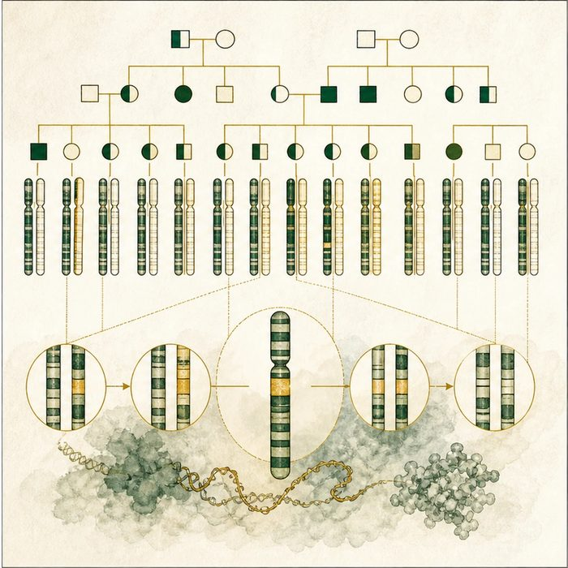
Biomedical teaching illustration: Follow a linked marker to chromosome 1q32
Analogy step | Biology step | How the relationship stays the same
Truck | Disease-associated chromosome segment | ________________________________
Nearby landmark | DNA marker | ________________________________
Route change | Meiotic recombination | ________________________________

GENETICS LESSON 4 | CASE FILE AND DECISION
4. Use the case evidence

ID | Finding supplied in the case | Why it matters
GEN04-E1 | In large Van der Woude families, certain chromosome 1 markers co-segregated with the phenotype. | The disease locus was linked to that region.
GEN04-E2 | Recombination events narrowed the shared interval to 1q32. | Family crossovers set region boundaries.
GEN04-E3 | The interval still contained more than one possible gene. | Linkage gives an address range, not a gene name.

5. Make the clinical decision
You are the linkage analyst for a historical gene hunt. A marker travels with the syndrome in nearly every informative relative, but several genes lie nearby.
A. Prioritize the linked interval for sequencing.
B. Declare the marker itself the causal gene.
C. Ignore recombination boundaries.
Decision. Choose the next step and cite what linkage can and cannot locate.
________________________________________________________________________________
________________________________________________________________________________
Claim ceiling: You may prioritize a locus. You may not call a marker causal or name IRF6 before sequence evidence.
Claim. State the choice you can defend.
________________________________________________________________________________
Evidence. Use these labeled IDs: GEN04-E1 + GEN04-E2.
________________________________________________________________________________
Reasoning. Explain why the evidence supports the claim and stays inside the claim ceiling.
________________________________________________________________________________
________________________________________________________________________________

GENETICS LESSON 4 | REDUCE, REFLECT, AND PREPARE
6. Reduce the lesson to one lasting idea

Take-home. Linkage follows inherited chromosome markers to narrow a gene's address before sequencing names the gene.
________________________________________________________________________________
________________________________________________________________________________
1. What does co-segregation mean?
________________________________________________________________________________
2. Why is a linked marker not automatically causal?
________________________________________________________________________________

Glossary
Term | Plain-English definition
DNA marker | A known, variable spot in the genome used as a trackable signpost near a gene, even though the marker itself is not the disease gene.
linkage | The tendency of two spots close together on a chromosome to be inherited together.
co-segregation | When a marker version and a disease are inherited together in every affected family member, evidence that the responsible gene sits nearby.
recombination | The shuffling of chromosome pieces during egg and sperm formation, which can occasionally separate a marker from a nearby gene.
locus | The specific address of a gene or marker on a chromosome, such as the band 1q32.

Next lesson unlock
We have an address, chromosome 1q32, but an address is not a name. What is the actual gene sitting there, and what does it make?
The journal links on the lesson page are optional. Everything required for this guided-notes set is already supplied here and in the case file.

