GENETICS DOMAIN | LESSON 3 OF 20 | CLINICAL GENETICIST

Does It Run in Families Like a Single Gene?
Does Mateo's isolated cleft fit clean single-gene (dominant) transmission, or something else?
CARRY FORWARD  A syndrome claim requires a repeatable pattern of features, not a cleft plus a familiar gene name. | 10-YEAR TAKEAWAY  Most isolated clefts fit a multifactorial threshold model in which many small influences add to risk.

Cells differentiate | Development sculpts | Cells move | Development can go wrong

1. Observe the analogy before naming the biology

Illustration: Several weights tip a balanced scale
1. Can one small weight tip the scale by itself?
________________________________________________________________________________
2. Why might two people carry different combinations?
________________________________________________________________________________
3. What changes when the total crosses the line?
________________________________________________________________________________

GENETICS LESSON 3 | RULES AND BIOLOGY MAPPING
2. Turn observations into rules

1. Rule 1: Add multiple small contributions. Explain it in your own words.
________________________________________________________________________________
2. Rule 2: Risk and outcome are not the same thing. Explain it in your own words.
________________________________________________________________________________
3. Rule 3: Crossing a threshold can produce a yes-or-no anatomy from graded liability. Explain it in your own words.
________________________________________________________________________________
Where the analogy stops: Biological liability cannot be measured as literal weights in one person.

3. Map the rules onto the biomedical example
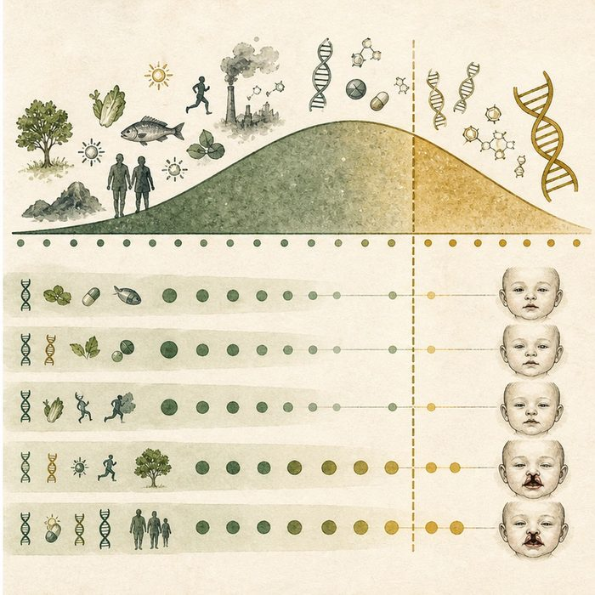
Biomedical teaching illustration: Model isolated cleft as multifactorial liability
Analogy step | Biology step | How the relationship stays the same
Small weights | Risk alleles and environmental factors | ________________________________
Scale total | Underlying liability | ________________________________
Tip point | Developmental threshold for clefting | ________________________________

GENETICS LESSON 3 | CASE FILE AND DECISION
4. Use the case evidence

ID | Finding supplied in the case | Why it matters
GEN03-E1 | Mateo's pedigree does not show clean vertical transmission. | A fully penetrant dominant model is a poor fit.
GEN03-E2 | Isolated cleft risk is influenced by many genetic loci and non-genetic factors. | Multiple contributors are expected.
GEN03-E3 | A person can carry risk factors without developing a cleft. | Penetrance is not all-or-none for each risk factor.

5. Make the clinical decision
You are selecting the inheritance model for the case board. The board offers either one dominant allele with complete penetrance or a multifactorial threshold model.
A. Choose the multifactorial threshold model.
B. Choose complete dominant inheritance despite unaffected parents.
C. Say genetics cannot affect isolated clefts.
Decision. Choose the model and cite both pedigree and population evidence.
________________________________________________________________________________
________________________________________________________________________________
Claim ceiling: You may choose the best-fit model. You may not calculate Mateo's exact liability or identify each contributor.
Claim. State the choice you can defend.
________________________________________________________________________________
Evidence. Use these labeled IDs: GEN03-E1 + GEN03-E2.
________________________________________________________________________________
Reasoning. Explain why the evidence supports the claim and stays inside the claim ceiling.
________________________________________________________________________________
________________________________________________________________________________

GENETICS LESSON 3 | REDUCE, REFLECT, AND PREPARE
6. Reduce the lesson to one lasting idea

Take-home. Most isolated clefts fit a multifactorial threshold model in which many small influences add to risk.
________________________________________________________________________________
________________________________________________________________________________
1. Why is the outcome discrete even when liability is graded?
________________________________________________________________________________
2. What evidence makes simple dominant inheritance less likely?
________________________________________________________________________________

Glossary
Term | Plain-English definition
autosomal dominant | A lesson term defined by the surrounding model and case evidence.
vertical transmission | A trait appearing in nearly every generation, passed directly from parent to child, the signature pattern of a dominant inheritance.
multifactorial inheritance | A trait caused by many small genetic and environmental factors adding up together, rather than by a single gene alone.
threshold model | The idea that a trait appears only when a person's combined liability from genes and environment crosses a set line.
liability | A person's total built-up risk for a trait from all their genetic and environmental factors combined, often pictured on a continuous scale.

Next lesson unlock
Mateo's cleft fits a multifactorial model where many small factors add up. But to understand cleft biology at all, scientists study the best-understood cleft gene in depth. Which gene is the best door into how clefts happen?
The journal links on the lesson page are optional. Everything required for this guided-notes set is already supplied here and in the case file.

