GENETICS DOMAIN | LESSON 2 OF 20 | CLINICAL GENETICIST

Screening for a Hidden Syndrome
What clue separates a syndrome from a lone cleft, and does Mateo show it?
CARRY FORWARD  A pedigree shows how a trait travels through a family; it does not prove that an isolated case is non-genetic. | 10-YEAR TAKEAWAY  A syndrome claim requires a repeatable pattern of features, not a cleft plus a familiar gene name.

Cells differentiate | Development sculpts | Cells move | Development can go wrong

1. Observe the analogy before naming the biology
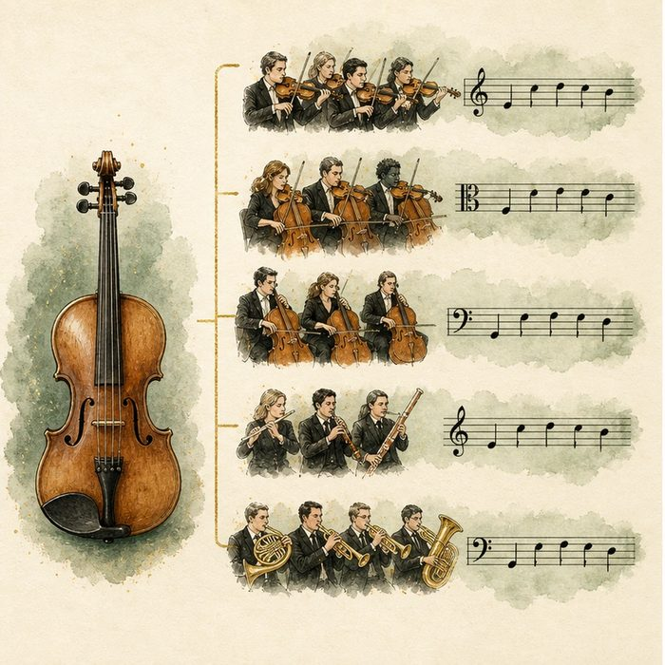
Illustration: One instrument or the whole musical theme
1. What turns one sound into a repeated theme?
________________________________________________________________________________
2. Which repeated features would make a pattern recognizable?
________________________________________________________________________________
3. Why is one shared note not enough?
________________________________________________________________________________

GENETICS LESSON 2 | RULES AND BIOLOGY MAPPING
2. Turn observations into rules

1. Rule 1: Screen for a set of associated features. Explain it in your own words.
________________________________________________________________________________
2. Rule 2: Use both present and absent findings. Explain it in your own words.
________________________________________________________________________________
3. Rule 3: A gene name does not replace phenotype evidence. Explain it in your own words.
________________________________________________________________________________
Where the analogy stops: Clinical syndromes are biological patterns, not music.

3. Map the rules onto the biomedical example
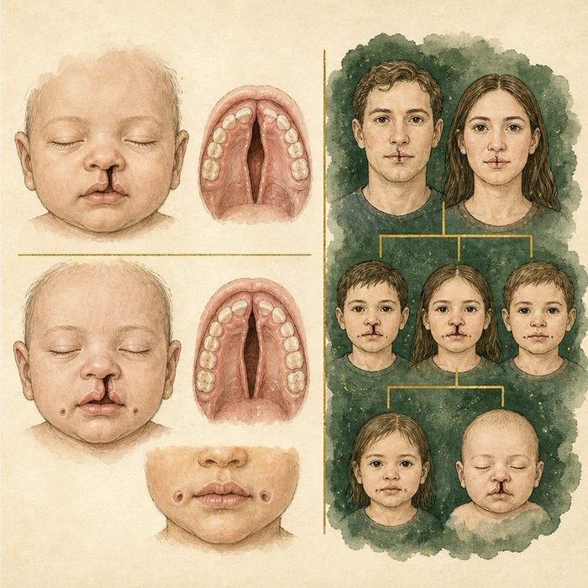
Biomedical teaching illustration: Compare isolated cleft with an IRF6-related syndrome pattern
Analogy step | Biology step | How the relationship stays the same
One instrument | Cleft as one finding | ________________________________
Repeated theme | Cleft plus lip pits and family pattern | ________________________________
Full score | Structured phenotype assessment | ________________________________

GENETICS LESSON 2 | CASE FILE AND DECISION
4. Use the case evidence

ID | Finding supplied in the case | Why it matters
GEN02-E1 | Mateo has no lower-lip pits on repeated examination. | A classic Van der Woude clue is absent.
GEN02-E2 | No additional anomaly pattern or affected relative is documented. | The current phenotype screen supports an isolated presentation.
GEN02-E3 | IRF6-related disorders are established by suggestive findings plus a pathogenic IRF6 variant. | Phenotype and molecular evidence work together.

5. Make the clinical decision
You are presenting the genetics screen. A teammate wants to label Van der Woude syndrome because IRF6 will be studied later.
A. Keep the case isolated-appearing pending molecular evidence.
B. Assign Van der Woude syndrome from the cleft alone.
C. Ignore lip pits and family history.
Decision. Choose the chart language and cite the absent pattern evidence.
________________________________________________________________________________
________________________________________________________________________________
Claim ceiling: You may say the current screen is isolated-appearing. You may not establish or exclude every syndrome without appropriate testing.
Claim. State the choice you can defend.
________________________________________________________________________________
Evidence. Use these labeled IDs: GEN02-E1 + GEN02-E2.
________________________________________________________________________________
Reasoning. Explain why the evidence supports the claim and stays inside the claim ceiling.
________________________________________________________________________________
________________________________________________________________________________

GENETICS LESSON 2 | REDUCE, REFLECT, AND PREPARE
6. Reduce the lesson to one lasting idea

Take-home. A syndrome claim requires a repeatable pattern of features, not a cleft plus a familiar gene name.
________________________________________________________________________________
________________________________________________________________________________
1. What pattern raises Van der Woude suspicion?
________________________________________________________________________________
2. Why does studying IRF6 not diagnose Mateo?
________________________________________________________________________________

Glossary
Term | Plain-English definition
phenotype | The observable traits of an organism, such as appearance or function, that result from its genotype combined with environmental influences.
syndromic cleft | A cleft that comes packaged with other features as part of a named syndrome, accounting for roughly 30 percent of clefts.
nonsyndromic (lone) cleft | A cleft that occurs on its own without other birth differences, making up roughly 70 percent of all clefts.
Van der Woude syndrome (VWS) | The most common single-gene cause of cleft lip and palate, usually from an IRF6 change, whose hallmark is small lower-lip pits.
lip pits | Small paired depressions on the lower lip that serve as the hallmark sign flagging Van der Woude syndrome, a cleft-related disorder.

Next lesson unlock
Mateo has no lip pits and no other features, so his cleft screens as isolated. But even an isolated cleft must follow some inheritance logic. Does an isolated cleft like Mateo's travel through families the clean way a single dominant gene would?
The journal links on the lesson page are optional. Everything required for this guided-notes set is already supplied here and in the case file.

