GENETICS DOMAIN | LESSON 1 OF 20 | INTAKE GENETICIST

Chance or Genetic? Reading Mateo's Family Tree
Is Mateo's cleft a one-time chance event, or is it written into his family?
CARRY FORWARD  Mateo's cleft is best explained as a developmental pathway outcome with bounded evidence, not as one proven cause. | 10-YEAR TAKEAWAY  A pedigree shows how a trait travels through a family; it does not prove that an isolated case is non-genetic.

Cells differentiate | Development sculpts | Cells move | Development can go wrong

1. Observe the analogy before naming the biology
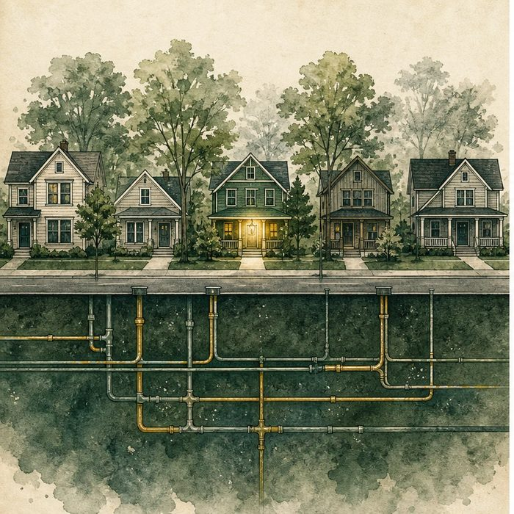
Illustration: A neighborhood map shows connections, not hidden wiring
1. Which connections can the map show directly?
________________________________________________________________________________
2. What important system remains hidden underground?
________________________________________________________________________________
3. Why would one affected home not prove a random event?
________________________________________________________________________________

GENETICS LESSON 1 | RULES AND BIOLOGY MAPPING
2. Turn observations into rules

1. Rule 1: Record relationships before explaining cause. Explain it in your own words.
________________________________________________________________________________
2. Rule 2: An absent family pattern lowers some hypotheses but does not erase genetics. Explain it in your own words.
________________________________________________________________________________
3. Rule 3: One pedigree is evidence, not a final mechanism. Explain it in your own words.
________________________________________________________________________________
Where the analogy stops: Families are not neighborhoods. The analogy models visible relationships versus hidden causes.

3. Map the rules onto the biomedical example
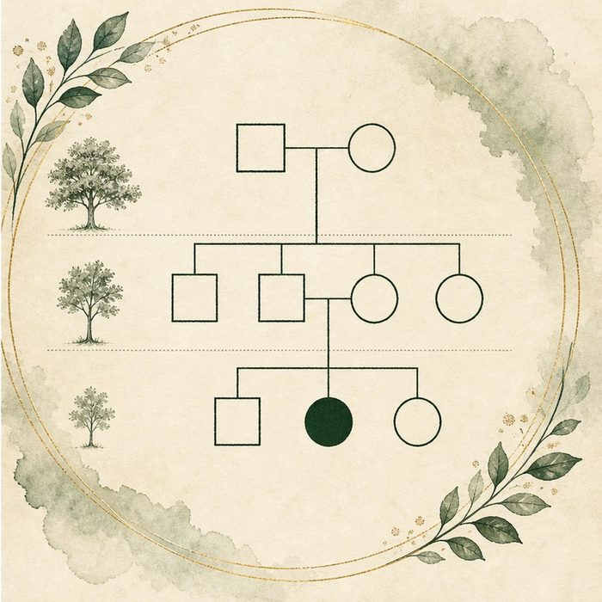
Biomedical teaching illustration: Build Mateo's three-generation pedigree
Analogy step | Biology step | How the relationship stays the same
Connected homes | Biological relatives | ________________________________
Marked home | Affected family member | ________________________________
Hidden utilities | Unobserved variants and multifactorial risk | ________________________________

GENETICS LESSON 1 | CASE FILE AND DECISION
4. Use the case evidence

ID | Finding supplied in the case | Why it matters
GEN01-E1 | Mateo is the only reported relative with a cleft across three generations. | The pedigree appears sporadic rather than strongly familial.
GEN01-E2 | Both parents are unaffected. | A simple fully penetrant dominant pattern is not supported.
GEN01-E3 | Isolated clefts can still involve inherited and new genetic risk factors. | No family history does not mean no genetic contribution.

5. Make the clinical decision
You are the intake genetic counselor. Mateo's parents ask whether the empty family history means the cleft was only chance.
A. Say the pedigree looks isolated but cannot exclude genetic risk.
B. Say no relatives means genes played no role.
C. Diagnose a dominant syndrome from one affected child.
Decision. Choose the counseling statement and cite the pedigree plus its limit.
________________________________________________________________________________
________________________________________________________________________________
Claim ceiling: You may describe the observed family pattern. You may not exclude genetic contribution or name an inheritance model yet.
Claim. State the choice you can defend.
________________________________________________________________________________
Evidence. Use these labeled IDs: GEN01-E1 + GEN01-E2.
________________________________________________________________________________
Reasoning. Explain why the evidence supports the claim and stays inside the claim ceiling.
________________________________________________________________________________
________________________________________________________________________________

GENETICS LESSON 1 | REDUCE, REFLECT, AND PREPARE
6. Reduce the lesson to one lasting idea

Take-home. A pedigree shows how a trait travels through a family; it does not prove that an isolated case is non-genetic.
________________________________________________________________________________
________________________________________________________________________________
1. What does Mateo's pedigree show?
________________________________________________________________________________
2. What genetic claim can it not close?
________________________________________________________________________________

Glossary
Term | Plain-English definition
pedigree | A family tree drawn with standard symbols (squares for males, circles for females, filled for affected) so any geneticist can read a family at a glance.
proband | The first affected person whose case brings a family in for genetic study, marked with an arrow on the pedigree.
isolated (sporadic) case | A trait that appears in just one person in a family, with no other clearly affected relatives.
familial case | An instance of a trait or condition that appears in more than one relative, often across several generations of a family.
generation | One layer of a family tree, such as grandparents, then parents, then children, shown as a row on a pedigree.

Next lesson unlock
Mateo's cleft looks isolated and his parents are unaffected, but a cleft can sometimes be one feature of a hidden syndrome. What would a syndrome look like, and how would we screen for one?
The journal links on the lesson page are optional. Everything required for this guided-notes set is already supplied here and in the case file.

