EXPERIMENTAL DESIGN DOMAIN | LESSON 20 OF 20 | PRINCIPAL INVESTIGATOR (THE WHOLE TEAM)

What New Question About Mateo Would You Investigate, and How?
What new question about Mateo's cleft is worth investigating, and how would you design a sound, ethical study to answer it?
CARRY FORWARD  Transparent reporting lets others appraise and reproduce methods, but it cannot repair a weak design. | 10-YEAR TAKEAWAY  A defensible study plan aligns question, design, variables, sampling, analysis, ethics, reporting, and a claim ceiling.

Cells differentiate | Development sculpts | Cells move | Development can go wrong

1. Observe the analogy before naming the biology

Illustration: A blueprint board checks every connection before construction
1. Which card determines the design?
________________________________________________________________________________
2. Where could one broken connection invalidate the plan?
________________________________________________________________________________
3. Which boundary stops the claim from outrunning evidence?
________________________________________________________________________________

EXPERIMENTAL DESIGN LESSON 20 | RULES AND BIOLOGY MAPPING
2. Turn observations into rules

1. Rule 1: Make every method trace back to the question. Explain it in your own words.
________________________________________________________________________________
2. Rule 2: Supply data, safeguards, and decision rules before results are known. Explain it in your own words.
________________________________________________________________________________
3. Rule 3: Write the strongest claim the design could support and no stronger. Explain it in your own words.
________________________________________________________________________________
Where the analogy stops: Research plans must adapt to real participants, sites, data, and oversight after review begins.

3. Map the rules onto the biomedical example
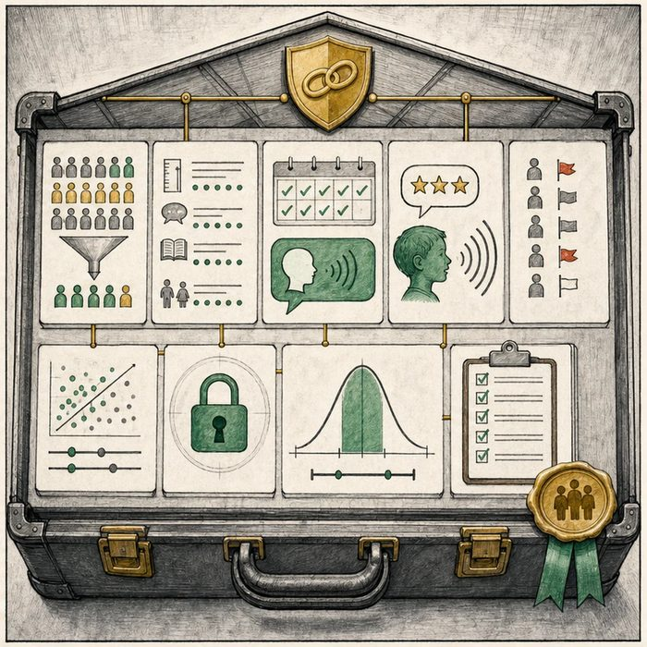
Biomedical teaching illustration: Defend one complete Mateo-related study protocol
Analogy step | Biology step | How the relationship stays the same
Blueprint purpose | Research question and hypothesis | ________________________________
Connected systems | Design, variables, sampling, and analysis | ________________________________
Inspection boundary | Ethics, reporting, and claim ceiling | ________________________________

EXPERIMENTAL DESIGN LESSON 20 | CASE FILE AND DECISION
4. Use the case evidence

ID | Finding supplied in the case | Why it matters
EXP20-E1 | The question asks whether a structured speech follow-up program is associated with improved age-8 communication after palate repair. | The outcome and population are specific, but the program is not randomly assigned.
EXP20-E2 | The supplied synthetic CSV contains 24 coded records with program group, center, baseline score, age-8 score, and missing-data flags. | Students can complete the design without outside recruitment or invented measurements.
EXP20-E3 | The analysis compares adjusted estimates, reports intervals and missingness, protects coded data, and follows STROBE. | The strongest result is an adjusted association, not proof of cause.

5. Make the clinical decision
You are the principal investigator at the protocol defense. The board must select one complete plan from three proposals using only the supplied case file and dataset.
A. Approve the aligned coded-records cohort with its observational claim ceiling.
B. Approve a plan that recruits unnamed children and invents measurements.
C. Call the program causal because the adjusted p-value is small.
Decision. Choose the defensible protocol and justify question, design, variables, sample, analysis, ethics, reporting, and claim ceiling.
________________________________________________________________________________
________________________________________________________________________________
Claim ceiling: You may defend an adjusted observational association using the supplied dataset. You may not claim causation or require outside data.
Claim. State the choice you can defend.
________________________________________________________________________________
Evidence. Use these labeled IDs: EXP20-E1 + EXP20-E2.
________________________________________________________________________________
Reasoning. Explain why the evidence supports the claim and stays inside the claim ceiling.
________________________________________________________________________________
________________________________________________________________________________

EXPERIMENTAL DESIGN LESSON 20 | REDUCE, REFLECT, AND PREPARE
6. Reduce the lesson to one lasting idea

Take-home. A defensible study plan aligns question, design, variables, sampling, analysis, ethics, reporting, and a claim ceiling.
________________________________________________________________________________
________________________________________________________________________________
1. Why can students finish this study inside the lesson package?
________________________________________________________________________________
2. What is the strongest supported claim?
________________________________________________________________________________

Glossary
Term | Plain-English definition
study protocol | The detailed written plan for a study that sets the question, methods, and steps before any data are collected.
primary outcome | The single main result a study is designed to measure, chosen ahead of time to answer its central question.
multifactorial | Caused by several genes acting together with environmental factors, not by a single gene alone.
nonsyndromic | Describing a condition, such as a cleft, that occurs on its own without a set of other linked birth differences.
convergent evidence | Support for a conclusion that comes from several independent methods or studies pointing to the same answer, which makes it more trustworthy.

Next lesson unlock
We answered the whole domain's question with this one: you can take a fresh question about Mateo's cleft and design a sound, ethical study, and you discovered his cleft is nonsyndromic and multifactorial by reasoning across the evidence, not by being told. The studies you read this year were designed by scientists years ago. The next generation of evidence about clefts like Mateo's will come from studies that students like you design. So the question that opens onto the rest of your life: what will you ask, and who will you become to answer it?
The journal links on the lesson page are optional. Everything required for this guided-notes set is already supplied here and in the case file.

