EXPERIMENTAL DESIGN DOMAIN | LESSON 19 OF 20 | SCIENCE WRITER

How Does the World Check That a Study Is Trustworthy?
Once a study is finished, how does the rest of the world check whether it is actually trustworthy?
CARRY FORWARD  Child research requires favorable risk and benefit, IRB review, parental permission, and affirmative assent when the child is capable. | 10-YEAR TAKEAWAY  Transparent reporting lets others appraise and reproduce methods, but it cannot repair a weak design.

Cells differentiate | Development sculpts | Cells move | Development can go wrong

1. Observe the analogy before naming the biology
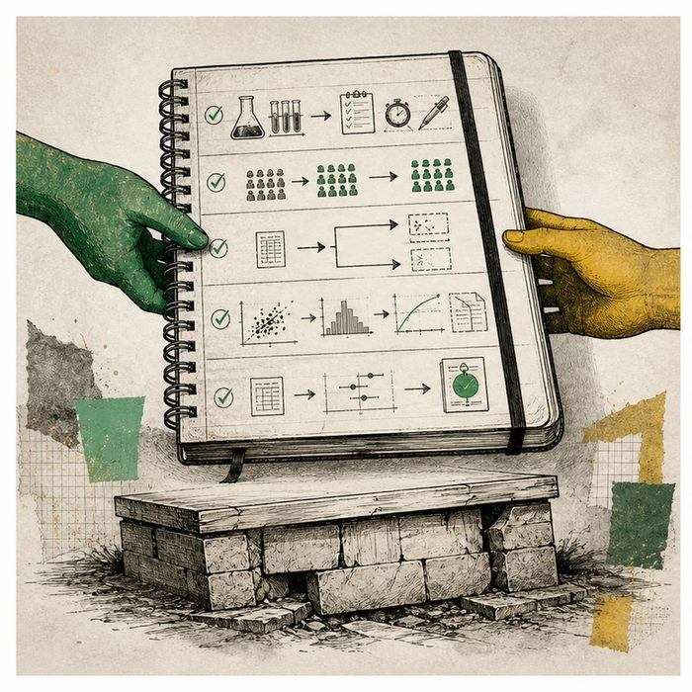
Illustration: A lab notebook must let an outside team repeat the route
1. Which detail lets the next team repeat the method?
________________________________________________________________________________
2. Where are missing participants shown?
________________________________________________________________________________
3. What if the original design was unfair but perfectly reported?
________________________________________________________________________________

EXPERIMENTAL DESIGN LESSON 19 | RULES AND BIOLOGY MAPPING
2. Turn observations into rules

1. Rule 1: Report planned and actual methods, participants, outcomes, and analyses. Explain it in your own words.
________________________________________________________________________________
2. Rule 2: Use the guideline matched to the study type. Explain it in your own words.
________________________________________________________________________________
3. Rule 3: Separate reporting from design quality, replication, and peer review. Explain it in your own words.
________________________________________________________________________________
Where the analogy stops: Exact reproduction may be impossible across people and settings, even when methods are transparent.

3. Map the rules onto the biomedical example
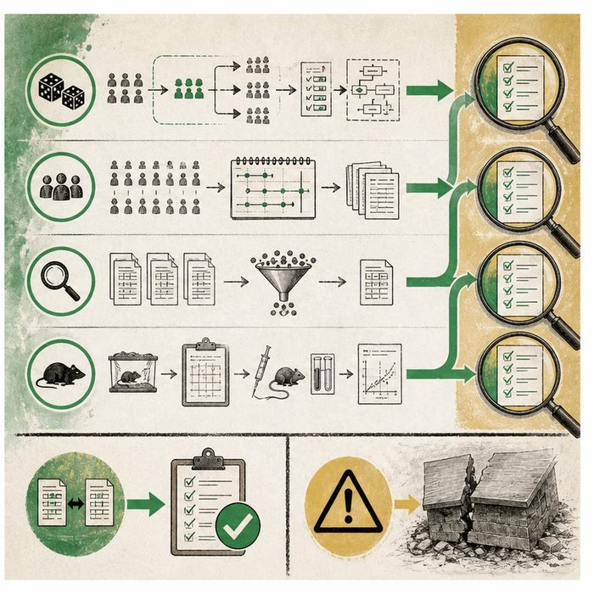
Biomedical teaching illustration: Match CONSORT, STROBE, PRISMA, and ARRIVE to four studies
Analogy step | Biology step | How the relationship stays the same
Participant route map | CONSORT for randomized trials | ________________________________
Observation record | STROBE for observational studies | ________________________________
Search and model notebooks | PRISMA and ARRIVE | ________________________________

EXPERIMENTAL DESIGN LESSON 19 | CASE FILE AND DECISION
4. Use the case evidence

ID | Finding supplied in the case | Why it matters
EXP19-E1 | The trial report includes eligibility, allocation, participant flow, outcomes, harms, and analysis. | Readers can check what happened from enrollment to result.
EXP19-E2 | The study type determines the matched guideline: CONSORT, STROBE, PRISMA, or ARRIVE. | One checklist does not fit every design.
EXP19-E3 | A fully reported study still has unconcealed allocation and severe missing data. | Transparency exposes the weakness but does not remove it.

5. Make the clinical decision
You are the journal reproducibility editor. An author says completing a reporting checklist proves the study is trustworthy.
A. Use the matched guideline, then judge design, conduct, analysis, and replication separately.
B. Accept the checklist as proof of validity.
C. Reject reporting guidelines because they cannot fix a study.
Decision. Choose the editorial decision and match each supplied study to its guideline.
________________________________________________________________________________
________________________________________________________________________________
Claim ceiling: You may judge reporting completeness and exposed strengths or weaknesses. You may not call a study reproducible or valid from a checklist alone.
Claim. State the choice you can defend.
________________________________________________________________________________
Evidence. Use these labeled IDs: EXP19-E1 + EXP19-E2.
________________________________________________________________________________
Reasoning. Explain why the evidence supports the claim and stays inside the claim ceiling.
________________________________________________________________________________
________________________________________________________________________________

EXPERIMENTAL DESIGN LESSON 19 | REDUCE, REFLECT, AND PREPARE
6. Reduce the lesson to one lasting idea

Take-home. Transparent reporting lets others appraise and reproduce methods, but it cannot repair a weak design.
________________________________________________________________________________
________________________________________________________________________________
1. Which guideline fits a systematic review?
________________________________________________________________________________
2. Why does reporting not repair weak design?
________________________________________________________________________________

Glossary
Term | Plain-English definition
reproducibility | The ability to get the same results when an experiment is repeated using the same methods, which builds trust in findings.
reporting standard | An agreed set of items a study must describe so readers can judge and reproduce the work, like the PRISMA checklist for reviews.
peer review | The process where independent experts evaluate a research study for quality and accuracy before it is published.
CONSORT | A standard checklist and flow diagram that researchers use to report every key detail of a randomized controlled trial clearly and honestly.
STROBE | A standard checklist that guides researchers on how to clearly and fully report observational studies in medicine.

Next lesson unlock
We answered today's question: reporting standards, reproducibility, and peer review let the world check a study instead of trusting it on faith. Across this whole domain you have learned to ask a researchable question, build a hypothesis, pick a design, control bias, run the stats, clear ethics, and report it all. So here is the last test: what new question about Mateo's cleft would YOU investigate, and how would you design a study to answer it? We chase that next time, and this time the study is yours.
The journal links on the lesson page are optional. Everything required for this guided-notes set is already supplied here and in the case file.

