EXPERIMENTAL DESIGN DOMAIN | LESSON 18 OF 20 | BIOETHICIST / IRB LIAISON

What Makes Research on Children Ethical?
What has to be true before scientists are allowed to study a baby like Mateo?
CARRY FORWARD  Systematic reviews reduce cherry-picking, while meta-analysis is credible only when studies and pooling assumptions support it. | 10-YEAR TAKEAWAY  Child research requires favorable risk and benefit, IRB review, parental permission, and affirmative assent when the child is capable.

Cells differentiate | Development sculpts | Cells move | Development can go wrong

1. Observe the analogy before naming the biology

Illustration: A field trip needs safety review, adult permission, and child agreement
1. Who reviews the plan before anyone joins?
________________________________________________________________________________
2. Whose permission is needed?
________________________________________________________________________________
3. How can a child show an affirmative choice?
________________________________________________________________________________

EXPERIMENTAL DESIGN LESSON 18 | RULES AND BIOLOGY MAPPING
2. Turn observations into rules

1. Rule 1: Use added protections for children and minimize risk. Explain it in your own words.
________________________________________________________________________________
2. Rule 2: Obtain parental permission unless an approved exception applies. Explain it in your own words.
________________________________________________________________________________
3. Rule 3: Seek affirmative, age-appropriate assent when the child is capable. Explain it in your own words.
________________________________________________________________________________
Where the analogy stops: Research ethics is governed by regulations, context, and individual capacity, not one school-trip form.

3. Map the rules onto the biomedical example
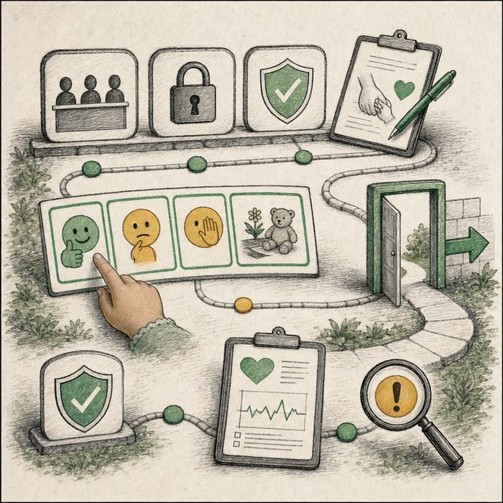
Biomedical teaching illustration: Apply Subpart D protections to a pediatric speech study
Analogy step | Biology step | How the relationship stays the same
Independent safety review | IRB review | ________________________________
Caregiver form | Parental permission | ________________________________
Child agreement card | Affirmative assent when capable | ________________________________

EXPERIMENTAL DESIGN LESSON 18 | CASE FILE AND DECISION
4. Use the case evidence

ID | Finding supplied in the case | Why it matters
EXP18-E1 | The study involves children, coded recordings, and no change from accepted care. | The IRB must assess risk, privacy, and added protections.
EXP18-E2 | The protocol gives caregivers plain-language information and time for questions. | Permission should be informed and voluntary.
EXP18-E3 | Children who can understand receive an age-appropriate explanation and are asked for affirmative agreement. | Assent is more than silence or failure to object.

5. Make the clinical decision
You are the pediatric IRB reviewer. A protocol says parental signature alone is enough and children should not be told because that is faster.
A. Require IRB-approved protections, permission, and capability-based assent.
B. Use only the parent signature for every capable child.
C. Treat a child's silence as affirmative assent.
Decision. Choose the ethics correction and explain the role of the IRB, permission, and assent.
________________________________________________________________________________
________________________________________________________________________________
Claim ceiling: You may apply the supplied educational ethics framework. You may not replace local IRB review or legal guidance.
Claim. State the choice you can defend.
________________________________________________________________________________
Evidence. Use these labeled IDs: EXP18-E1 + EXP18-E2.
________________________________________________________________________________
Reasoning. Explain why the evidence supports the claim and stays inside the claim ceiling.
________________________________________________________________________________
________________________________________________________________________________

EXPERIMENTAL DESIGN LESSON 18 | REDUCE, REFLECT, AND PREPARE
6. Reduce the lesson to one lasting idea

Take-home. Child research requires favorable risk and benefit, IRB review, parental permission, and affirmative assent when the child is capable.
________________________________________________________________________________
________________________________________________________________________________
1. What extra review protects children?
________________________________________________________________________________
2. Why is silence not assent?
________________________________________________________________________________

Glossary
Term | Plain-English definition
informed consent | Agreeing to a treatment or study only after truly understanding its purpose, risks, benefits, and alternatives; the understanding, not the signature, is the ethics.
assent | A child or teen's own agreement to take part in a study, given alongside a parent's legal permission, after the study is explained at their level.
equipoise | Genuine uncertainty in the expert community about which treatment is better, which is what makes randomly assigning patients in a trial ethical.
Institutional Review Board (IRB) | A committee that reviews research involving people to make sure it is ethical and that participants are protected from harm.
incidental findings | Unexpected health results discovered by a test that was looking for something else, raising questions about whether to report them.

Next lesson unlock
We answered today's question: an ethical study needs IRB approval, real consent and assent, and genuine equipoise. But clearing ethics only means a study was allowed to run, not that its result is true. Suppose a study cleared every ethics check and was run perfectly. How does the rest of the world confirm it is trustworthy and not just one team's claim? We chase that next time.
The journal links on the lesson page are optional. Everything required for this guided-notes set is already supplied here and in the case file.

