EXPERIMENTAL DESIGN DOMAIN | LESSON 17 OF 20 | DATA SCIENTIST

How Do We Combine Many Studies Into One Answer?
How do we combine many separate studies into one trustworthy answer, without cherry-picking?
CARRY FORWARD  Bias is directional design or measurement error; confounding mixes effects; each threat needs a matched safeguard. | 10-YEAR TAKEAWAY  Systematic reviews reduce cherry-picking, while meta-analysis is credible only when studies and pooling assumptions support it.

Cells differentiate | Development sculpts | Cells move | Development can go wrong

1. Observe the analogy before naming the biology

Illustration: A recipe search needs a sieve before ingredients enter one bowl
1. Which records are found before the sieve?
________________________________________________________________________________
2. Who sets the inclusion holes and when?
________________________________________________________________________________
3. Why might some ingredients remain outside the bowl?
________________________________________________________________________________

EXPERIMENTAL DESIGN LESSON 17 | RULES AND BIOLOGY MAPPING
2. Turn observations into rules

1. Rule 1: Predefine eligibility, search, outcomes, and analysis. Explain it in your own words.
________________________________________________________________________________
2. Rule 2: Assess risk of bias before pooling. Explain it in your own words.
________________________________________________________________________________
3. Rule 3: Interpret heterogeneity and pool only when the combined estimate has clear meaning. Explain it in your own words.
________________________________________________________________________________
Where the analogy stops: Studies are not interchangeable ingredients, and statistical weights do not erase design flaws.

3. Map the rules onto the biomedical example
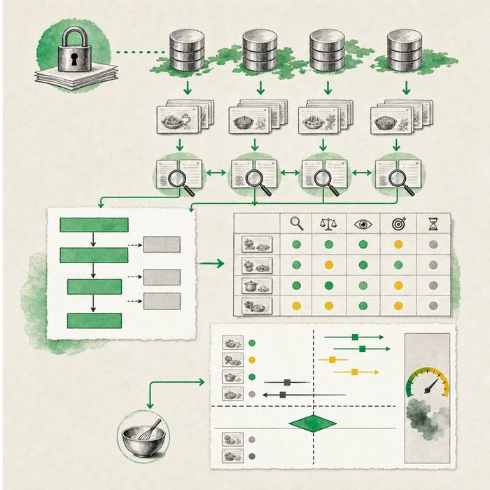
Biomedical teaching illustration: Move from a PRISMA flow diagram to a defensible forest plot
Analogy step | Biology step | How the relationship stays the same
Search shelves | Comprehensive literature search | ________________________________
Eligibility sieve | Predefined inclusion and exclusion rules | ________________________________
Pooling bowl | Meta-analysis when studies are compatible | ________________________________

EXPERIMENTAL DESIGN LESSON 17 | CASE FILE AND DECISION
4. Use the case evidence

ID | Finding supplied in the case | Why it matters
EXP17-E1 | The protocol was registered before screening and lists databases, eligibility, outcomes, and analysis. | The process is harder to change after seeing results.
EXP17-E2 | Two studies use blinded age-5 VPI ratings, while one uses an unvalidated parent question at age 2. | Outcome differences may limit a meaningful pooled estimate.
EXP17-E3 | The forest plot shows effects in different directions and major clinical differences across centers. | Heterogeneity must be explained rather than hidden by one average.

5. Make the clinical decision
You are the systematic-review editor deciding whether to approve pooling. The authors want one dramatic number even though one study measures a different outcome and timing.
A. Present the review and pool only a justified compatible subset.
B. Combine every number because meta-analysis is always strongest.
C. Discard studies that disagree with the preferred answer.
Decision. Choose the synthesis plan and cite protocol, outcome compatibility, and heterogeneity evidence.
________________________________________________________________________________
________________________________________________________________________________
Claim ceiling: You may synthesize and pool compatible studies when justified. You may not claim a pooled estimate repairs weak or incompatible evidence.
Claim. State the choice you can defend.
________________________________________________________________________________
Evidence. Use these labeled IDs: EXP17-E1 + EXP17-E2.
________________________________________________________________________________
Reasoning. Explain why the evidence supports the claim and stays inside the claim ceiling.
________________________________________________________________________________
________________________________________________________________________________

EXPERIMENTAL DESIGN LESSON 17 | REDUCE, REFLECT, AND PREPARE
6. Reduce the lesson to one lasting idea

Take-home. Systematic reviews reduce cherry-picking, while meta-analysis is credible only when studies and pooling assumptions support it.
________________________________________________________________________________
________________________________________________________________________________
1. What should be planned before screening?
________________________________________________________________________________
2. When might a review avoid one pooled estimate?
________________________________________________________________________________

Glossary
Term | Plain-English definition
systematic review | A study that follows a planned, transparent method to gather, judge, and combine all relevant research on one question.
meta-analysis | A study that statistically combines the results of many separate studies to reach a more reliable overall conclusion.
heterogeneity | Wide variation within a group, such as many different genetic causes leading to the same outward condition.
PRISMA 2020 | A widely used checklist and flow diagram that guides researchers to report systematic reviews clearly, completely, and transparently.
publication bias | The tendency for studies with positive or exciting results to get published while studies with no effect stay hidden, skewing the evidence.

Next lesson unlock
Combining studies only works if the studies were done on real children fairly. But every study we pool was run on real babies and families. What rules protect children in research in the first place, and who decides what is allowed? We chase that next time.
The journal links on the lesson page are optional. Everything required for this guided-notes set is already supplied here and in the case file.

