EXPERIMENTAL DESIGN DOMAIN | LESSON 16 OF 20 | BIOSTATISTICIAN

What Could Fool Us Into the Wrong Conclusion?
What could fool us into thinking we found the right cause, when we did not?
CARRY FORWARD  An operational definition makes speech scoring repeatable, while patient-reported outcomes capture effects clinician scores can miss. | 10-YEAR TAKEAWAY  Bias is directional design or measurement error; confounding mixes effects; each threat needs a matched safeguard.

Cells differentiate | Development sculpts | Cells move | Development can go wrong

1. Observe the analogy before naming the biology

Illustration: A crooked mirror and a hidden magnet distort results in different ways
1. Which problem changes the measurement itself?
________________________________________________________________________________
2. Which adds another cause linked to both sides?
________________________________________________________________________________
3. Would a larger sample fix either problem?
________________________________________________________________________________

EXPERIMENTAL DESIGN LESSON 16 | RULES AND BIOLOGY MAPPING
2. Turn observations into rules

1. Rule 1: Name the direction and stage of each bias. Explain it in your own words.
________________________________________________________________________________
2. Rule 2: Draw the confounder linked to exposure and outcome. Explain it in your own words.
________________________________________________________________________________
3. Rule 3: Choose a safeguard that fits the threat. Explain it in your own words.
________________________________________________________________________________
Where the analogy stops: Real studies can have many interacting biases and unmeasured confounders, not one visible mirror or magnet.

3. Map the rules onto the biomedical example
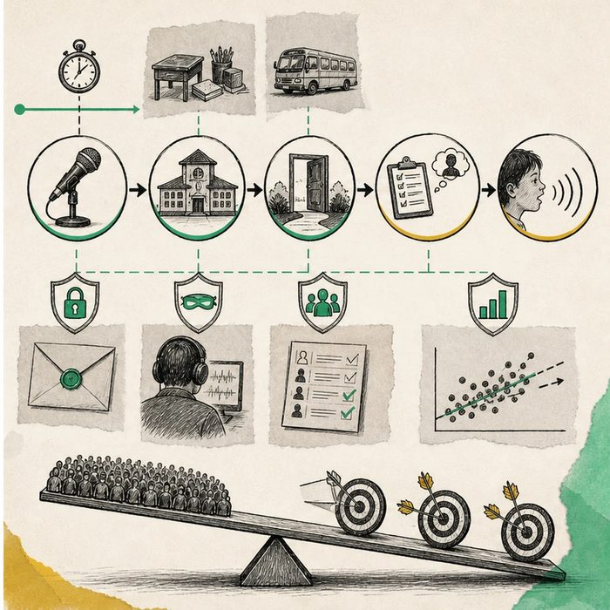
Biomedical teaching illustration: Red-team a speech study for selection, measurement, and confounding
Analogy step | Biology step | How the relationship stays the same
Crooked mirror | Measurement bias | ________________________________
Missing participants | Selection and attrition bias | ________________________________
Hidden magnet | Confounder linked to exposure and outcome | ________________________________

EXPERIMENTAL DESIGN LESSON 16 | CASE FILE AND DECISION
4. Use the case evidence

ID | Finding supplied in the case | Why it matters
EXP16-E1 | Earlier-repair participants are more likely to receive care at high-volume centers with strong speech services. | Center resources could confound an observational comparison.
EXP16-E2 | Assessors know each child's group and expect earlier repair to work. | Expectation could create directional measurement bias.
EXP16-E3 | Follow-up is 92 percent in one group and 71 percent in the other, with access-related reasons. | Differential attrition could change the comparison.

5. Make the clinical decision
You are the adversarial methods reviewer before data lock. The team says a sample of 5,000 makes bias and confounding disappear.
A. Match each supplied threat with a design, measurement, or analysis safeguard.
B. Accept the claim because large samples remove systematic error.
C. List every possible bias without changing the protocol.
Decision. Choose the red-team response and propose one matched safeguard per evidence card.
________________________________________________________________________________
________________________________________________________________________________
Claim ceiling: You may reduce named threats. You may not claim adjustment removes all unmeasured bias or confounding.
Claim. State the choice you can defend.
________________________________________________________________________________
Evidence. Use these labeled IDs: EXP16-E1 + EXP16-E2.
________________________________________________________________________________
Reasoning. Explain why the evidence supports the claim and stays inside the claim ceiling.
________________________________________________________________________________
________________________________________________________________________________

EXPERIMENTAL DESIGN LESSON 16 | REDUCE, REFLECT, AND PREPARE
6. Reduce the lesson to one lasting idea

Take-home. Bias is directional design or measurement error; confounding mixes effects; each threat needs a matched safeguard.
________________________________________________________________________________
________________________________________________________________________________
1. Why can a large sample still be biased?
________________________________________________________________________________
2. How is a confounder different from measurement bias?
________________________________________________________________________________

Glossary
Term | Plain-English definition
bias | A systematic error in how data is collected or interpreted that tilts results in one direction, making conclusions less accurate or unfair.
confounding | When a hidden third factor influences both the suspected cause and the outcome, making a link look real when it may be misleading.
blinding | Keeping participants, researchers, or both unaware of who got which treatment so expectations cannot bias the results.
recall bias | A study error where people with a condition remember past exposures differently than people without it, distorting the results.
surgeon-as-confounder | A study bias where differences in patient outcomes come from which surgeon operated rather than from the treatment being tested.

Next lesson unlock
We answered today's question: bias, confounding, and weak blinding can all fool us. But even a careful single study can be a fluke or can disagree with the next study. How do we gather every study on a question and combine them into one trustworthy answer? We chase that next time.
The journal links on the lesson page are optional. Everything required for this guided-notes set is already supplied here and in the case file.

