EXPERIMENTAL DESIGN DOMAIN | LESSON 15 OF 20 | STUDY COORDINATOR (OUTCOME-MEASUREMENT SEAT)

How Do You Measure Something as Fuzzy as Speech?
How do you turn a fuzzy idea like 'good speech' into something you can measure fairly and identically for hundreds of different children?
CARRY FORWARD  TOPS supports a narrow claim: earlier repair lowered VPI in its eligible population, with uncertainty and limits. | 10-YEAR TAKEAWAY  An operational definition makes speech scoring repeatable, while patient-reported outcomes capture effects clinician scores can miss.

Cells differentiate | Development sculpts | Cells move | Development can go wrong

1. Observe the analogy before naming the biology
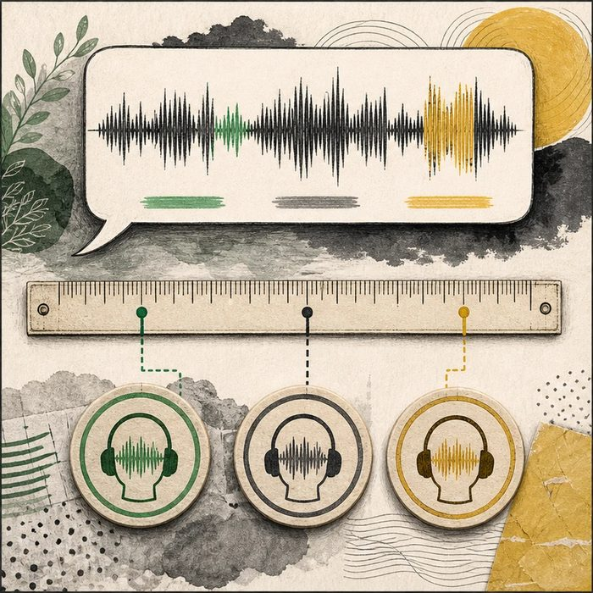
Illustration: A calibrated ruler and several listeners turn a fuzzy judgment into a shared measure
1. Where are the scoring boundaries?
________________________________________________________________________________
2. Why do listeners use the same examples?
________________________________________________________________________________
3. Which experience is only visible to the speaker?
________________________________________________________________________________

EXPERIMENTAL DESIGN LESSON 15 | RULES AND BIOLOGY MAPPING
2. Turn observations into rules

1. Rule 1: Define each outcome before data collection. Explain it in your own words.
________________________________________________________________________________
2. Rule 2: Train and test raters with coded samples. Explain it in your own words.
________________________________________________________________________________
3. Rule 3: Pair clinical measures with validated patient-reported outcomes when relevant. Explain it in your own words.
________________________________________________________________________________
Where the analogy stops: Speech varies by language, dialect, development, task, and context, so no single score captures the whole experience.

3. Map the rules onto the biomedical example
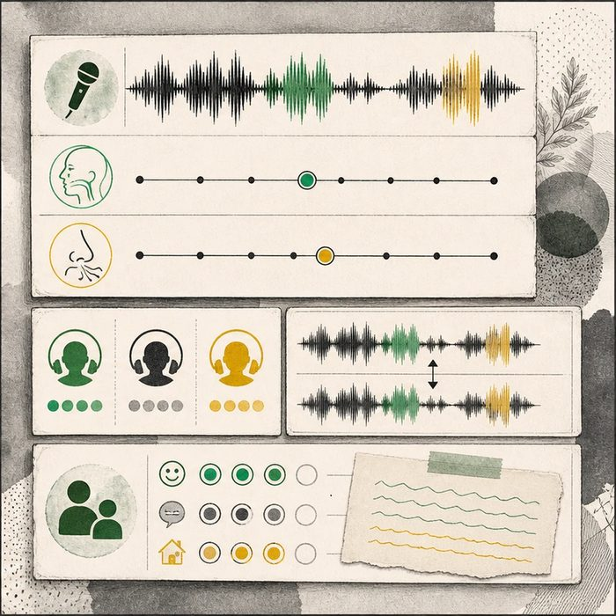
Biomedical teaching illustration: Operationalize VPI and speech participation
Analogy step | Biology step | How the relationship stays the same
Calibrated ruler | Operational definition | ________________________________
Trained listeners | Rater standardization and reliability | ________________________________
Speaker card | Patient-reported outcome | ________________________________

EXPERIMENTAL DESIGN LESSON 15 | CASE FILE AND DECISION
4. Use the case evidence

ID | Finding supplied in the case | Why it matters
EXP15-E1 | The protocol defines VPI using specified ratings from standardized speech samples. | Every group is measured with the same rule.
EXP15-E2 | Assessors are trained, blinded to timing, and agreement is checked on duplicate coded recordings. | The process tests whether scoring is reliable.
EXP15-E3 | A validated child or caregiver measure records speech participation and burden. | The study includes an outcome that clinical resonance scores may miss.

5. Make the clinical decision
You are the speech-outcomes lead finalizing the protocol. The draft outcome is simply 'speech sounds better,' with no task, rule, or patient voice.
A. Define the task, rubric, training, blinding, reliability check, and reported outcome.
B. Keep the phrase because every listener knows better speech.
C. Use only one surgeon's impression.
Decision. Choose the measurement plan and explain what each measure adds.
________________________________________________________________________________
________________________________________________________________________________
Claim ceiling: You may define reliable study outcomes. You may not claim one score represents every language, dialect, or lived experience.
Claim. State the choice you can defend.
________________________________________________________________________________
Evidence. Use these labeled IDs: EXP15-E1 + EXP15-E2.
________________________________________________________________________________
Reasoning. Explain why the evidence supports the claim and stays inside the claim ceiling.
________________________________________________________________________________
________________________________________________________________________________

EXPERIMENTAL DESIGN LESSON 15 | REDUCE, REFLECT, AND PREPARE
6. Reduce the lesson to one lasting idea

Take-home. An operational definition makes speech scoring repeatable, while patient-reported outcomes capture effects clinician scores can miss.
________________________________________________________________________________
________________________________________________________________________________
1. What belongs in an operational definition?
________________________________________________________________________________
2. Why add a patient-reported outcome?
________________________________________________________________________________

Glossary
Term | Plain-English definition
outcome measure | The specific, defined result a study tracks to judge whether a treatment worked, such as speech quality or healing rate.
operational definition | A precise statement of how a concept will be measured or observed in a study, so anyone can apply it the same way.
standardization | Making methods, measurements, or definitions the same across a study or site, so results can be fairly compared.
patient-reported outcome | A result measured directly from what the patient says about their own health, symptoms, or quality of life.
validated instrument | A survey or test that has been formally checked to make sure it measures what it claims to, consistently and accurately.

Next lesson unlock
We now know how to measure a fuzzy outcome like speech carefully and the same way for every child. But even a perfectly measured outcome can still point us to the wrong cause. A real cleft trial once found its result was driven not by the treatment but by something hiding in the background. What could fool us, even when our measurements are flawless? We chase that next time.
The journal links on the lesson page are optional. Everything required for this guided-notes set is already supplied here and in the case file.

