EXPERIMENTAL DESIGN DOMAIN | LESSON 14 OF 20 | PRINCIPAL INVESTIGATOR (WITH THE TEAM BIOSTATISTICIAN)

The TOPS Trial: How Surgeons Tested the Best Time to Repair a Palate
How did one real randomized trial test the best timing of cleft palate surgery, and what exactly did its main result prove?
CARRY FORWARD  Fair treatment trials require equipoise, concealed randomization, unbiased outcome assessment, and analysis by assigned group. | 10-YEAR TAKEAWAY  TOPS supports a narrow claim: earlier repair lowered VPI in its eligible population, with uncertainty and limits.

Cells differentiate | Development sculpts | Cells move | Development can go wrong

1. Observe the analogy before naming the biology
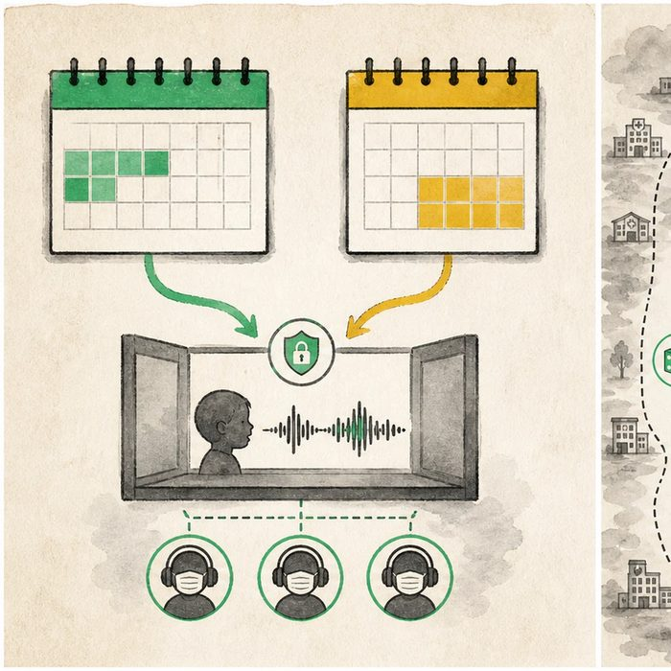
Illustration: Two calendar windows lead to one coded five-year review
1. What differs between the two paths?
________________________________________________________________________________
2. What remains standardized?
________________________________________________________________________________
3. Why are the final recordings coded?
________________________________________________________________________________

EXPERIMENTAL DESIGN LESSON 14 | RULES AND BIOLOGY MAPPING
2. Turn observations into rules

1. Rule 1: Read eligibility before applying the result. Explain it in your own words.
________________________________________________________________________________
2. Rule 2: Report effect size, interval, and outcome definition. Explain it in your own words.
________________________________________________________________________________
3. Rule 3: Carry safety, setting, and cleft-type limits into the conclusion. Explain it in your own words.
________________________________________________________________________________
Where the analogy stops: A calendar image hides clinical work, follow-up losses, and other outcomes that shape a real trial.

3. Map the rules onto the biomedical example
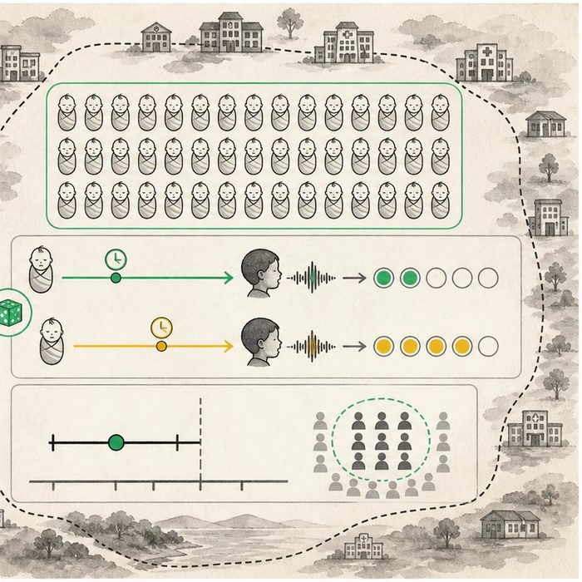
Biomedical teaching illustration: Read the TOPS trial from eligibility to claim ceiling
Analogy step | Biology step | How the relationship stays the same
Two calendar windows | 6-month and 12-month repair groups | ________________________________
Coded review | Blinded VPI assessment at age 5 | ________________________________
Boundary frame | Eligibility and setting limits | ________________________________

EXPERIMENTAL DESIGN LESSON 14 | CASE FILE AND DECISION
4. Use the case evidence

ID | Finding supplied in the case | Why it matters
EXP14-E1 | TOPS randomized 558 medically fit infants with nonsyndromic isolated cleft palate at 23 centers. | The study population did not include every cleft type or setting.
EXP14-E2 | VPI at age 5 occurred in 8.9 percent of the 6-month group and 15.0 percent of the 12-month group among analyzable participants. | The earlier group had fewer primary-outcome events.
EXP14-E3 | The risk ratio was 0.59 with a 95 percent interval from 0.36 to 0.99. | The estimate favors earlier repair, but other outcomes and uncertainty matter.

5. Make the clinical decision
You are the evidence lead briefing a cleft team. The team asks whether TOPS proves every infant with cleft lip and palate should have repair at 6 months in every center.
A. Apply the result to similar eligible infants while discussing uncertainty, setting, and other outcomes.
B. Generalize the result to every cleft type and center.
C. Ignore the trial because its interval approaches the null.
Decision. Choose the briefing and cite population, event rates, risk ratio, and one limit.
________________________________________________________________________________
________________________________________________________________________________
Claim ceiling: You may state the primary TOPS finding for its eligible population. You may not prescribe timing for Mateo or generalize to all clefts and settings.
Claim. State the choice you can defend.
________________________________________________________________________________
Evidence. Use these labeled IDs: EXP14-E1 + EXP14-E2.
________________________________________________________________________________
Reasoning. Explain why the evidence supports the claim and stays inside the claim ceiling.
________________________________________________________________________________
________________________________________________________________________________

EXPERIMENTAL DESIGN LESSON 14 | REDUCE, REFLECT, AND PREPARE
6. Reduce the lesson to one lasting idea

Take-home. TOPS supports a narrow claim: earlier repair lowered VPI in its eligible population, with uncertainty and limits.
________________________________________________________________________________
________________________________________________________________________________
1. Who was eligible for TOPS?
________________________________________________________________________________
2. Why can the result not be applied to every cleft case?
________________________________________________________________________________

Glossary
Term | Plain-English definition
primary outcome | The single main result a study is designed to measure, chosen ahead of time to answer its central question.
risk ratio | A number comparing the chance of an outcome in an exposed group versus an unexposed group; above 1 means higher risk with exposure.
confidence interval | A range of values that likely contains the true result, showing how precise an estimate is; a narrow range means more certainty.
power calculation | A planning step that estimates how many subjects a study needs to reliably detect a real effect if one exists.
generalizability | How well a study's findings hold true for people or settings beyond the specific group that was studied.

Next lesson unlock
TOPS rested on one judgment for every child: did this 5-year-old's speech sound right, or was it nasal and unclear? But good speech is not a number a machine prints out. How do you actually measure something as fuzzy as speech, fairly and the same way for hundreds of children? We chase that next time.
The journal links on the lesson page are optional. Everything required for this guided-notes set is already supplied here and in the case file.

