EXPERIMENTAL DESIGN DOMAIN | LESSON 13 OF 20 | PRINCIPAL INVESTIGATOR (CLINICAL-TRIAL DESIGN SEAT)

The Fairest Test: How to Compare Two Treatments in Real Children
When you cannot control a child's biology, what makes a comparison of two treatments actually fair?
CARRY FORWARD  Loss plus targeted rescue strengthens causation when the rescue is specific, verified, and compared with controls. | 10-YEAR TAKEAWAY  Fair treatment trials require equipoise, concealed randomization, unbiased outcome assessment, and analysis by assigned group.

Cells differentiate | Development sculpts | Cells move | Development can go wrong

1. Observe the analogy before naming the biology
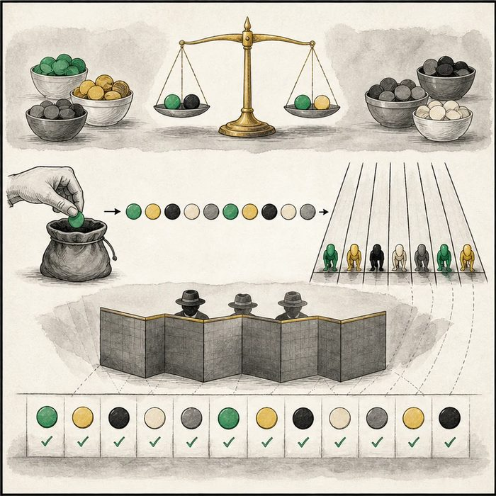
Illustration: A fair race uses concealed lanes, blinded judges, and every assigned runner
1. Who knows the lane before assignment?
________________________________________________________________________________
2. What is hidden from judges?
________________________________________________________________________________
3. Why keep runners in their assigned lane during analysis?
________________________________________________________________________________

EXPERIMENTAL DESIGN LESSON 13 | RULES AND BIOLOGY MAPPING
2. Turn observations into rules

1. Rule 1: Randomize only between acceptable options under genuine uncertainty. Explain it in your own words.
________________________________________________________________________________
2. Rule 2: Conceal assignment and blind outcome assessment when feasible. Explain it in your own words.
________________________________________________________________________________
3. Rule 3: Use intention-to-treat to preserve the assigned comparison. Explain it in your own words.
________________________________________________________________________________
Where the analogy stops: Clinical trials cannot blind every participant or clinician, and patient care must continue throughout the study.

3. Map the rules onto the biomedical example
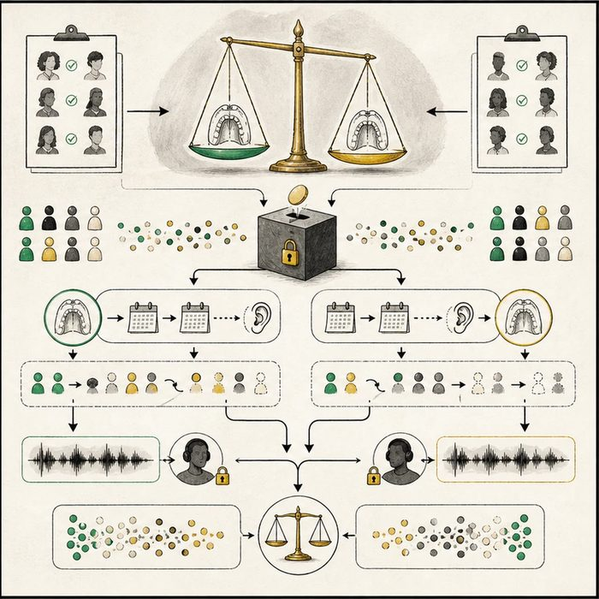
Biomedical teaching illustration: Design a fair comparison of two accepted palate-repair timings
Analogy step | Biology step | How the relationship stays the same
Concealed lane draw | Allocation concealment and randomization | ________________________________
Coded judges | Blinded outcome assessment | ________________________________
Assigned-runner roster | Intention-to-treat analysis | ________________________________

EXPERIMENTAL DESIGN LESSON 13 | CASE FILE AND DECISION
4. Use the case evidence

ID | Finding supplied in the case | Why it matters
EXP13-E1 | Both timings are accepted options and experts remain uncertain about their balance of outcomes. | Clinical equipoise can support randomization.
EXP13-E2 | A central system reveals assignment only after an eligible infant is enrolled. | Allocation concealment reduces selection manipulation.
EXP13-E3 | Speech assessors receive coded recordings and analysis keeps participants in assigned groups. | Blinding and intention-to-treat protect the comparison.

5. Make the clinical decision
You are the clinical-trial methods chair. A surgeon wants to choose timing after seeing the next assignment and remove crossovers from analysis.
A. Use concealed randomization, coded assessment, and intention-to-treat.
B. Let the recruiter predict and change assignments.
C. Analyze only participants who perfectly followed the schedule.
Decision. Choose the fair-trial plan and explain the threat controlled by each safeguard.
________________________________________________________________________________
________________________________________________________________________________
Claim ceiling: You may design the comparison when both options are acceptable. You may not randomize repair versus knowingly harmful no repair.
Claim. State the choice you can defend.
________________________________________________________________________________
Evidence. Use these labeled IDs: EXP13-E1 + EXP13-E2.
________________________________________________________________________________
Reasoning. Explain why the evidence supports the claim and stays inside the claim ceiling.
________________________________________________________________________________
________________________________________________________________________________

EXPERIMENTAL DESIGN LESSON 13 | REDUCE, REFLECT, AND PREPARE
6. Reduce the lesson to one lasting idea

Take-home. Fair treatment trials require equipoise, concealed randomization, unbiased outcome assessment, and analysis by assigned group.
________________________________________________________________________________
________________________________________________________________________________
1. What must exist before randomization is ethical?
________________________________________________________________________________
2. Why keep crossovers in their assigned group?
________________________________________________________________________________

Glossary
Term | Plain-English definition
randomized controlled trial | A study that randomly assigns participants to a treatment or a control group, the strongest design for showing a treatment truly works.
randomization | Assigning participants to study groups purely by chance, so the groups start out similar and the comparison stays fair.
blinding | Keeping participants, researchers, or both unaware of who got which treatment so expectations cannot bias the results.
intention-to-treat | A way to analyze a trial that keeps every patient in their first-assigned group, even if they switched or quit, to give an honest result.
equipoise | Genuine uncertainty in the expert community about which treatment is better, which is what makes randomly assigning patients in a trial ethical.

Next lesson unlock
We can design a fair trial on paper. But for Mateo's care, families face a real fight that lasted decades: at what age should a cleft palate be repaired? Earlier might help speech, but might harm facial growth. How did scientists run a real trial to settle that exact question, and what did they decide? We chase that next time.
The journal links on the lesson page are optional. Everything required for this guided-notes set is already supplied here and in the case file.

