EXPERIMENTAL DESIGN DOMAIN | LESSON 12 OF 20 | LAB SCIENTIST (CAUSAL-INFERENCE BENCH SEAT)

Knock It Out, Then Put It Back: Proving a Gene Causes a Defect
What extra experiment turns 'knock out the gene and a cleft appears' into proof the gene itself caused the cleft?
CARRY FORWARD  A model earns relevance by matching the mechanism and outcome needed for the question while following Replace, Reduce, and Refine. | 10-YEAR TAKEAWAY  Loss plus targeted rescue strengthens causation when the rescue is specific, verified, and compared with controls.

Cells differentiate | Development sculpts | Cells move | Development can go wrong

1. Observe the analogy before naming the biology
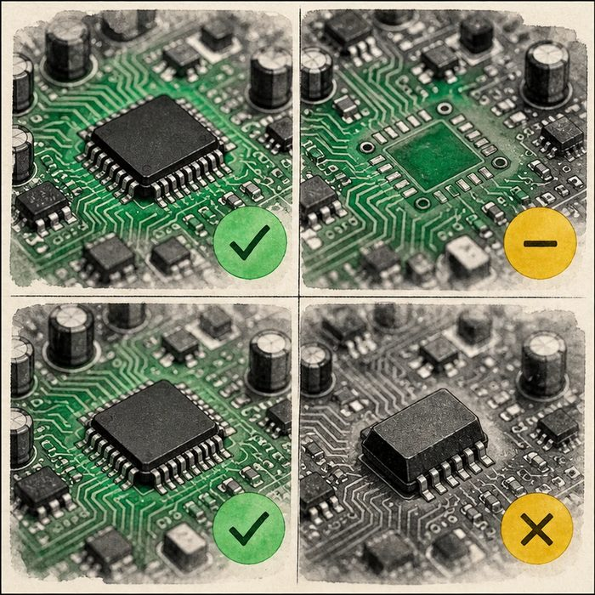
Illustration: Remove one circuit part, then restore that same part
1. What changes after the part is removed?
________________________________________________________________________________
2. Which replacement restores function?
________________________________________________________________________________
3. Why test a wrong or empty replacement?
________________________________________________________________________________

EXPERIMENTAL DESIGN LESSON 12 | RULES AND BIOLOGY MAPPING
2. Turn observations into rules

1. Rule 1: Show a phenotype after specific loss of function. Explain it in your own words.
________________________________________________________________________________
2. Rule 2: Restore the targeted function in the relevant place and time. Explain it in your own words.
________________________________________________________________________________
3. Rule 3: Compare rescue with mock and unrelated controls. Explain it in your own words.
________________________________________________________________________________
Where the analogy stops: Genes act in networks, so a rescue can be partial and may work through more than one pathway.

3. Map the rules onto the biomedical example
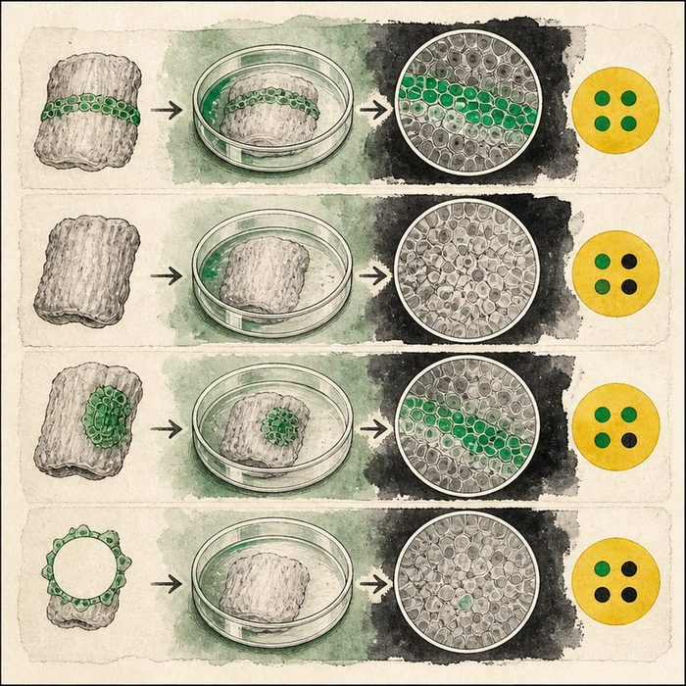
Biomedical teaching illustration: Test knockout and epithelial rescue of a palate phenotype
Analogy step | Biology step | How the relationship stays the same
Working circuit | Wild-type development | ________________________________
Missing component | Specific loss of gene function | ________________________________
Targeted replacement | Tissue and time-matched rescue | ________________________________

EXPERIMENTAL DESIGN LESSON 12 | CASE FILE AND DECISION
4. Use the case evidence

ID | Finding supplied in the case | Why it matters
EXP12-E1 | Wild-type cultures fuse in 18 of 20 samples, while knockout cultures fuse in 4 of 20. | Loss of function is associated with a large defect in this model.
EXP12-E2 | Targeted epithelial rescue restores fusion in 15 of 20 knockout samples. | Restoring function in the relevant tissue recovers much of the outcome.
EXP12-E3 | Empty-vector rescue produces fusion in 5 of 20 samples. | The delivery procedure alone does not explain the targeted rescue.

5. Make the clinical decision
You are the mechanism-review panelist. The team must decide whether knockout alone is enough for its strongest causal claim.
A. Use knockout plus targeted rescue and controls to strengthen the model-specific causal claim.
B. Claim the gene is sufficient for normal human palate development from knockout alone.
C. Ignore the empty-vector group because rescue improved.
Decision. Choose the claim and compare all four supplied groups.
________________________________________________________________________________
________________________________________________________________________________
Claim ceiling: You may claim that targeted restoration strengthens causation in this model. You may not claim strict sufficiency or a patient-specific cause.
Claim. State the choice you can defend.
________________________________________________________________________________
Evidence. Use these labeled IDs: EXP12-E1 + EXP12-E2.
________________________________________________________________________________
Reasoning. Explain why the evidence supports the claim and stays inside the claim ceiling.
________________________________________________________________________________
________________________________________________________________________________

EXPERIMENTAL DESIGN LESSON 12 | REDUCE, REFLECT, AND PREPARE
6. Reduce the lesson to one lasting idea

Take-home. Loss plus targeted rescue strengthens causation when the rescue is specific, verified, and compared with controls.
________________________________________________________________________________
________________________________________________________________________________
1. What does the empty-vector group control?
________________________________________________________________________________
2. Why is rescue not automatic proof of strict sufficiency?
________________________________________________________________________________

Glossary
Term | Plain-English definition
knockout | An organism or cell engineered to have a specific gene switched off, used to reveal what that gene normally does.
rescue experiment | Adding a working gene back into a mutant to see if it restores the normal trait, which proves that gene was responsible.
causation | When one factor actually brings about another, shown by controlled evidence rather than by the two simply appearing together.
redundancy control | Repeating measurements or samples in an experiment so a single fluke does not drive the conclusion.
necessity and sufficiency | Two tests of a cause: necessary means the result fails without it, and sufficient means the factor alone can produce the result.

Next lesson unlock
In a mouse we control everything, so we can prove cause by cutting a gene and putting it back. But we cannot assign a gene, or a surgery, to a baby like Mateo on purpose. When the subjects are children and the question is which treatment is better, how do we make a fair comparison without controlling their biology directly? We chase that next time.
The journal links on the lesson page are optional. Everything required for this guided-notes set is already supplied here and in the case file.

