EXPERIMENTAL DESIGN DOMAIN | LESSON 11 OF 20 | PRINCIPAL INVESTIGATOR (WITH THE LAB'S ANIMAL-WELFARE LIAISON)

When Is a Mouse a Good Stand-In for Mateo?
When does studying a mouse actually teach us something true about Mateo, and when does it fool us?
CARRY FORWARD  CRISPR is a controlled perturbation only when the edit, mosaicism, phenotype, and off-target controls are verified. | 10-YEAR TAKEAWAY  A model earns relevance by matching the mechanism and outcome needed for the question while following Replace, Reduce, and Refine.

Cells differentiate | Development sculpts | Cells move | Development can go wrong

1. Observe the analogy before naming the biology
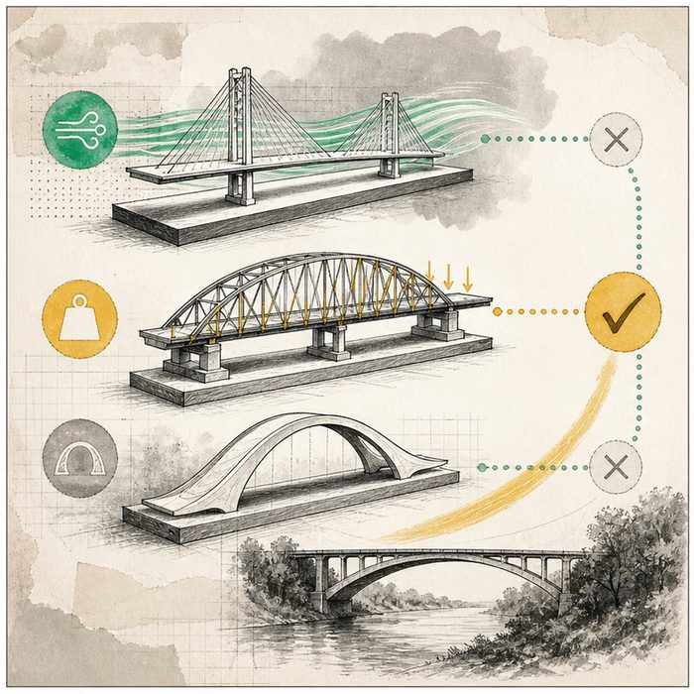
Illustration: A scale model is useful only for the feature being tested
1. Which model can test load?
________________________________________________________________________________
2. Which model only matches appearance?
________________________________________________________________________________
3. What question could be answered without a whole animal?
________________________________________________________________________________

EXPERIMENTAL DESIGN LESSON 11 | RULES AND BIOLOGY MAPPING
2. Turn observations into rules

1. Rule 1: Define the exact mechanism and outcome the model must reproduce. Explain it in your own words.
________________________________________________________________________________
2. Rule 2: Use the least sentient suitable system. Explain it in your own words.
________________________________________________________________________________
3. Rule 3: Replace, Reduce, and Refine animal use while preserving a valid answer. Explain it in your own words.
________________________________________________________________________________
Where the analogy stops: Living models can share pathways without copying every feature of human development or care.

3. Map the rules onto the biomedical example
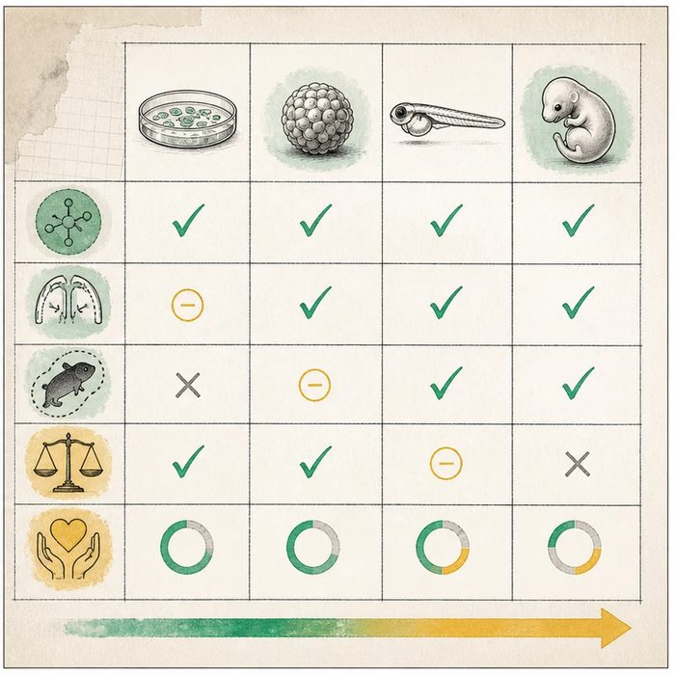
Biomedical teaching illustration: Select a model for palatal shelf elevation
Analogy step | Biology step | How the relationship stays the same
Feature under test | Construct and functional relevance | ________________________________
Visible similarity | Face validity | ________________________________
Least burdensome model | Replace, Reduce, Refine | ________________________________

EXPERIMENTAL DESIGN LESSON 11 | CASE FILE AND DECISION
4. Use the case evidence

ID | Finding supplied in the case | Why it matters
EXP11-E1 | The question asks whether a pathway changes mammalian palatal shelf elevation and fusion. | A model must represent the relevant tissue movement and timing.
EXP11-E2 | A cell culture can test signaling but cannot reproduce whole-palate elevation. | It can replace animals for some early questions, not the full outcome.
EXP11-E3 | A mouse study uses prior data for sample size, shared controls, analgesia, humane endpoints, and blinded scoring. | The design applies Reduce and Refine while protecting validity.

5. Make the clinical decision
You are the model-selection and animal-welfare reviewer. The team wants to use the largest animal available because it seems more human-like.
A. Choose the least burdensome model that can measure the required mechanism and outcome.
B. Choose by body size alone.
C. Reject all nonhuman and cell models as useless.
Decision. Choose the model sequence and justify it with mechanism fit plus the 3Rs.
________________________________________________________________________________
________________________________________________________________________________
Claim ceiling: You may judge fitness for the stated question. You may not call any model a complete stand-in for Mateo.
Claim. State the choice you can defend.
________________________________________________________________________________
Evidence. Use these labeled IDs: EXP11-E1 + EXP11-E2.
________________________________________________________________________________
Reasoning. Explain why the evidence supports the claim and stays inside the claim ceiling.
________________________________________________________________________________
________________________________________________________________________________

EXPERIMENTAL DESIGN LESSON 11 | REDUCE, REFLECT, AND PREPARE
6. Reduce the lesson to one lasting idea

Take-home. A model earns relevance by matching the mechanism and outcome needed for the question while following Replace, Reduce, and Refine.
________________________________________________________________________________
________________________________________________________________________________
1. What should determine model choice?
________________________________________________________________________________
2. What do the three Rs mean?
________________________________________________________________________________

Glossary
Term | Plain-English definition
animal model | A lab animal, such as a mouse, used to study a human disease because its biology is similar enough to test causes and treatments safely.
face validity | Whether a test or measure looks, on the surface, like it really assesses what it claims to assess.
construct validity | How well a test or measurement actually captures the abstract idea it claims to measure, rather than something else.
the 3Rs | An ethics framework for animal research, replace, reduce, and refine, that minimizes animal use and suffering while keeping good science.
ARRIVE guidelines | A standard checklist for reporting animal research clearly and completely, so other scientists can judge the study and repeat it.

Next lesson unlock
We decided a mouse can be a fair stand-in when its construct and face validity hold up. But knocking out a gene and seeing a cleft is not yet proof the gene caused it; something else changed by the same edit could be to blame. So next: how do we prove the gene itself, and nothing else, caused the cleft? We chase that next time.
The journal links on the lesson page are optional. Everything required for this guided-notes set is already supplied here and in the case file.

