EXPERIMENTAL DESIGN DOMAIN | LESSON 10 OF 20 | LAB SCIENTIST ON THE CLEFT RESEARCH TEAM

CRISPR as an Experimental Tool
How do we edit a specific gene to test exactly what it does?
CARRY FORWARD  Orthogonal assays answer different mechanism questions: where RNA or protein is and what changes after perturbation. | 10-YEAR TAKEAWAY  CRISPR is a controlled perturbation only when the edit, mosaicism, phenotype, and off-target controls are verified.

Cells differentiate | Development sculpts | Cells move | Development can go wrong

1. Observe the analogy before naming the biology
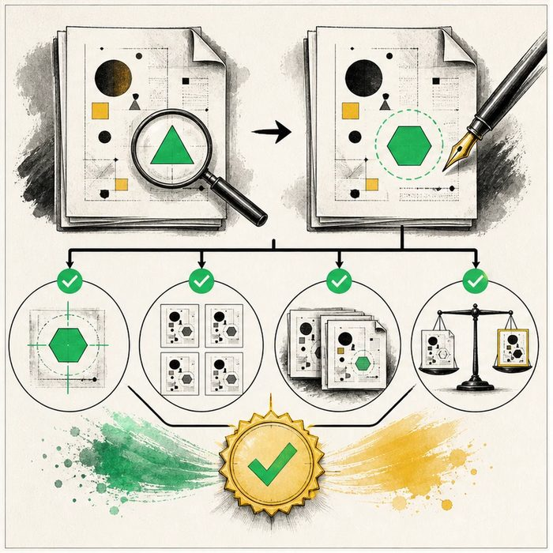
Illustration: A precision editor needs verification stations after every change
1. How is the intended change confirmed?
________________________________________________________________________________
2. Where could an unintended edit hide?
________________________________________________________________________________
3. What if only some copies were changed?
________________________________________________________________________________

EXPERIMENTAL DESIGN LESSON 10 | RULES AND BIOLOGY MAPPING
2. Turn observations into rules

1. Rule 1: Sequence the intended target after editing. Explain it in your own words.
________________________________________________________________________________
2. Rule 2: Assess mosaicism and plausible off-target sites. Explain it in your own words.
________________________________________________________________________________
3. Rule 3: Compare multiple guides, controls, and repeated phenotypes. Explain it in your own words.
________________________________________________________________________________
Where the analogy stops: Genomes are three-dimensional biological systems, not pages with fully predictable text edits.

3. Map the rules onto the biomedical example
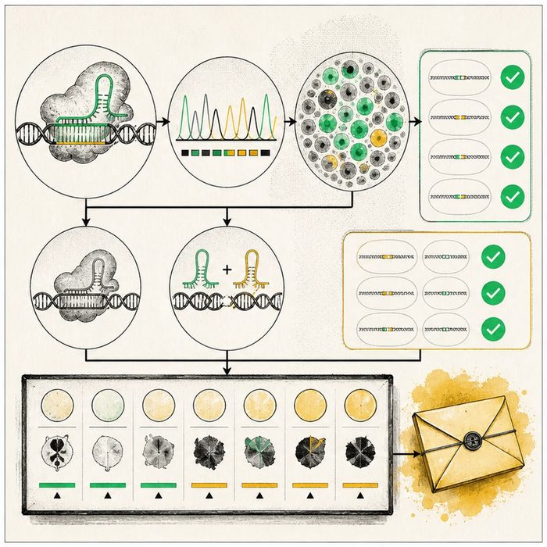
Biomedical teaching illustration: Verify a CRISPR perturbation before reading the palate phenotype
Analogy step | Biology step | How the relationship stays the same
Target word | Guide RNA target sequence | ________________________________
Mixed copies | Mosaic edited and unedited cells | ________________________________
Other pages | Off-target sites | ________________________________

EXPERIMENTAL DESIGN LESSON 10 | CASE FILE AND DECISION
4. Use the case evidence

ID | Finding supplied in the case | Why it matters
EXP10-E1 | Sequencing confirms a frameshift in 78 percent of reads from the target tissue. | The edit occurred, but the sample is mosaic.
EXP10-E2 | A second guide produces a similar phenotype while a non-targeting guide does not. | Independent perturbation and a negative control strengthen specificity.
EXP10-E3 | The top predicted off-target sites show no detectable edits in the supplied assay. | The tested concern is reduced, not eliminated everywhere in the genome.

5. Make the clinical decision
You are the genome-editing quality reviewer. One embryo has a palate defect after injection, but the target was not sequenced and no control guide was used.
A. Withhold the gene-function claim and require edit plus specificity checks.
B. Call the gene causal because CRISPR was injected.
C. Ignore mosaicism because some cells were edited.
Decision. Choose the claim status and cite the minimum verification steps needed next.
________________________________________________________________________________
________________________________________________________________________________
Claim ceiling: You may interpret the supplied edit and control checks. You may not claim all off-target effects are absent or a human treatment is ready.
Claim. State the choice you can defend.
________________________________________________________________________________
Evidence. Use these labeled IDs: EXP10-E1 + EXP10-E2.
________________________________________________________________________________
Reasoning. Explain why the evidence supports the claim and stays inside the claim ceiling.
________________________________________________________________________________
________________________________________________________________________________

EXPERIMENTAL DESIGN LESSON 10 | REDUCE, REFLECT, AND PREPARE
6. Reduce the lesson to one lasting idea

Take-home. CRISPR is a controlled perturbation only when the edit, mosaicism, phenotype, and off-target controls are verified.
________________________________________________________________________________
________________________________________________________________________________
1. What does mosaicism mean?
________________________________________________________________________________
2. Why use a second guide?
________________________________________________________________________________

Glossary
Term | Plain-English definition
CRISPR-Cas9 | A gene-editing tool that uses a guide RNA to steer the Cas9 protein to a chosen DNA site and cut it, so a sequence can be changed.
guide RNA | A lesson term defined by the surrounding model and case evidence.
off-target editing | An unwanted DNA change made by a gene-editing tool at the wrong spot in the genome, away from its intended target.
mosaicism | When a person's body contains two or more genetically different sets of cells that arose from a single fertilized egg.
editing efficiency | The percentage of treated cells in which a gene-editing tool such as CRISPR actually made the intended change to the DNA.
sequence verification | Reading a stretch of DNA again to confirm that a detected variant is real and not an error from the test.

Next lesson unlock
We can now edit a gene precisely in a mouse, but Mateo is not a mouse. When is a mouse actually a good stand-in for him, and when does the species gap make the answer untrustworthy?
The journal links on the lesson page are optional. Everything required for this guided-notes set is already supplied here and in the case file.

