EXPERIMENTAL DESIGN DOMAIN | LESSON 9 OF 20 | LAB SCIENTIST ON THE CLEFT RESEARCH TEAM

Taking a Gene to the Bench
How do we test a gene's actual job at the bench?
CARRY FORWARD  Many tests inflate false positives, so thresholds and independent replication must be planned before results are seen. | 10-YEAR TAKEAWAY  Orthogonal assays answer different mechanism questions: where RNA or protein is and what changes after perturbation.

Cells differentiate | Development sculpts | Cells move | Development can go wrong

1. Observe the analogy before naming the biology
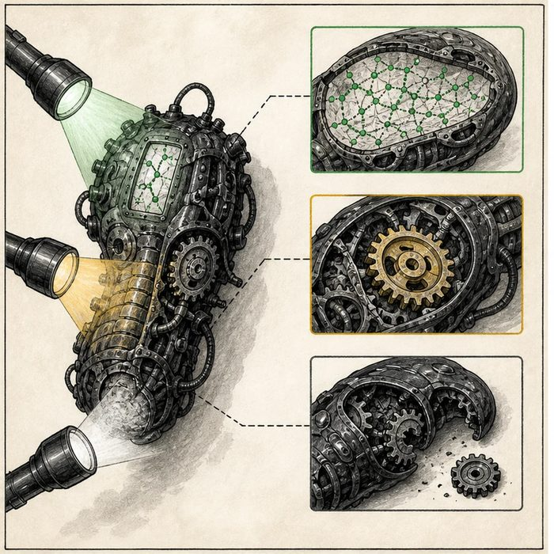
Illustration: Three flashlights reveal message, material, and system failure
1. Which light shows where the message is?
________________________________________________________________________________
2. Which shows where the working part is?
________________________________________________________________________________
3. Which reveals what changes when the part is missing?
________________________________________________________________________________

EXPERIMENTAL DESIGN LESSON 9 | RULES AND BIOLOGY MAPPING
2. Turn observations into rules

1. Rule 1: Match each assay to one question. Explain it in your own words.
________________________________________________________________________________
2. Rule 2: Include negative and positive controls. Explain it in your own words.
________________________________________________________________________________
3. Rule 3: Combine location evidence with perturbation evidence before claiming function. Explain it in your own words.
________________________________________________________________________________
Where the analogy stops: Assays produce measured signals with noise and controls, not perfectly revealing beams.

3. Map the rules onto the biomedical example
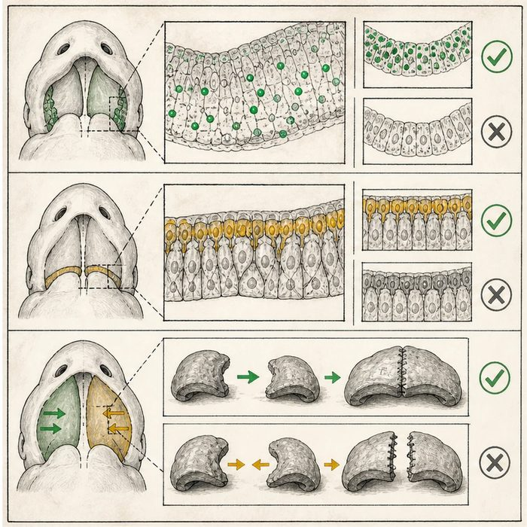
Biomedical teaching illustration: Test a candidate developmental gene with three assays
Analogy step | Biology step | How the relationship stays the same
Wiring-map light | RNA in situ hybridization | ________________________________
Working-part light | Protein immunohistochemistry | ________________________________
Removal test | Knockout or knockdown phenotype | ________________________________

EXPERIMENTAL DESIGN LESSON 9 | CASE FILE AND DECISION
4. Use the case evidence

ID | Finding supplied in the case | Why it matters
EXP09-E1 | RNA signal appears in developing palatal shelves at the relevant stage. | The gene is transcribed in a useful place and time.
EXP09-E2 | Protein staining appears in palatal epithelium and is absent in the no-primary-antibody control. | The protein location is supported by a specificity control.
EXP09-E3 | Perturbed embryos show altered shelf elevation more often than matched controls. | Changing the gene is associated with a phenotype, but other effects still need checks.

5. Make the clinical decision
You are planning the bench follow-up to a replicated locus. The team has funding for three assays and must decide whether one expression image alone proves function.
A. Combine RNA location, protein location, perturbation, and controls.
B. Use one bright stain as proof the gene causes cleft palate.
C. Skip controls because the candidate came from GWAS.
Decision. Choose the assay set and state the specific question each assay answers.
________________________________________________________________________________
________________________________________________________________________________
Claim ceiling: You may connect expression and perturbation evidence. You may not treat location alone as causal proof.
Claim. State the choice you can defend.
________________________________________________________________________________
Evidence. Use these labeled IDs: EXP09-E1 + EXP09-E2.
________________________________________________________________________________
Reasoning. Explain why the evidence supports the claim and stays inside the claim ceiling.
________________________________________________________________________________
________________________________________________________________________________

EXPERIMENTAL DESIGN LESSON 9 | REDUCE, REFLECT, AND PREPARE
6. Reduce the lesson to one lasting idea

Take-home. Orthogonal assays answer different mechanism questions: where RNA or protein is and what changes after perturbation.
________________________________________________________________________________
________________________________________________________________________________
1. What does in situ hybridization locate?
________________________________________________________________________________
2. Why is expression alone not proof of function?
________________________________________________________________________________

Glossary
Term | Plain-English definition
knockout | An organism or cell engineered to have a specific gene switched off, used to reveal what that gene normally does.
conditional knockout | A genetic tool that switches a gene off only in certain cells or at a chosen time, so researchers can study its role without affecting the whole animal.
in situ hybridization | A lab method that uses a labeled probe to show exactly where a specific gene's RNA or DNA sits inside a tissue or cell.
immunohistochemistry | A lab technique that uses antibodies tagged with stain to show exactly where a specific protein sits within a tissue slice.
penetrance | The fraction of people carrying a disease-linked genotype who actually show the trait.
control | The comparison condition that isolates the effect of the variable being tested by keeping everything else the same.

Next lesson unlock
A knockout removes a gene and a stain shows where it sits, but both are slow and blunt; building a conditional-knockout mouse takes many crosses and many months. Is there a faster, more precise way to edit a gene on purpose and read out exactly what it does?
The journal links on the lesson page are optional. Everything required for this guided-notes set is already supplied here and in the case file.

