EXPERIMENTAL DESIGN DOMAIN | LESSON 8 OF 20 | BIOSTATISTICIAN ON THE CLEFT RESEARCH TEAM

Why Gene Studies Use Such Tiny P-Values
Why do gene studies demand a far tinier p-value than 0.05?
CARRY FORWARD  Effect size and confidence interval show magnitude and precision; a p-value measures model compatibility, not truth. | 10-YEAR TAKEAWAY  Many tests inflate false positives, so thresholds and independent replication must be planned before results are seen.

Cells differentiate | Development sculpts | Cells move | Development can go wrong

1. Observe the analogy before naming the biology
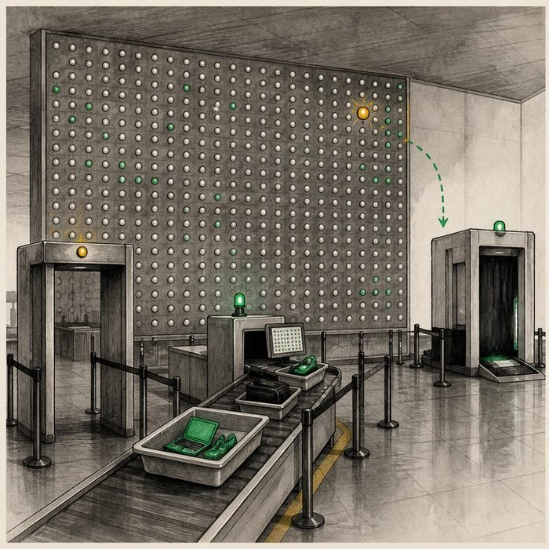
Illustration: Thousands of airport alarms require a stricter screen and a second check
1. What happens when thousands of sensors each can false-alarm?
________________________________________________________________________________
2. Why set the alert rule before scanning?
________________________________________________________________________________
3. What does the second scanner add?
________________________________________________________________________________

EXPERIMENTAL DESIGN LESSON 8 | RULES AND BIOLOGY MAPPING
2. Turn observations into rules

1. Rule 1: Count how many tests are being run. Explain it in your own words.
________________________________________________________________________________
2. Rule 2: Predefine a correction or threshold suited to the analysis. Explain it in your own words.
________________________________________________________________________________
3. Rule 3: Replicate the signal in independent data. Explain it in your own words.
________________________________________________________________________________
Where the analogy stops: Genome signals are not threats, and statistical correction does not determine biological importance.

3. Map the rules onto the biomedical example
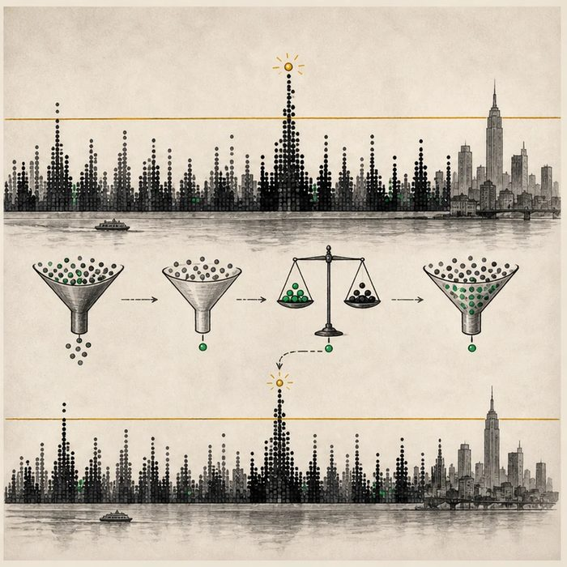
Biomedical teaching illustration: Control false positives in a common-variant GWAS
Analogy step | Biology step | How the relationship stays the same
Many sensors | Millions of variant tests | ________________________________
Strict alert rule | Multiple-testing threshold | ________________________________
Second scanner | Independent replication | ________________________________

EXPERIMENTAL DESIGN LESSON 8 | CASE FILE AND DECISION
4. Use the case evidence

ID | Finding supplied in the case | Why it matters
EXP08-E1 | Testing one million variants at p below 0.05 would produce many chance hits under the null. | A usual single-test threshold is not adequate for a genome-wide scan.
EXP08-E2 | For many common-variant GWAS analyses, p below 5 x 10^-8 is a conventional threshold. | The convention is not universal for every genetic analysis.
EXP08-E3 | The candidate peak repeats in an independent cohort with the same direction of effect. | Replication lowers concern that the first signal was sample-specific chance or error.

5. Make the clinical decision
You are the GWAS quality-control lead. A peak has p equal to 2 x 10^-6 in the discovery sample and no replication result.
A. Label it suggestive and require the planned threshold, quality checks, and replication.
B. Declare it significant because it is below 0.05.
C. Use 5 x 10^-8 as a magic rule for every genetic test.
Decision. Choose the report language and explain how multiplicity and replication change the claim.
________________________________________________________________________________
________________________________________________________________________________
Claim ceiling: You may apply the supplied common-variant GWAS convention. You may not treat that number as universal or proof of mechanism.
Claim. State the choice you can defend.
________________________________________________________________________________
Evidence. Use these labeled IDs: EXP08-E1 + EXP08-E2.
________________________________________________________________________________
Reasoning. Explain why the evidence supports the claim and stays inside the claim ceiling.
________________________________________________________________________________
________________________________________________________________________________

EXPERIMENTAL DESIGN LESSON 8 | REDUCE, REFLECT, AND PREPARE
6. Reduce the lesson to one lasting idea

Take-home. Many tests inflate false positives, so thresholds and independent replication must be planned before results are seen.
________________________________________________________________________________
________________________________________________________________________________
1. Why is p below 0.05 too loose for one million tests?
________________________________________________________________________________
2. What does replication add beyond a smaller p-value?
________________________________________________________________________________

Glossary
Term | Plain-English definition
multiple testing | Running many statistical tests at once, which raises the chance of a false positive and requires a stricter cutoff to stay reliable.
false positive | A test result that signals a condition is present when it actually is not, a kind of error that can lead to needless worry or treatment.
Bonferroni correction | A math adjustment that makes the cutoff for significance stricter when you run many tests, so chance results are not mistaken for real ones.
genome-wide significance | A very strict p-value cutoff (about 5 in 100 million) used in genome-wide studies so that testing millions of spots does not produce false hits.
false discovery rate | The expected share of results called significant that are actually false alarms, a key check when many tests are run at once.
replication | Repeating a study to see if the result holds; a key test of whether a finding is real.

Next lesson unlock
Gene studies use a tiny p-value because a million tests breed a million chances to be fooled, and replication seals the deal. But even a rock-solid statistical link never proves IRF6 does anything to tissue. How would we leave the spreadsheet, go to the bench, and test what IRF6 actually does to a developing palate?
The journal links on the lesson page are optional. Everything required for this guided-notes set is already supplied here and in the case file.

