EXPERIMENTAL DESIGN DOMAIN | LESSON 7 OF 20 | BIOSTATISTICIAN ON THE CLEFT RESEARCH TEAM

Is the Association Real, or Just Chance?
How do we know an association is real and not just chance?
CARRY FORWARD  Gene discovery combines broad scans, family structure, quality control, and independent replication. | 10-YEAR TAKEAWAY  Effect size and confidence interval show magnitude and precision; a p-value measures model compatibility, not truth.

Cells differentiate | Development sculpts | Cells move | Development can go wrong

1. Observe the analogy before naming the biology
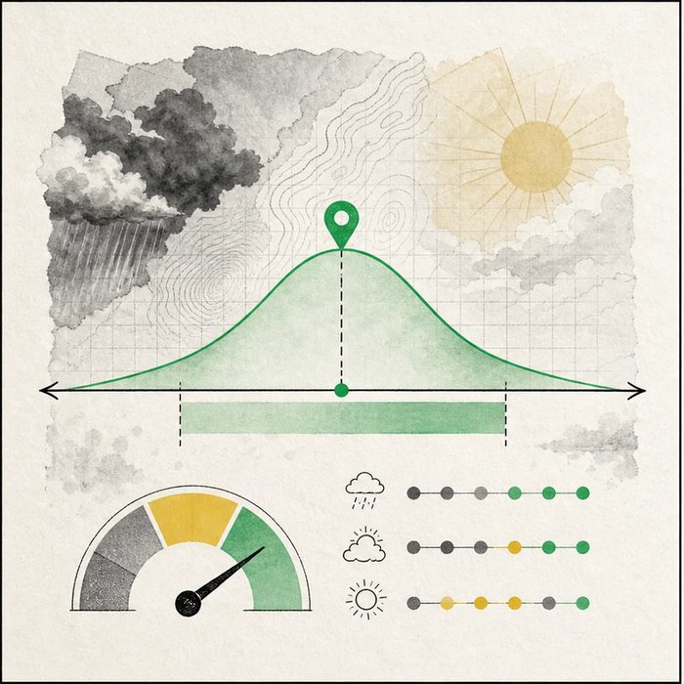
Illustration: A forecast needs an estimate and range, not a yes-or-no stamp
1. Which mark gives the best estimate?
________________________________________________________________________________
2. What does the width of the band show?
________________________________________________________________________________
3. Why can a tiny gauge reading not prove the forecast is true?
________________________________________________________________________________

EXPERIMENTAL DESIGN LESSON 7 | RULES AND BIOLOGY MAPPING
2. Turn observations into rules

1. Rule 1: Read the effect size first. Explain it in your own words.
________________________________________________________________________________
2. Rule 2: Use the interval to judge precision and compatible values. Explain it in your own words.
________________________________________________________________________________
3. Rule 3: Interpret the p-value with design, bias, and prior evidence. Explain it in your own words.
________________________________________________________________________________
Where the analogy stops: Statistical uncertainty is not weather uncertainty, and its meaning depends on model assumptions.

3. Map the rules onto the biomedical example
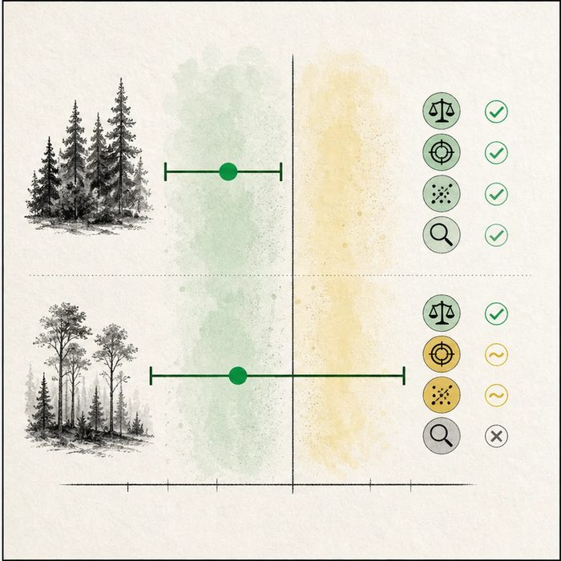
Biomedical teaching illustration: Interpret two treatment estimates without a significance shortcut
Analogy step | Biology step | How the relationship stays the same
Forecast estimate | Effect size | ________________________________
Forecast range | Confidence interval | ________________________________
Model gauge | P-value under a null model | ________________________________

EXPERIMENTAL DESIGN LESSON 7 | CASE FILE AND DECISION
4. Use the case evidence

ID | Finding supplied in the case | Why it matters
EXP07-E1 | Study A reports a risk ratio of 0.60 with a 95 percent interval from 0.37 to 0.98. | The estimate suggests lower risk, with values near no difference still close to the interval edge.
EXP07-E2 | Study B reports a risk ratio of 0.55 with an interval from 0.18 to 1.67. | The result is much less precise and includes possible benefit, no difference, or harm.
EXP07-E3 | A p-value is calculated under a statistical model and null hypothesis. | It is not the probability that the scientific claim is true or false.

5. Make the clinical decision
You are the data reviewer preparing a one-slide result summary. A teammate wants to label Study A true and Study B false based only on whether p is below 0.05.
A. Compare effect sizes, intervals, designs, and bias before stating the claim.
B. Use p below 0.05 as proof and ignore magnitude.
C. Use the larger-looking effect as proof even when its interval is wide.
Decision. Choose the interpretation and explain why the two intervals support different precision claims.
________________________________________________________________________________
________________________________________________________________________________
Claim ceiling: You may describe magnitude, precision, and statistical compatibility. You may not convert a threshold into scientific truth.
Claim. State the choice you can defend.
________________________________________________________________________________
Evidence. Use these labeled IDs: EXP07-E1 + EXP07-E2.
________________________________________________________________________________
Reasoning. Explain why the evidence supports the claim and stays inside the claim ceiling.
________________________________________________________________________________
________________________________________________________________________________

EXPERIMENTAL DESIGN LESSON 7 | REDUCE, REFLECT, AND PREPARE
6. Reduce the lesson to one lasting idea

Take-home. Effect size and confidence interval show magnitude and precision; a p-value measures model compatibility, not truth.
________________________________________________________________________________
________________________________________________________________________________
1. Which result is more precise, and why?
________________________________________________________________________________
2. What does a p-value not tell you?
________________________________________________________________________________

Glossary
Term | Plain-English definition
association | A statistical link where two things tend to occur together, which suggests a relationship but does not by itself prove one causes the other.
odds ratio | A number comparing the odds of having a factor in affected versus unaffected people; above 1 suggests the factor is associated.
p-value | A number showing how likely a result could happen just by chance; a smaller p-value makes luck a less believable explanation.
confidence interval | A range of values that likely contains the true result, showing how precise an estimate is; a narrow range means more certainty.
statistical significance | A result unlikely to be due to chance, often shown by a p-value below a set threshold such as 0.05.
null result | A finding that shows no meaningful effect or difference, which is still valuable evidence and worth reporting.

Next lesson unlock
One p-value below 0.05 feels convincing, but a GWAS runs about a million tests at once. If 0.05 lets through a 1-in-20 fluke, how many flukes slip through a million tests, and why do gene studies demand a far tinier p-value?
The journal links on the lesson page are optional. Everything required for this guided-notes set is already supplied here and in the case file.

