EXPERIMENTAL DESIGN DOMAIN | LESSON 6 OF 20 | DATA SCIENTIST ON THE CLEFT RESEARCH TEAM

Finding a Risk Gene Among Millions of Bases
How do scientists find a single risk gene hidden among millions of DNA bases?
CARRY FORWARD  Cohorts establish time order, while twin comparisons estimate population patterns under assumptions rather than one person's cause. | 10-YEAR TAKEAWAY  Gene discovery combines broad scans, family structure, quality control, and independent replication.

Cells differentiate | Development sculpts | Cells move | Development can go wrong

1. Observe the analogy before naming the biology
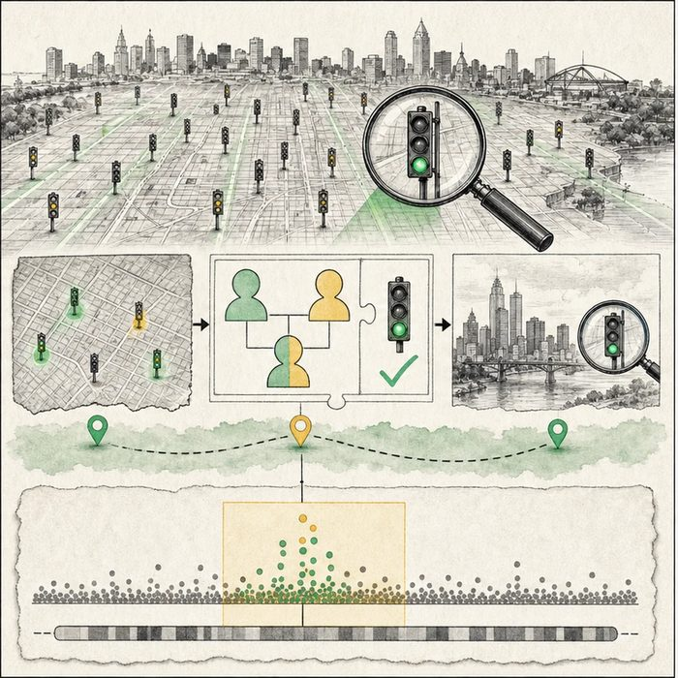
Illustration: A citywide signal scan needs family checkpoints and a second city
1. Where does the broad scan find candidate signals?
________________________________________________________________________________
2. How does the family gate check transmission?
________________________________________________________________________________
3. Why must another city repeat the result?
________________________________________________________________________________

EXPERIMENTAL DESIGN LESSON 6 | RULES AND BIOLOGY MAPPING
2. Turn observations into rules

1. Rule 1: Scan broadly without choosing only favorite genes. Explain it in your own words.
________________________________________________________________________________
2. Rule 2: Use family or population structure to test the signal. Explain it in your own words.
________________________________________________________________________________
3. Rule 3: Require quality control and independent replication. Explain it in your own words.
________________________________________________________________________________
Where the analogy stops: DNA variants are not streetlights, and nearby signals can mark a region without naming the causal gene.

3. Map the rules onto the biomedical example
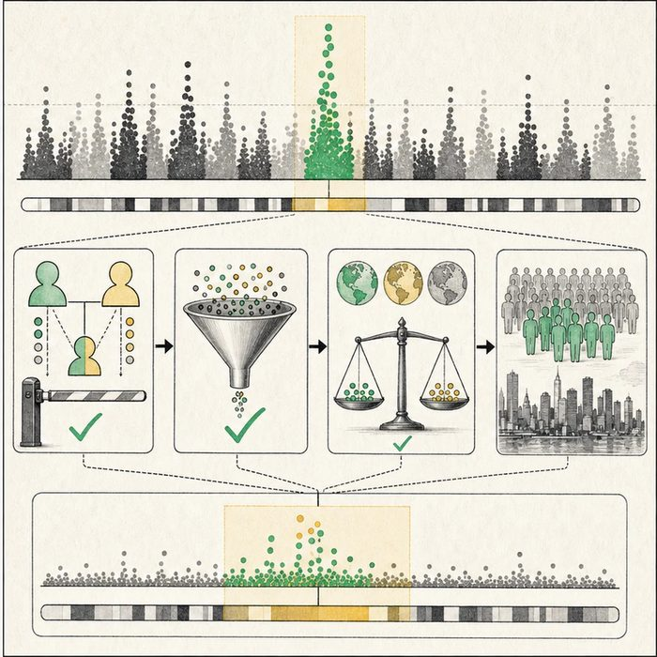
Biomedical teaching illustration: Move from a GWAS signal to a replicated cleft-risk locus
Analogy step | Biology step | How the relationship stays the same
Citywide scan | Genome-wide association study | ________________________________
Family checkpoint | Trio transmission test | ________________________________
Second city | Independent replication sample | ________________________________

EXPERIMENTAL DESIGN LESSON 6 | CASE FILE AND DECISION
4. Use the case evidence

ID | Finding supplied in the case | Why it matters
EXP06-E1 | A GWAS compares millions of common variants across many people. | It can reveal risk-associated regions without selecting one candidate in advance.
EXP06-E2 | A case-parent trio can test whether one allele is transmitted to affected children more often than expected. | Family structure can reduce some population-stratification problems.
EXP06-E3 | Genotyping quality, ancestry structure, sample size, and independent replication affect credibility. | A single peak is not yet a proven causal gene.

5. Make the clinical decision
You are the statistical geneticist reviewing a new genome-wide peak. One sample shows a strong signal near a developmental gene, but no second cohort has tested it.
A. Call it a candidate locus and require quality checks plus independent replication.
B. Name the nearest gene as Mateo's proven cause.
C. Ignore the signal because GWAS can never find useful loci.
Decision. Choose the next step and distinguish a locus, an associated variant, and a causal mechanism.
________________________________________________________________________________
________________________________________________________________________________
Claim ceiling: You may nominate a replicated risk locus. You may not name a causal gene or patient diagnosis from proximity alone.
Claim. State the choice you can defend.
________________________________________________________________________________
Evidence. Use these labeled IDs: EXP06-E1 + EXP06-E2.
________________________________________________________________________________
Reasoning. Explain why the evidence supports the claim and stays inside the claim ceiling.
________________________________________________________________________________
________________________________________________________________________________

EXPERIMENTAL DESIGN LESSON 6 | REDUCE, REFLECT, AND PREPARE
6. Reduce the lesson to one lasting idea

Take-home. Gene discovery combines broad scans, family structure, quality control, and independent replication.
________________________________________________________________________________
________________________________________________________________________________
1. What does a GWAS peak identify first?
________________________________________________________________________________
2. Why is replication independent?
________________________________________________________________________________

Glossary
Term | Plain-English definition
SNP | A single-nucleotide polymorphism, a one-letter difference in DNA at a specific spot that varies between people.
GWAS | A genome-wide association study, which scans DNA from many people to find genetic variants linked to a trait or disease.
transmission disequilibrium test | A family-based test that checks whether a gene variant is passed from heterozygous parents to affected children more often than chance.
case-parent trio | A study design that compares the DNA of an affected child with that of both parents to find gene variants passed down more often than expected.
over-transmission | When a particular gene version is passed from parents to affected children more often than the fifty-fifty rate expected by chance.
population stratification | A bias in genetic studies that appears when groups differ in both ancestry and trait rates, falsely linking variants to the trait.

Next lesson unlock
A scan and a trio test both flagged rs642961 near IRF6. But a flag is not proof. With millions of SNPs and hundreds of trios, some hits happen by pure luck. How do we tell a real association from a lucky roll of the dice?
The journal links on the lesson page are optional. Everything required for this guided-notes set is already supplied here and in the case file.

