EXPERIMENTAL DESIGN DOMAIN | LESSON 5 OF 20 | EPIDEMIOLOGIST ON THE CLEFT RESEARCH TEAM

Measuring Inheritance Over Time and in Twins
How can a study measure risk forward in time, and how can comparing twins separate inherited risk from environmental risk?
CARRY FORWARD  Case-control studies efficiently study rare outcomes, but their odds ratios remain vulnerable to selection, recall, and confounding. | 10-YEAR TAKEAWAY  Cohorts establish time order, while twin comparisons estimate population patterns under assumptions rather than one person's cause.

Cells differentiate | Development sculpts | Cells move | Development can go wrong

1. Observe the analogy before naming the biology
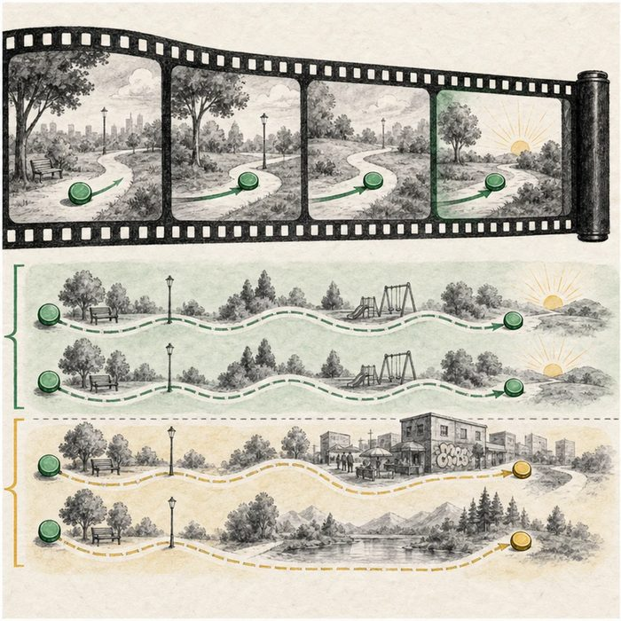
Illustration: A movie follows events forward while a matched split screen compares two paths
1. Which panel shows the exposure before the outcome?
________________________________________________________________________________
2. What is more similar within one pair?
________________________________________________________________________________
3. Which shared condition could make a pair look genetically alike?
________________________________________________________________________________

EXPERIMENTAL DESIGN LESSON 5 | RULES AND BIOLOGY MAPPING
2. Turn observations into rules

1. Rule 1: Define the starting population before outcomes occur. Explain it in your own words.
________________________________________________________________________________
2. Rule 2: Measure exposure and follow-up consistently. Explain it in your own words.
________________________________________________________________________________
3. Rule 3: State the assumptions behind twin comparisons. Explain it in your own words.
________________________________________________________________________________
Where the analogy stops: People do not follow scripted film paths, and twins can share environments in unequal ways.

3. Map the rules onto the biomedical example
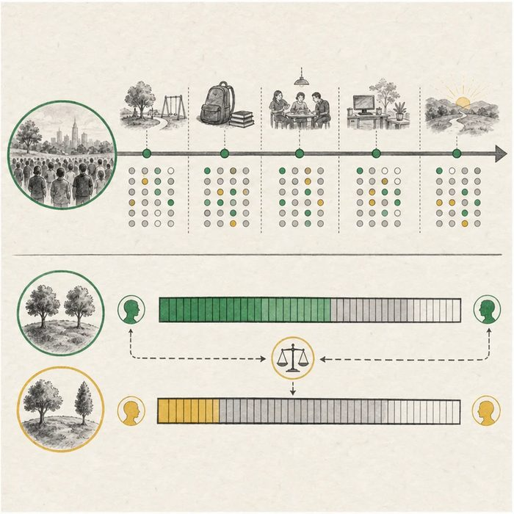
Biomedical teaching illustration: Compare a prospective cohort with a twin concordance study
Analogy step | Biology step | How the relationship stays the same
Forward film | Prospective cohort | ________________________________
Matched split screen | Twin comparison | ________________________________
Shared set | Shared genes and environment | ________________________________

EXPERIMENTAL DESIGN LESSON 5 | CASE FILE AND DECISION
4. Use the case evidence

ID | Finding supplied in the case | Why it matters
EXP05-E1 | A cohort records an exposure before birth outcomes are known. | This supports time order and reduces some recall problems.
EXP05-E2 | Monozygotic twins share more DNA than dizygotic twins on average. | Higher concordance can support a genetic contribution at the population level.
EXP05-E3 | Twin estimates rely on assumptions, and heritability changes across populations and settings. | The estimate does not assign a percentage cause to Mateo.

5. Make the clinical decision
You are selecting a design for a grant proposal on cleft risk. The proposal claims a twin study can cleanly separate genes from environment for one infant.
A. Use cohort and twin evidence with explicit assumptions and population-level wording.
B. Treat twin concordance as a personal genetic diagnosis.
C. Ignore shared environment because identical twins share DNA.
Decision. Choose the defensible claim and name one strength plus one assumption for each design.
________________________________________________________________________________
________________________________________________________________________________
Claim ceiling: You may discuss time order and population variance. You may not assign Mateo's cleft a heritability percentage or single cause.
Claim. State the choice you can defend.
________________________________________________________________________________
Evidence. Use these labeled IDs: EXP05-E1 + EXP05-E2.
________________________________________________________________________________
Reasoning. Explain why the evidence supports the claim and stays inside the claim ceiling.
________________________________________________________________________________
________________________________________________________________________________

EXPERIMENTAL DESIGN LESSON 5 | REDUCE, REFLECT, AND PREPARE
6. Reduce the lesson to one lasting idea

Take-home. Cohorts establish time order, while twin comparisons estimate population patterns under assumptions rather than one person's cause.
________________________________________________________________________________
________________________________________________________________________________
1. What time-order strength does a cohort add?
________________________________________________________________________________
2. Why is heritability not a personal cause score?
________________________________________________________________________________

Glossary
Term | Plain-English definition
cohort study | A study that follows a group of people over time, comparing those with and without an exposure to see who develops an outcome.
prospective | Describing a study that follows participants forward in time from the start, recording events as they happen rather than looking back.
relative risk | A number comparing how likely an outcome is in an exposed group versus an unexposed group, where one means no difference.
twin study | Research that compares identical and fraternal twins to estimate how much of a trait is due to genes versus environment.
concordance | How often both members of a pair, such as twins, share the same trait or condition.
zygosity | Whether twins came from one fertilized egg that split (identical) or from two separate fertilized eggs (fraternal).
heritability | A measure of how much of the variation in a trait across a population is due to genetic differences rather than environment.

Next lesson unlock
The twin study tells us genes carry most of the risk, but heritability is just a number; it does not name a single gene. Out of roughly twenty thousand genes, how do scientists track down the specific risk gene hiding among millions of bases?
The journal links on the lesson page are optional. Everything required for this guided-notes set is already supplied here and in the case file.

