EXPERIMENTAL DESIGN DOMAIN | LESSON 4 OF 20 | EPIDEMIOLOGIST ON THE CLEFT RESEARCH TEAM

Studying a Cause You Cannot Assign
If we cannot assign a suspected harmful exposure, how can we still gather evidence about whether it raises the chance of a cleft?
CARRY FORWARD  The strongest design is the one that fits the question and controls its main threats. | 10-YEAR TAKEAWAY  Case-control studies efficiently study rare outcomes, but their odds ratios remain vulnerable to selection, recall, and confounding.

Cells differentiate | Development sculpts | Cells move | Development can go wrong

1. Observe the analogy before naming the biology
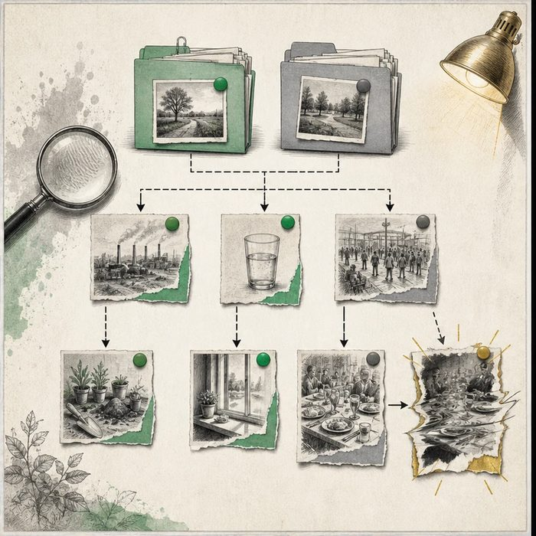
Illustration: A detective starts with a rare event and looks backward for clues
1. Which group is selected because the event happened?
________________________________________________________________________________
2. Where does the search move in time?
________________________________________________________________________________
3. Which clue could be remembered differently by the two groups?
________________________________________________________________________________

EXPERIMENTAL DESIGN LESSON 4 | RULES AND BIOLOGY MAPPING
2. Turn observations into rules

1. Rule 1: Select cases by outcome and comparable controls without it. Explain it in your own words.
________________________________________________________________________________
2. Rule 2: Measure prior exposure the same way. Explain it in your own words.
________________________________________________________________________________
3. Rule 3: Read an odds ratio with its interval and bias risks. Explain it in your own words.
________________________________________________________________________________
Where the analogy stops: Unlike a detective story, an association may have several explanations and may never identify one culprit.

3. Map the rules onto the biomedical example
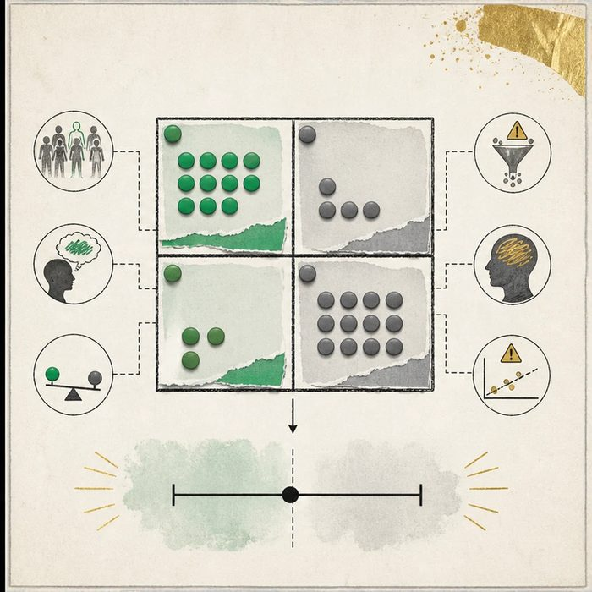
Biomedical teaching illustration: Test a suspected exposure with a supplied 2 by 2 table
Analogy step | Biology step | How the relationship stays the same
Rare event file | Cleft case group | ________________________________
Comparison file | Control group from the same population | ________________________________
Backward clue search | Prior exposure history | ________________________________

EXPERIMENTAL DESIGN LESSON 4 | CASE FILE AND DECISION
4. Use the case evidence

ID | Finding supplied in the case | Why it matters
EXP04-E1 | The table has 30 exposed and 70 unexposed cases, plus 15 exposed and 85 unexposed controls. | The odds ratio is about 2.4.
EXP04-E2 | The reported 95 percent confidence interval is 0.9 to 3.4. | The interval includes 1.0, so the data remain compatible with no odds difference.
EXP04-E3 | Parents of affected infants may recall an exposure differently while searching for an explanation. | Recall bias could inflate or reduce the observed association.

5. Make the clinical decision
You are the epidemiologist reviewing a suspected prenatal exposure. The team must decide whether the supplied result proves that the exposure caused clefts.
A. Report an uncertain association and plan better exposure measurement plus confounder control.
B. Declare the exposure proven causal because the odds ratio is above 1.
C. Declare no possible effect because the interval crosses 1.
Decision. Choose the interpretation and cite the odds ratio, interval, and one bias risk.
________________________________________________________________________________
________________________________________________________________________________
Claim ceiling: You may report the observed association and uncertainty. You may not claim individual blame or causation.
Claim. State the choice you can defend.
________________________________________________________________________________
Evidence. Use these labeled IDs: EXP04-E1 + EXP04-E2.
________________________________________________________________________________
Reasoning. Explain why the evidence supports the claim and stays inside the claim ceiling.
________________________________________________________________________________
________________________________________________________________________________

EXPERIMENTAL DESIGN LESSON 4 | REDUCE, REFLECT, AND PREPARE
6. Reduce the lesson to one lasting idea

Take-home. Case-control studies efficiently study rare outcomes, but their odds ratios remain vulnerable to selection, recall, and confounding.
________________________________________________________________________________
________________________________________________________________________________
1. Why is this design efficient for a rare outcome?
________________________________________________________________________________
2. What does an interval that includes 1.0 mean here?
________________________________________________________________________________

Glossary
Term | Plain-English definition
case-control study | A study that starts with people who have a condition (cases) and people who do not (controls), then looks back to compare past exposures.
exposure | Contact with a substance, agent, or condition that could affect health, such as a chemical, pathogen, or environmental factor.
odds ratio | A number comparing the odds of having a factor in affected versus unaffected people; above 1 suggests the factor is associated.
95 percent confidence interval | A range of values, built from sample data, that would capture the true value about 95 times out of 100 if the study were repeated.
recall bias | A study error where people with a condition remember past exposures differently than people without it, distorting the results.
matching | Pairing study participants with similar traits like age or sex across groups so those traits cannot bias the comparison.
teratogen | An agent such as a drug, chemical, or infection that can disrupt development and cause birth differences if exposure happens during pregnancy.

Next lesson unlock
The case-control design lets us chase causes from the outside world without assigning harm. But Mateo's sparse family history keeps nagging us. How would we measure how much of cleft risk is inherited rather than environmental, when you cannot give a memory questionnaire about DNA?
The journal links on the lesson page are optional. Everything required for this guided-notes set is already supplied here and in the case file.

