EXPERIMENTAL DESIGN DOMAIN | LESSON 3 OF 20 | PRINCIPAL INVESTIGATOR (PI)

Why We Trust Some Studies More Than Others
When two studies disagree, what about a study's design tells us which result to trust more?
CARRY FORWARD  A falsifiable hypothesis links a defined change to a defined outcome and states what would count against it. | 10-YEAR TAKEAWAY  The strongest design is the one that fits the question and controls its main threats.

Cells differentiate | Development sculpts | Cells move | Development can go wrong

1. Observe the analogy before naming the biology
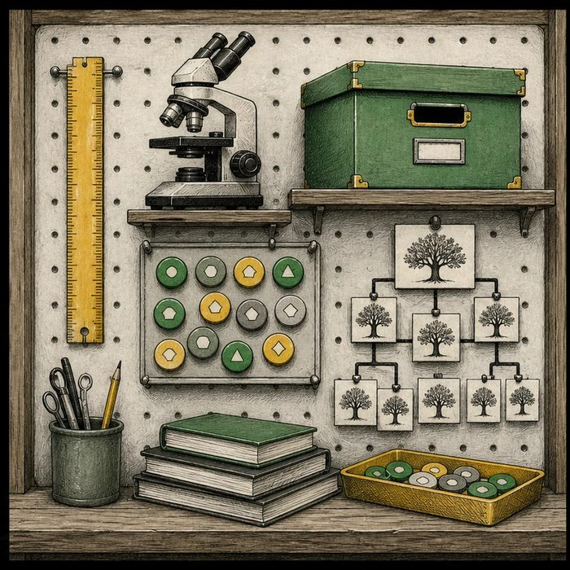
Illustration: A tool wall has no single best tool for every job
1. Which tool measures length?
________________________________________________________________________________
2. Which tool reveals a hidden structure?
________________________________________________________________________________
3. Why would ranking every tool from weak to strong be misleading?
________________________________________________________________________________

EXPERIMENTAL DESIGN LESSON 3 | RULES AND BIOLOGY MAPPING
2. Turn observations into rules

1. Rule 1: Name the question type first. Explain it in your own words.
________________________________________________________________________________
2. Rule 2: Choose the design that can answer it ethically. Explain it in your own words.
________________________________________________________________________________
3. Rule 3: Identify the main bias or alternative explanation the design must control. Explain it in your own words.
________________________________________________________________________________
Where the analogy stops: Study designs involve people, biology, time, and uncertainty, not just tools with one fixed use.

3. Map the rules onto the biomedical example
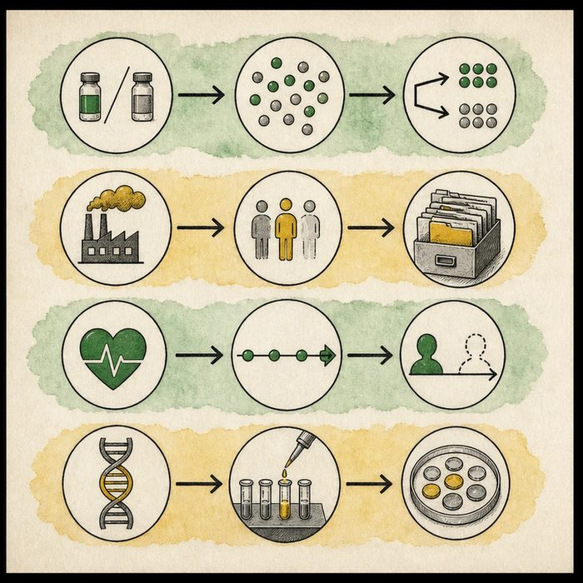
Biomedical teaching illustration: Match four cleft questions to four study designs
Analogy step | Biology step | How the relationship stays the same
Ruler | Measurement or prognosis design | ________________________________
Randomized lane | Assignable treatment comparison | ________________________________
Microscope | Mechanism experiment | ________________________________

EXPERIMENTAL DESIGN LESSON 3 | CASE FILE AND DECISION
4. Use the case evidence

ID | Finding supplied in the case | Why it matters
EXP03-E1 | Repair timing is an assignable clinical choice when both options are acceptable. | A randomized trial can compare the treatment options under equipoise.
EXP03-E2 | A suspected harmful pregnancy exposure cannot be assigned. | An observational design is required for that cause question.
EXP03-E3 | A gene mechanism requires perturbation and molecular or tissue outcomes. | A bench experiment answers a different question than a treatment trial.

5. Make the clinical decision
You are chairing the design-selection meeting. A teammate declares that an RCT is always the best design for every cleft question.
A. Match each design to the treatment, harm, prognosis, or mechanism question.
B. Use an RCT even when it assigns suspected harm.
C. Use a case report for every question because it is fastest.
Decision. Choose the design rule and match the three supplied questions to appropriate designs.
________________________________________________________________________________
________________________________________________________________________________
Claim ceiling: You may select a design family. You may not call any design free of bias or automatically decisive.
Claim. State the choice you can defend.
________________________________________________________________________________
Evidence. Use these labeled IDs: EXP03-E1 + EXP03-E2.
________________________________________________________________________________
Reasoning. Explain why the evidence supports the claim and stays inside the claim ceiling.
________________________________________________________________________________
________________________________________________________________________________

EXPERIMENTAL DESIGN LESSON 3 | REDUCE, REFLECT, AND PREPARE
6. Reduce the lesson to one lasting idea

Take-home. The strongest design is the one that fits the question and controls its main threats.
________________________________________________________________________________
________________________________________________________________________________
1. Why can a suspected harmful exposure not be randomized?
________________________________________________________________________________
2. Which design family can test a gene mechanism directly?
________________________________________________________________________________

Glossary
Term | Plain-English definition
evidence hierarchy | A ranking of research designs by how trustworthy their evidence is, placing systematic reviews and trials above observational studies and expert opinion.
levels of evidence | A ranking of how trustworthy a study's findings are, with reviews of many strong trials at the top and single expert opinions near the bottom.
randomized controlled trial | A study that randomly assigns participants to a treatment or a control group, the strongest design for showing a treatment truly works.
observational study | A study that watches and records what happens to groups without assigning any treatment, so it can show links but not prove cause.
case report | A detailed written account of one patient's diagnosis, treatment, and outcome, useful for sharing rare or unusual findings.
bias | A systematic error in how data is collected or interpreted that tilts results in one direction, making conclusions less accurate or unfair.
confounding | When a hidden third factor influences both the suspected cause and the outcome, making a link look real when it may be misleading.

Next lesson unlock
A randomized trial sits near the top because we can assign who gets the treatment. But we could never assign a baby to a harmful chemical in the womb. So how does science study a cause it is forbidden to hand out?
The journal links on the lesson page are optional. Everything required for this guided-notes set is already supplied here and in the case file.

