EXPERIMENTAL DESIGN DOMAIN | LESSON 2 OF 20 | PRINCIPAL INVESTIGATOR (PI)

From a Question to a Testable Hypothesis
How do we turn our PICO question into a hypothesis that an experiment could actually disprove, and what parts of the study must we control?
CARRY FORWARD  A researchable question names a population, a factor or intervention, a comparison, and a measurable outcome. | 10-YEAR TAKEAWAY  A falsifiable hypothesis links a defined change to a defined outcome and states what would count against it.

Cells differentiate | Development sculpts | Cells move | Development can go wrong

1. Observe the analogy before naming the biology
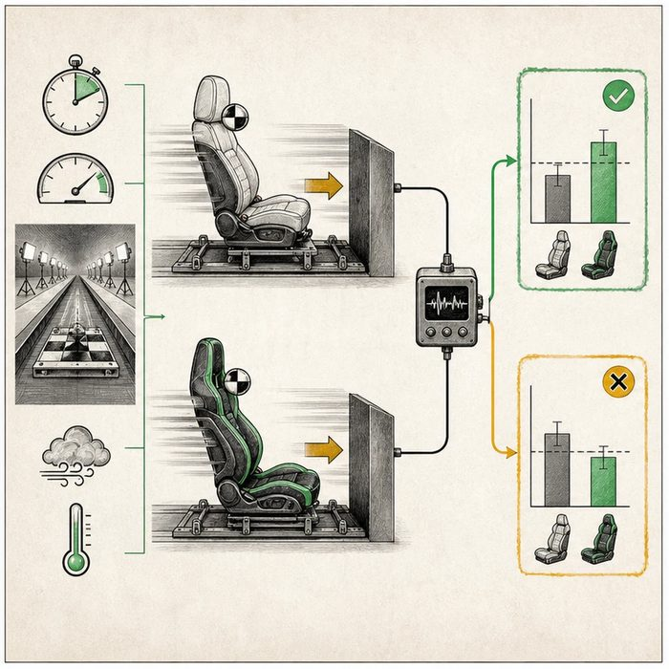
Illustration: A crash-test prediction names the change, the sensor, and the failure result
1. What is deliberately changed?
________________________________________________________________________________
2. Which sensor records the result?
________________________________________________________________________________
3. Which result would make the prediction fail?
________________________________________________________________________________

EXPERIMENTAL DESIGN LESSON 2 | RULES AND BIOLOGY MAPPING
2. Turn observations into rules

1. Rule 1: Change one defined independent variable. Explain it in your own words.
________________________________________________________________________________
2. Rule 2: Measure one defined dependent outcome. Explain it in your own words.
________________________________________________________________________________
3. Rule 3: Write a result that could count against the prediction. Explain it in your own words.
________________________________________________________________________________
Where the analogy stops: Human clinical studies cannot control every feature as tightly as a mechanical crash test.

3. Map the rules onto the biomedical example
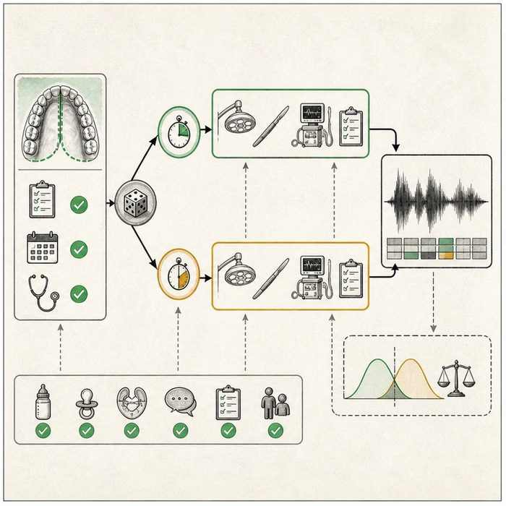
Biomedical teaching illustration: Convert the PICO question into a testable timing hypothesis
Analogy step | Biology step | How the relationship stays the same
Seat design | Repair timing, the independent variable | ________________________________
Force sensor | VPI at age 5, the dependent outcome | ________________________________
Failed prediction | No lower VPI in the earlier group | ________________________________

EXPERIMENTAL DESIGN LESSON 2 | CASE FILE AND DECISION
4. Use the case evidence

ID | Finding supplied in the case | Why it matters
EXP02-E1 | The proposed study compares repair at 6 months with repair at 12 months. | Repair timing is the factor that differs between groups.
EXP02-E2 | The primary outcome is VPI status at age 5. | The outcome must be measured the same way in both groups.
EXP02-E3 | A valid hypothesis can be challenged by equal or higher VPI in the 6-month group. | The prediction is falsifiable rather than protected from failure.

5. Make the clinical decision
You are the methods lead completing the hypothesis card. A draft says, 'Earlier surgery will help somehow,' and the team must decide whether it can guide a study.
A. Rewrite it with timing, VPI at age 5, and a result that would oppose the prediction.
B. Keep it because every positive change can count as success.
C. Remove the comparison group so no result can disagree.
Decision. Choose the revision and identify the independent variable, dependent variable, and falsifying result.
________________________________________________________________________________
________________________________________________________________________________
Claim ceiling: You may state a testable prediction. You may not claim the hypothesis is true before the comparison.
Claim. State the choice you can defend.
________________________________________________________________________________
Evidence. Use these labeled IDs: EXP02-E1 + EXP02-E2.
________________________________________________________________________________
Reasoning. Explain why the evidence supports the claim and stays inside the claim ceiling.
________________________________________________________________________________
________________________________________________________________________________

EXPERIMENTAL DESIGN LESSON 2 | REDUCE, REFLECT, AND PREPARE
6. Reduce the lesson to one lasting idea

Take-home. A falsifiable hypothesis links a defined change to a defined outcome and states what would count against it.
________________________________________________________________________________
________________________________________________________________________________
1. Which variable is repair timing?
________________________________________________________________________________
2. What finding would count against the earlier-is-better prediction?
________________________________________________________________________________

Glossary
Term | Plain-English definition
hypothesis | A testable, falsifiable prediction about how variables relate, written so an experiment can support it or prove it wrong.
null hypothesis | The default assumption that there is no real effect or difference, which a study tries to disprove with its data.
independent variable | The one factor a researcher deliberately changes in an experiment to test its effect on the measured outcome.
dependent variable | The outcome a researcher measures in an experiment, which may change in response to the variable being tested.
controlled variable | A factor kept the same across every group in an experiment so it cannot secretly affect the results.
control group | A comparison group set up to be like the treated group except for the one change being tested, so you can tell if that change did anything.
falsifiable | Able to be proven wrong by a real measurement, a key feature of a good scientific question or hypothesis.

Next lesson unlock
We can design a single study and predict what would prove us wrong. But two honest studies on the same question can reach opposite answers. Why do scientists trust some study designs more than others?
The journal links on the lesson page are optional. Everything required for this guided-notes set is already supplied here and in the case file.

