EXPERIMENTAL DESIGN DOMAIN | LESSON 1 OF 20 | PRINCIPAL INVESTIGATOR (PI)

From an Observation to a Researchable Question
Out of everything we could ask about Mateo, which questions can science actually answer, and how do we sharpen one of them?
CARRY FORWARD  A complete anatomical story can define structures, functions, repairs, and uncertainties while leaving treatment comparisons open to experiment. | 10-YEAR TAKEAWAY  A researchable question names a population, a factor or intervention, a comparison, and a measurable outcome.

Cells differentiate | Development sculpts | Cells move | Development can go wrong

1. Observe the analogy before naming the biology
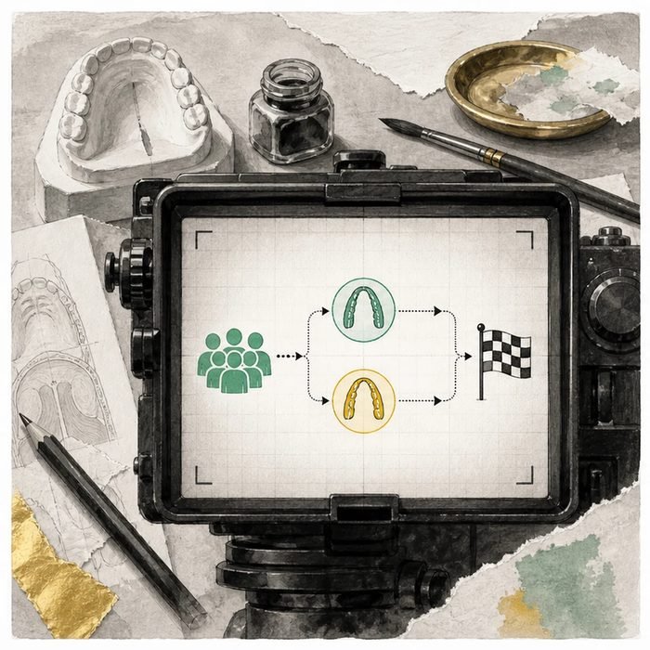
Illustration: A camera turns a wide scene into one answerable frame
1. What is outside the frame?
________________________________________________________________________________
2. Which action and comparison remain inside it?
________________________________________________________________________________
3. How will the camera know when the moment has happened?
________________________________________________________________________________

EXPERIMENTAL DESIGN LESSON 1 | RULES AND BIOLOGY MAPPING
2. Turn observations into rules

1. Rule 1: Name who is being studied. Explain it in your own words.
________________________________________________________________________________
2. Rule 2: Name the factor or intervention and comparison. Explain it in your own words.
________________________________________________________________________________
3. Rule 3: Name an outcome that can be measured at a set time. Explain it in your own words.
________________________________________________________________________________
Where the analogy stops: A study question guides evidence collection, but it cannot remove every uncertainty the way a camera crops a scene.

3. Map the rules onto the biomedical example
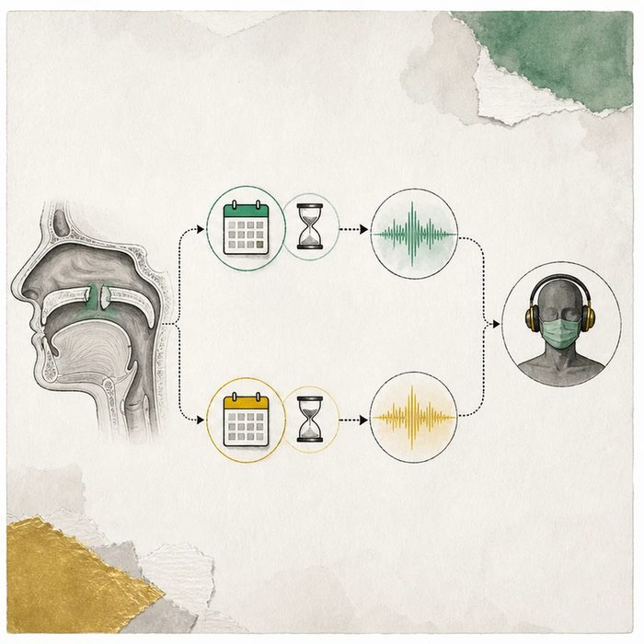
Biomedical teaching illustration: Frame the palate-timing question with PICO
Analogy step | Biology step | How the relationship stays the same
Subject in frame | Population | ________________________________
Two possible actions | Intervention and comparison | ________________________________
Visible finish line | Measurable outcome and time | ________________________________

EXPERIMENTAL DESIGN LESSON 1 | CASE FILE AND DECISION
4. Use the case evidence

ID | Finding supplied in the case | Why it matters
EXP01-E1 | The open anatomical question is whether repair timing changes later speech function. | The question concerns a treatment choice, not the cause of Mateo's cleft.
EXP01-E2 | A supplied candidate population is medically fit infants with isolated cleft palate. | The population is specific enough to set eligibility rules.
EXP01-E3 | VPI can be scored at age 5 by trained assessors. | The outcome and time point can be defined before the study begins.

5. Make the clinical decision
You are the junior investigator writing the first protocol line. The team must choose one question before enrolling any participants.
A. Among eligible infants, does repair at 6 rather than 12 months reduce VPI at age 5?
B. What is the best cleft surgery?
C. Did Mateo's family cause his cleft?
Decision. Choose the researchable question and label its population, intervention, comparison, outcome, and time.
________________________________________________________________________________
________________________________________________________________________________
Claim ceiling: You may define the study question. You may not predict which timing is better before data are collected.
Claim. State the choice you can defend.
________________________________________________________________________________
Evidence. Use these labeled IDs: EXP01-E1 + EXP01-E2.
________________________________________________________________________________
Reasoning. Explain why the evidence supports the claim and stays inside the claim ceiling.
________________________________________________________________________________
________________________________________________________________________________

EXPERIMENTAL DESIGN LESSON 1 | REDUCE, REFLECT, AND PREPARE
6. Reduce the lesson to one lasting idea

Take-home. A researchable question names a population, a factor or intervention, a comparison, and a measurable outcome.
________________________________________________________________________________
________________________________________________________________________________
1. What does the C in PICO name?
________________________________________________________________________________
2. Why does the age 5 time point matter?
________________________________________________________________________________

Glossary
Term | Plain-English definition
researchable question | A question that is specific and measurable enough to answer with data through a feasible study.
PICO | A framework for building a clear research question by naming the Patient, Intervention, Comparison, and Outcome.
population | A defined group of individuals being studied or counted, such as all newborns in a region during one year.
comparison | The other group or condition you measure your treatment against, so you can judge whether the treatment made a real difference.
outcome | The measured result a study tracks to judge whether a treatment or condition makes a difference.
empirical | Based on direct observation, measurement, or experiment rather than on theory or opinion alone.

Next lesson unlock
We turned an observation into a sharp PICO question. But a question is still not a prediction. How do we turn a PICO question into a hypothesis we can actually prove wrong, with variables we control and a clear way to fail?
The journal links on the lesson page are optional. Everything required for this guided-notes set is already supplied here and in the case file.

