DISEASE DOMAIN | LESSON 20 OF 20 | THE WHOLE CLEFT TEAM

Mateo's Complete Clinical Story (and His Diagnosis)
Putting every clue together, what is Mateo's diagnosis, and how do we justify it?
CARRY FORWARD  A cleft team works when specialists share one plan, one record, and clear ownership across time. | 10-YEAR TAKEAWAY  Mateo's record supports an isolated, nonsyndromic cleft lip and palate with multifactorial risk and lifelong coordinated care.

Cells differentiate | Development sculpts | Cells move | Development can go wrong

1. Observe the analogy before naming the biology
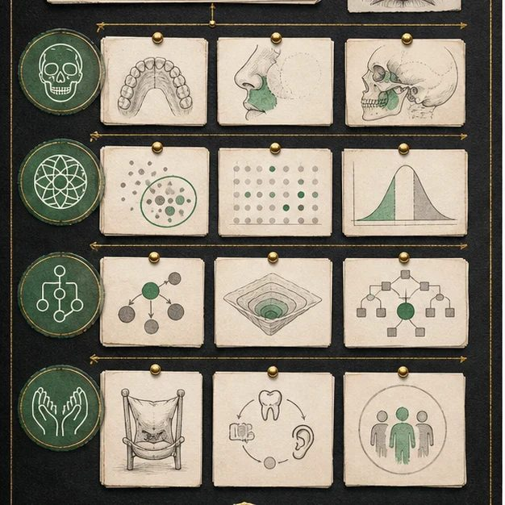
Illustration: A case conference weighs the whole evidence board
1. Which cards describe anatomy, cause, and care?
________________________________________________________________________________
2. Which missing card would change the conclusion?
________________________________________________________________________________
3. How do claim limits protect the final decision?
________________________________________________________________________________

DISEASE LESSON 20 | RULES AND BIOLOGY MAPPING
2. Turn observations into rules

1. Rule 1: Use the full evidence pattern, not one striking clue. Explain it in your own words.
________________________________________________________________________________
2. Rule 2: Separate description, classification, cause model, and care plan. Explain it in your own words.
________________________________________________________________________________
3. Rule 3: State what would make the conclusion change. Explain it in your own words.
________________________________________________________________________________
Where the analogy stops: A medical synthesis is not a courtroom verdict. The analogy models evidence organization and claim limits.

3. Map the rules onto the biomedical example
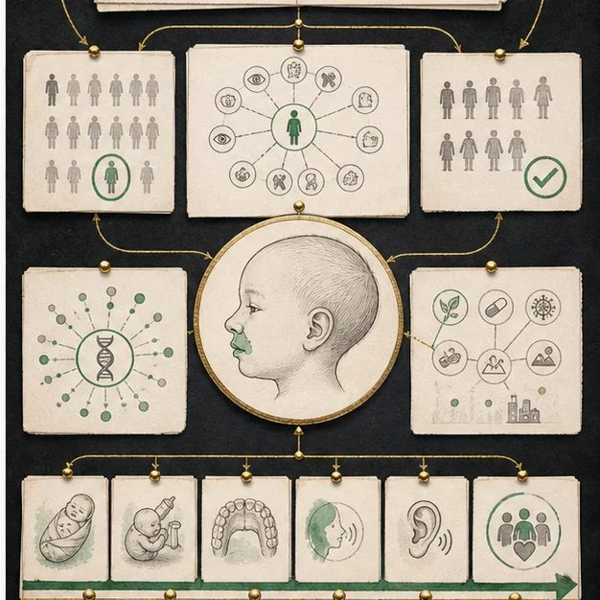
Biomedical teaching illustration: Build Mateo's final clinical synthesis
Analogy step | Biology step | How the relationship stays the same
Observation cards | Stable case evidence from all 20 lessons | ________________________________
Claim columns | Anatomic diagnosis, isolated-versus-syndromic classification, cause model, care plan | ________________________________
Revision trigger | A new family-history, developmental, or multi-system finding | ________________________________

DISEASE LESSON 20 | CASE FILE AND DECISION
4. Use the case evidence

ID | Finding supplied in the case | Why it matters
D20-E1 | The anatomy is a complete unilateral left cleft lip and palate. | The structural diagnosis is specific and stable.
D20-E2 | Repeated exam, family history, and follow-up show no consistent additional syndrome pattern. | The record supports an isolated, nonsyndromic classification at this time.
D20-E3 | No single proven cause is identified, and research supports many contributing gene and environment influences. | A multifactorial risk model fits the evidence.
D20-E4 | Mateo needs staged feeding, surgical, speech, hearing, dental, growth, psychosocial, and coordination follow-up. | The diagnosis includes a longitudinal care plan, not only a label.

5. Make the clinical decision
You are presenting Mateo at the five-domain grand rounds. The panel asks for one complete diagnosis statement and one condition that would make you reopen it.
A. Isolated nonsyndromic complete unilateral left cleft lip and palate, likely multifactorial, with staged team care
B. A cleft caused by one specific exposure
C. A confirmed syndrome despite no matching pattern
Decision. Choose the synthesis, cite at least three evidence IDs, and name one new finding that would require revision.
________________________________________________________________________________
________________________________________________________________________________
Claim ceiling: You may state the best current synthesis. You may not claim certainty about one causal variant or exposure.
Claim. State the choice you can defend.
________________________________________________________________________________
Evidence. Use these labeled IDs: D20-E1 + D20-E2 + D20-E3 + D20-E4.
________________________________________________________________________________
Reasoning. Explain why the evidence supports the claim and stays inside the claim ceiling.
________________________________________________________________________________
________________________________________________________________________________

DISEASE LESSON 20 | REDUCE, REFLECT, AND PREPARE
6. Reduce the lesson to one lasting idea

Take-home. Mateo's record supports an isolated, nonsyndromic cleft lip and palate with multifactorial risk and lifelong coordinated care.
________________________________________________________________________________
________________________________________________________________________________
1. What evidence supports each part of the final diagnosis statement?
________________________________________________________________________________
2. What new evidence would make the team reopen the syndromic question?
________________________________________________________________________________

Glossary
Term | Plain-English definition
nonsyndromic | Describing a condition, such as a cleft, that occurs on its own without a set of other linked birth differences.
isolated cleft | A cleft of the lip or palate that occurs on its own, without other birth differences or a recognized syndrome.
multifactorial inheritance | A trait caused by many small genetic and environmental factors adding up together, rather than by a single gene alone.
recurrence risk | The chance that a future child in the same family will also be affected by a given condition.
synthesis | Building a molecule in the cell, as in protein synthesis (making a protein from mRNA).
diagnosis of exclusion | A diagnosis reached only after ruling out every other likely cause, since no single test can confirm the condition directly.

Next lesson unlock
We answered the question we have chased since day one: Mateo has isolated, nonsyndromic cleft lip and palate, multifactorial, managed over a lifetime. But Mateo is not only the disease team's patient. The genetic, developmental, anatomical, and experimental teams have studied the same patient from their own angles. Five lenses, one Mateo, one diagnosis: bring your Disease Domain Report to the joint conference and see how your answer matches theirs.
The journal links on the lesson page are optional. Everything required for this guided-notes set is already supplied here and in the case file.

