DISEASE DOMAIN | LESSON 19 OF 20 | CLEFT TEAM COORDINATOR (TEAM DESIGN)

How a Team Delivers Care Without Gaps
Why is cleft care delivered by a coordinated team, and how does that team keep an 18-year plan from developing gaps?
CARRY FORWARD  A repaired cleft still needs surveillance because speech, hearing, teeth, airway, and growth can change later. | 10-YEAR TAKEAWAY  A cleft team works when specialists share one plan, one record, and clear ownership across time.

Cells differentiate | Development sculpts | Cells move | Development can go wrong

1. Observe the analogy before naming the biology

Illustration: An orchestra needs a shared score and a conductor
1. What happens if each section uses a different score?
________________________________________________________________________________
2. Does the conductor replace the specialists?
________________________________________________________________________________
3. How does the group know who enters next?
________________________________________________________________________________

DISEASE LESSON 19 | RULES AND BIOLOGY MAPPING
2. Turn observations into rules

1. Rule 1: Keep one shared plan. Explain it in your own words.
________________________________________________________________________________
2. Rule 2: Preserve specialist expertise while coordinating timing. Explain it in your own words.
________________________________________________________________________________
3. Rule 3: Name who owns the next action and handoff. Explain it in your own words.
________________________________________________________________________________
Where the analogy stops: Care is a partnership with the patient and family, not a performance controlled by one person. The analogy models coordination.

3. Map the rules onto the biomedical example
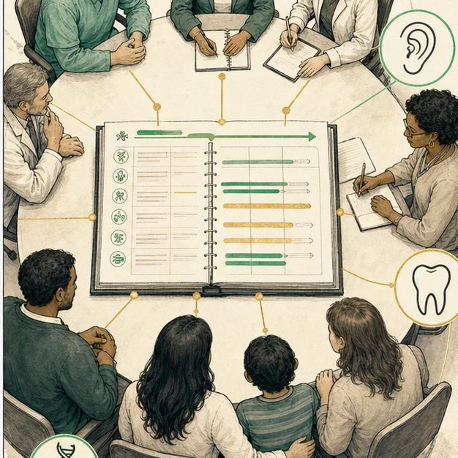
Biomedical teaching illustration: Coordinate many specialists around one child
Analogy step | Biology step | How the relationship stays the same
Shared score | Shared longitudinal care plan and record | ________________________________
Instrument sections | Surgery, speech, hearing, dental, genetics, psychosocial care | ________________________________
Conductor cues | Coordinator tracks timing, ownership, and handoffs | ________________________________

DISEASE LESSON 19 | CASE FILE AND DECISION
4. Use the case evidence

ID | Finding supplied in the case | Why it matters
D19-E1 | Mateo has three follow-up actions due in different clinics within six months. | Uncoordinated scheduling creates a risk that one action will be missed.
D19-E2 | The speech finding affects surgical planning, and hearing status affects speech interpretation. | The specialists' decisions depend on each other's evidence.
D19-E3 | The family asks for one contact person and one written plan. | Coordination must be visible and usable to the family.

5. Make the clinical decision
You are the cleft team coordinator closing the conference. Before the meeting ends, every next action needs an owner, date window, and handoff.
A. Publish one shared action list with named owners and a family contact
B. Let each clinic contact the family separately
C. Record only the surgery plan
Decision. Choose the coordination plan and show where each evidence item changes the plan.
________________________________________________________________________________
________________________________________________________________________________
Claim ceiling: You may assign ownership and sequence. You may not make a specialist's clinical decision without that specialist and the family.
Claim. State the choice you can defend.
________________________________________________________________________________
Evidence. Use these labeled IDs: D19-E1 + D19-E2 + D19-E3.
________________________________________________________________________________
Reasoning. Explain why the evidence supports the claim and stays inside the claim ceiling.
________________________________________________________________________________
________________________________________________________________________________

DISEASE LESSON 19 | REDUCE, REFLECT, AND PREPARE
6. Reduce the lesson to one lasting idea

Take-home. A cleft team works when specialists share one plan, one record, and clear ownership across time.
________________________________________________________________________________
________________________________________________________________________________
1. Why is a list of specialists not yet a coordinated team?
________________________________________________________________________________
2. What four items belong in every handoff?
________________________________________________________________________________

Glossary
Term | Plain-English definition
multidisciplinary team | A lesson term defined by the surrounding model and case evidence.
coordinator | A team member who organizes a patient's many appointments and specialists, keeping multidisciplinary cleft care running smoothly.
continuity of care | Keeping a patient connected to the same coordinated care team over time, so treatment stays consistent across many visits and years.
handoff | The careful transfer of a patient's care and information from one clinician or team to the next so nothing important is missed.
longitudinal care | Ongoing medical care that follows a patient over many years through changing needs, rather than a single one-time treatment.
care plan | A written, organized strategy describing a patient's health needs, goals, and the specific treatments and steps the care team will follow.

Next lesson unlock
We answered how the team holds it all together: shared records, a coordinator, and continuity across 18 years. That completes the machinery of Mateo's care. So now, with everything from his first newborn exam to his lifelong team in hand, we can finally ask the biggest question of all: what is Mateo's complete clinical story, and what, after eighteen lessons of evidence, is his actual diagnosis?
The journal links on the lesson page are optional. Everything required for this guided-notes set is already supplied here and in the case file.

