DISEASE DOMAIN | LESSON 18 OF 20 | CLEFT TEAM COORDINATOR (LONG-TERM SURVEILLANCE)

A Repaired Cleft Is Not a Cured Cleft
What can still go wrong for Mateo after his cleft is repaired, and which team member is positioned to catch each problem?
CARRY FORWARD  Equal treatment is not always equitable care; the plan must remove the barriers that block access to the same health goal. | 10-YEAR TAKEAWAY  A repaired cleft still needs surveillance because speech, hearing, teeth, airway, and growth can change later.

Cells differentiate | Development sculpts | Cells move | Development can go wrong

1. Observe the analogy before naming the biology
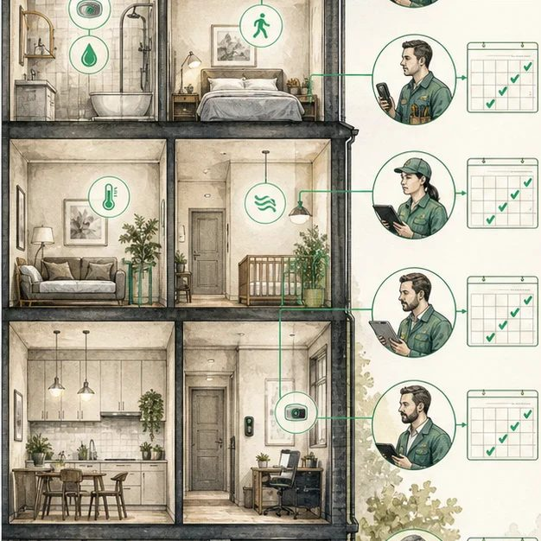
Illustration: Different smoke detectors guard different rooms
1. Why is one detector not enough for the whole building?
________________________________________________________________________________
2. Which signal belongs to which room?
________________________________________________________________________________
3. What happens if nobody checks the batteries?
________________________________________________________________________________

DISEASE LESSON 18 | RULES AND BIOLOGY MAPPING
2. Turn observations into rules

1. Rule 1: Match each risk to a detection method. Explain it in your own words.
________________________________________________________________________________
2. Rule 2: Assign ownership for every alert. Explain it in your own words.
________________________________________________________________________________
3. Rule 3: Repeat checks because conditions change over time. Explain it in your own words.
________________________________________________________________________________
Where the analogy stops: Complications are not fires. The analogy models targeted surveillance and ownership.

3. Map the rules onto the biomedical example
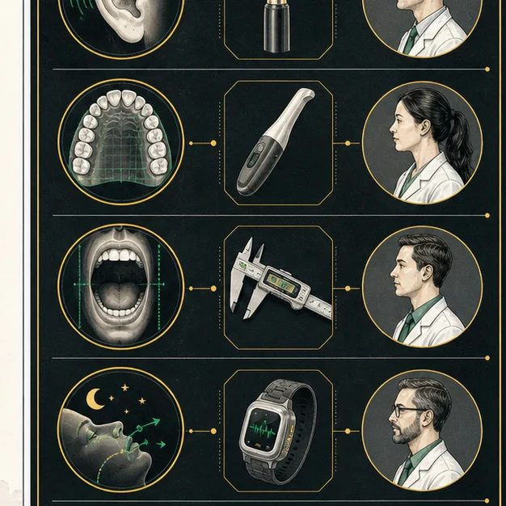
Biomedical teaching illustration: Match each possible complication to its detector
Analogy step | Biology step | How the relationship stays the same
Sensor type | Speech test, hearing test, exam, imaging, or sleep study | ________________________________
Room | Specific structure or function at risk | ________________________________
Alarm owner | Named specialist responsible for follow-up | ________________________________

DISEASE LESSON 18 | CASE FILE AND DECISION
4. Use the case evidence

ID | Finding supplied in the case | Why it matters
D18-E1 | Mateo has new nasal air escape during fast speech. | Speech and velopharyngeal function need reassessment.
D18-E2 | Hearing is stable, and middle-ear fluid is not present today. | Hearing surveillance continues, but it is not the immediate problem.
D18-E3 | The dental team notes a narrowing upper arch during growth. | Orthodontic monitoring needs a separate plan.

5. Make the clinical decision
You are leading the annual cleft team review. You must route each finding to the right specialist and decide what happens first.
A. Prioritize speech evaluation, continue hearing surveillance, and schedule orthodontic review
B. Send every finding to the surgeon
C. Declare care complete because the cleft was repaired
Decision. Build the routing plan and cite one evidence ID for each action.
________________________________________________________________________________
________________________________________________________________________________
Claim ceiling: You may identify the next evaluation. You may not diagnose the cause of a new problem before the specialist assessment.
Claim. State the choice you can defend.
________________________________________________________________________________
Evidence. Use these labeled IDs: D18-E1 + D18-E2 + D18-E3.
________________________________________________________________________________
Reasoning. Explain why the evidence supports the claim and stays inside the claim ceiling.
________________________________________________________________________________
________________________________________________________________________________

DISEASE LESSON 18 | REDUCE, REFLECT, AND PREPARE
6. Reduce the lesson to one lasting idea

Take-home. A repaired cleft still needs surveillance because speech, hearing, teeth, airway, and growth can change later.
________________________________________________________________________________
________________________________________________________________________________
1. Why is surveillance not the same as expecting a complication?
________________________________________________________________________________
2. Which specialist owns each of today's findings?
________________________________________________________________________________

Glossary
Term | Plain-English definition
oronasal fistula | An abnormal opening left between the mouth and nose after cleft repair, which can let fluid or air leak through.
velopharyngeal insufficiency | When the soft palate cannot fully seal off the nose during speech, letting air escape and making speech sound nasal.
midface hypoplasia | Underdevelopment of the middle of the face, so the cheeks and upper jaw look flat or set back, common after cleft repair.
obstructive sleep apnea | Repeated pauses in breathing during sleep caused when the airway at the back of the throat narrows or collapses.
surveillance | The ongoing, systematic collection and analysis of health data to detect disease early, track its trends, and trigger a timely public health response.
complication | An unwanted problem that develops during or after treatment, such as infection or a wound that breaks open after surgery.

Next lesson unlock
We answered what can still go wrong and who catches it. But Mateo now needs a surgeon, a speech-language pathologist, an audiologist, an orthodontist, and more, all watching different things across many years. How does one team deliver all of this care without anything falling through the cracks?
The journal links on the lesson page are optional. Everything required for this guided-notes set is already supplied here and in the case file.

