DISEASE DOMAIN | LESSON 17 OF 20 | CLEFT TEAM COORDINATOR (HEALTH-EQUITY LENS)

Does Every Child Like Mateo Get the Same Care?
Does access to cleft care depend on who you are and where you are born, and what does that mean for children like Mateo?
CARRY FORWARD  Psychosocial care belongs in the treatment plan because health includes confidence, relationships, school, and family well-being. | 10-YEAR TAKEAWAY  Equal treatment is not always equitable care; the plan must remove the barriers that block access to the same health goal.

Cells differentiate | Development sculpts | Cells move | Development can go wrong

1. Observe the analogy before naming the biology
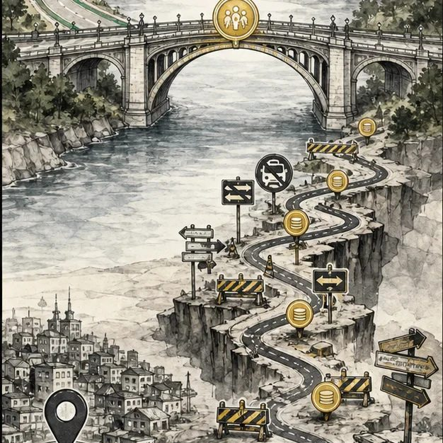
Illustration: The same bridge is not equally reachable from every road
1. Is the bridge itself different?
________________________________________________________________________________
2. Which road barriers change who can use it?
________________________________________________________________________________
3. What could be redesigned without lowering the destination?
________________________________________________________________________________

DISEASE LESSON 17 | RULES AND BIOLOGY MAPPING
2. Turn observations into rules

1. Rule 1: Measure access to the outcome, not only whether a service exists. Explain it in your own words.
________________________________________________________________________________
2. Rule 2: Name the barrier before choosing the solution. Explain it in your own words.
________________________________________________________________________________
3. Rule 3: Keep the clinical goal while changing the route. Explain it in your own words.
________________________________________________________________________________
Where the analogy stops: Families are not locations on a map. The analogy models structural barriers to access.

3. Map the rules onto the biomedical example
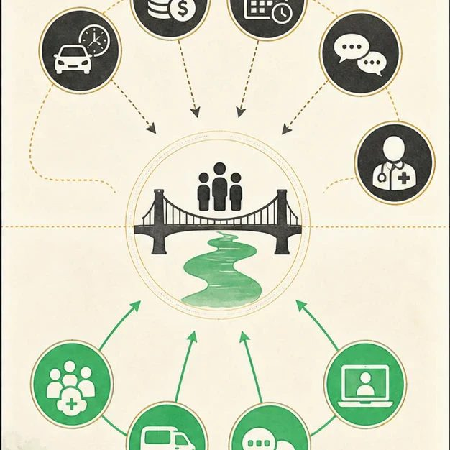
Biomedical teaching illustration: Redesign the route to coordinated cleft care
Analogy step | Biology step | How the relationship stays the same
Long road | Travel distance and specialist shortages | ________________________________
Toll gate | Cost, insurance, and missed work | ________________________________
Road signs | Language access and understandable instructions | ________________________________

DISEASE LESSON 17 | CASE FILE AND DECISION
4. Use the case evidence

ID | Finding supplied in the case | Why it matters
D17-E1 | The family missed two visits because the caregiver could not leave work and the clinic is across the city. | Scheduling and transportation are documented barriers.
D17-E2 | The next required services are hearing and speech follow-up, both available through the hospital network. | The clinical goal is clear and should remain unchanged.
D17-E3 | The network offers combined appointments, transportation support, and telehealth check-ins when clinically appropriate. | Available supports match the named barriers.

5. Make the clinical decision
You are the care coordinator after two missed visits. You need a recovery plan that protects care without blaming the family.
A. Bundle visits, arrange transportation support, and use appropriate telehealth follow-up
B. Discharge the family for noncompliance
C. Lower the hearing and speech goals
Decision. Choose the recovery plan and match each support to one documented barrier.
________________________________________________________________________________
________________________________________________________________________________
Claim ceiling: You may respond to the documented barriers. You may not invent income, immigration, language, or family details not in the case.
Claim. State the choice you can defend.
________________________________________________________________________________
Evidence. Use these labeled IDs: D17-E1 + D17-E2 + D17-E3.
________________________________________________________________________________
Reasoning. Explain why the evidence supports the claim and stays inside the claim ceiling.
________________________________________________________________________________
________________________________________________________________________________

DISEASE LESSON 17 | REDUCE, REFLECT, AND PREPARE
6. Reduce the lesson to one lasting idea

Take-home. Equal treatment is not always equitable care; the plan must remove the barriers that block access to the same health goal.
________________________________________________________________________________
________________________________________________________________________________
1. What is the difference between equal and equitable care in this case?
________________________________________________________________________________
2. Which support matches each documented barrier?
________________________________________________________________________________

Glossary
Term | Plain-English definition
health equity | The goal that everyone has a fair chance to be healthy, by removing avoidable barriers tied to income, race, or where people live.
access | The ability of people, especially those with low income or in rural areas, to actually reach and receive the medical care they need.
global burden | The total impact of a disease worldwide, counting how many people it affects and the illness, disability, and cost it causes.
disparity | An unfair, avoidable difference in health or care between groups, often tied to income, geography, race, or access to treatment.
social determinants of health | The conditions in which people live, learn, work, and access care that shape their health beyond their biology.
untreated cleft | A cleft lip or palate that has not been surgically repaired, which can affect feeding, speech, hearing, and dental health over time.

Next lesson unlock
We answered that access is unequal, and that Mateo is fortunate to have a full team. But even with full access, the work is not finished. A repaired cleft is not a cured cleft. What problems can arise later for Mateo, even years after surgery, and how would the team catch them?
The journal links on the lesson page are optional. Everything required for this guided-notes set is already supplied here and in the case file.

