DISEASE DOMAIN | LESSON 16 OF 20 | PSYCHOLOGIST / SOCIAL WORKER (CLEFT TEAM)

Supporting Mateo and His Family Beyond the Body
What does Mateo's family need beyond surgery and medicine, and how can the team meet those needs?
CARRY FORWARD  Growth decisions come from trends across time, not one measurement on one day. | 10-YEAR TAKEAWAY  Psychosocial care belongs in the treatment plan because health includes confidence, relationships, school, and family well-being.

Cells differentiate | Development sculpts | Cells move | Development can go wrong

1. Observe the analogy before naming the biology

Illustration: A bridge needs support below the visible roadway
1. Which supports are easy to see?
________________________________________________________________________________
2. What happens if hidden supports weaken?
________________________________________________________________________________
3. How would you inspect support before a crisis?
________________________________________________________________________________

DISEASE LESSON 16 | RULES AND BIOLOGY MAPPING
2. Turn observations into rules

1. Rule 1: Visible function depends on less visible support. Explain it in your own words.
________________________________________________________________________________
2. Rule 2: Check support before failure is obvious. Explain it in your own words.
________________________________________________________________________________
3. Rule 3: Strength can grow through family, peer, school, and clinical connections. Explain it in your own words.
________________________________________________________________________________
Where the analogy stops: People are not structures. The analogy only shows that hidden support affects visible well-being.

3. Map the rules onto the biomedical example
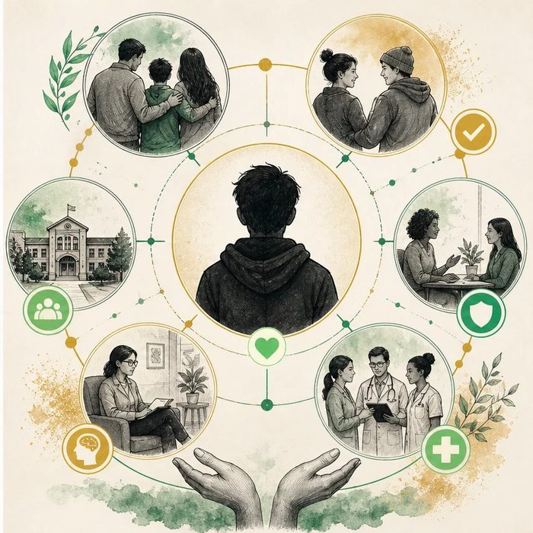
Biomedical teaching illustration: Assess the whole child, not only the repaired anatomy
Analogy step | Biology step | How the relationship stays the same
Roadway | Visible participation in school and care | ________________________________
Support beams | Family, peer, social, and mental-health supports | ________________________________
Routine inspection | Age-appropriate psychosocial screening | ________________________________

DISEASE LESSON 16 | CASE FILE AND DECISION
4. Use the case evidence

ID | Finding supplied in the case | Why it matters
D16-E1 | Mateo's family reports stress from repeated appointments and worry about other people's reactions. | Family burden is part of the current health picture.
D16-E2 | Mateo participates in class but avoids speaking during a new peer group activity. | A context-specific concern deserves a private, nonjudgmental check-in.
D16-E3 | No crisis signs are reported, and Mateo identifies one trusted adult and one supportive friend. | The plan can build on existing strengths while monitoring needs.

5. Make the clinical decision
You are the team social worker before a school transition. The family asks whether support is necessary if Mateo is medically stable.
A. Offer a private check-in, family resources, and a school support plan based on Mateo's preferences
B. Wait for a crisis
C. Assume every child with a cleft feels the same
Decision. Choose the support plan and separate the evidence from assumptions about how Mateo feels.
________________________________________________________________________________
________________________________________________________________________________
Claim ceiling: You may identify needs reported in the case. You may not assign feelings, diagnoses, or stigma experiences that Mateo did not report.
Claim. State the choice you can defend.
________________________________________________________________________________
Evidence. Use these labeled IDs: D16-E1 + D16-E2 + D16-E3.
________________________________________________________________________________
Reasoning. Explain why the evidence supports the claim and stays inside the claim ceiling.
________________________________________________________________________________
________________________________________________________________________________

DISEASE LESSON 16 | REDUCE, REFLECT, AND PREPARE
6. Reduce the lesson to one lasting idea

Take-home. Psychosocial care belongs in the treatment plan because health includes confidence, relationships, school, and family well-being.
________________________________________________________________________________
________________________________________________________________________________
1. Why should the team ask rather than assume?
________________________________________________________________________________
2. Which strengths in the case can the plan build on?
________________________________________________________________________________

Glossary
Term | Plain-English definition
psychosocial | Relating to how a condition affects a person's emotions, self-image, and relationships, alongside its physical effects.
stigma | Unfair negative judgment or social shame directed at a person because of a visible difference or health condition.
resilience | The ability to recover and keep functioning well after stress, hardship, or setbacks.
family-centered care | A care approach that treats the family as partners in decisions, respecting their values, needs, and role alongside the medical team.
social worker | A care-team member who helps families navigate resources, costs, support services, and emotional needs around a child's condition.
support care | Care aimed at easing symptoms and helping daily function, such as feeding aids and hearing support, alongside the main treatment.

Next lesson unlock
We answered what Mateo's family needs beyond the body. But we have assumed his team will provide all of this. Does every child like Mateo actually get the same care, whether they are born in a big city, a rural town, or a low-income country?
The journal links on the lesson page are optional. Everything required for this guided-notes set is already supplied here and in the case file.

