DISEASE DOMAIN | LESSON 15 OF 20 | PEDIATRICIAN (CLEFT TEAM)

Is Mateo Growing Well?
Why are cleft infants at risk for poor growth, and how does the pediatrician keep track of whether Mateo is growing and developing well?
CARRY FORWARD  Dental and orthodontic care is staged because teeth, bone, and facial growth change on different schedules. | 10-YEAR TAKEAWAY  Growth decisions come from trends across time, not one measurement on one day.

Cells differentiate | Development sculpts | Cells move | Development can go wrong

1. Observe the analogy before naming the biology

Illustration: A movie shows change that a snapshot cannot
1. What can the sequence show that one frame cannot?
________________________________________________________________________________
2. Which direction is the trend moving?
________________________________________________________________________________
3. When would a single low point be less concerning?
________________________________________________________________________________

DISEASE LESSON 15 | RULES AND BIOLOGY MAPPING
2. Turn observations into rules

1. Rule 1: Repeat measurements in the same way. Explain it in your own words.
________________________________________________________________________________
2. Rule 2: Look for direction and rate of change. Explain it in your own words.
________________________________________________________________________________
3. Rule 3: Interpret the trend with development and clinical context. Explain it in your own words.
________________________________________________________________________________
Where the analogy stops: Growth is not a movie with identical frames. The analogy models the value of repeated observations.

3. Map the rules onto the biomedical example
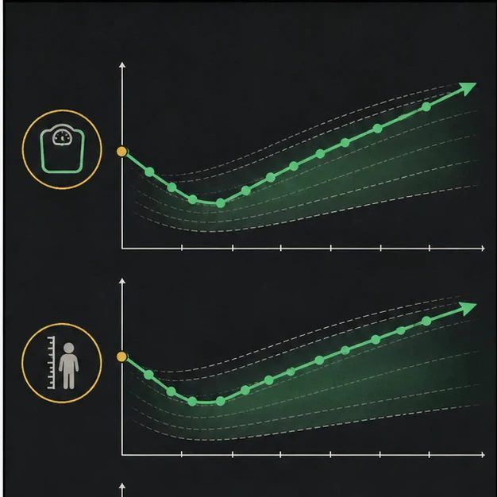
Biomedical teaching illustration: Read Mateo's growth as a longitudinal pattern
Analogy step | Biology step | How the relationship stays the same
Single frame | One weight or percentile | ________________________________
Frame sequence | Repeated measurements over months | ________________________________
Plot change | Growth trend and milestone progression | ________________________________

DISEASE LESSON 15 | CASE FILE AND DECISION
4. Use the case evidence

ID | Finding supplied in the case | Why it matters
D15-E1 | Mateo's weight dropped during the first feeding week but rose steadily after the assisted-feeding plan began. | The intervention appears to improve intake.
D15-E2 | Length and head circumference continue along their prior percentile bands. | Overall physical growth remains proportionate.
D15-E3 | Motor, language, and social milestones are appropriate for the visit. | Developmental progress supports continued monitoring rather than an emergency conclusion.

5. Make the clinical decision
You are the pediatrician reviewing the longitudinal record. You must decide whether to admit Mateo for urgent growth failure or continue the current plan with close follow-up.
A. Continue the effective feeding plan with scheduled growth and development checks
B. Base the decision only on the first low weight
C. Ignore all future growth because the latest weight improved
Decision. Choose the plan and describe the trend across all three evidence IDs.
________________________________________________________________________________
________________________________________________________________________________
Claim ceiling: You may judge the current trend. You may not promise that later growth or facial development will stay normal.
Claim. State the choice you can defend.
________________________________________________________________________________
Evidence. Use these labeled IDs: D15-E1 + D15-E2 + D15-E3.
________________________________________________________________________________
Reasoning. Explain why the evidence supports the claim and stays inside the claim ceiling.
________________________________________________________________________________
________________________________________________________________________________

DISEASE LESSON 15 | REDUCE, REFLECT, AND PREPARE
6. Reduce the lesson to one lasting idea

Take-home. Growth decisions come from trends across time, not one measurement on one day.
________________________________________________________________________________
________________________________________________________________________________
1. Why is Mateo's first low weight not enough for today's decision?
________________________________________________________________________________
2. What additional trends help show whole-child development?
________________________________________________________________________________

Glossary
Term | Plain-English definition
failure to thrive | Poor weight gain and growth in an infant or child, often because feeding is difficult or nutrition is not absorbed well.
growth chart (percentile) | A standard chart that compares a child's height, weight, or head size to other children of the same age and sex using percentiles.
developmental milestone | A skill most children reach by a certain age, such as sitting, speaking words, or walking, used to track healthy growth.
midface growth | The forward and downward development of the central face, including the upper jaw and cheeks, which surgery and clefting can affect.
longitudinal monitoring | Following the same patients with repeated check-ups over months or years to track how their condition or treatment changes over time.

Next lesson unlock
We answered how the team keeps Mateo growing and developing well. His body and growth are well cared for. But a child is more than a body. Mateo and his parents face stares, worry, the stress of many appointments, and questions about how he will feel about himself. How do we support Mateo and his family beyond the body?
The journal links on the lesson page are optional. Everything required for this guided-notes set is already supplied here and in the case file.

