DISEASE DOMAIN | LESSON 14 OF 20 | DENTIST / ORTHODONTIST (CLEFT TEAM)

Caring for Mateo's Teeth and Bite
Why does a cleft lip and palate change the teeth and bite, and why is dental care spread across many years?
CARRY FORWARD  Cleft-related middle-ear fluid can reduce hearing, so repeated hearing checks protect speech development. | 10-YEAR TAKEAWAY  Dental and orthodontic care is staged because teeth, bone, and facial growth change on different schedules.

Cells differentiate | Development sculpts | Cells move | Development can go wrong

1. Observe the analogy before naming the biology
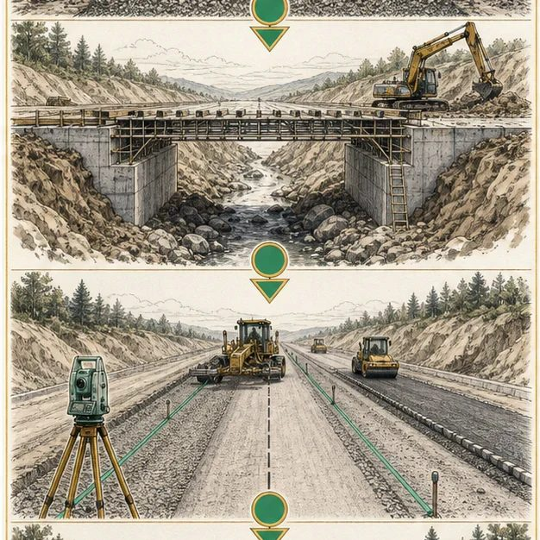
Illustration: Build the roadbed before aligning the lanes
1. Which step must happen before lanes can be aligned?
________________________________________________________________________________
2. What would fail if final paving came first?
________________________________________________________________________________
3. Which conditions would make the schedule change?
________________________________________________________________________________

DISEASE LESSON 14 | RULES AND BIOLOGY MAPPING
2. Turn observations into rules

1. Rule 1: Foundation changes can precede alignment. Explain it in your own words.
________________________________________________________________________________
2. Rule 2: Sequence depends on growth and eruption. Explain it in your own words.
________________________________________________________________________________
3. Rule 3: Different specialists own connected steps. Explain it in your own words.
________________________________________________________________________________
Where the analogy stops: Teeth and bone are living tissues, not asphalt. The analogy models sequence and dependency.

3. Map the rules onto the biomedical example
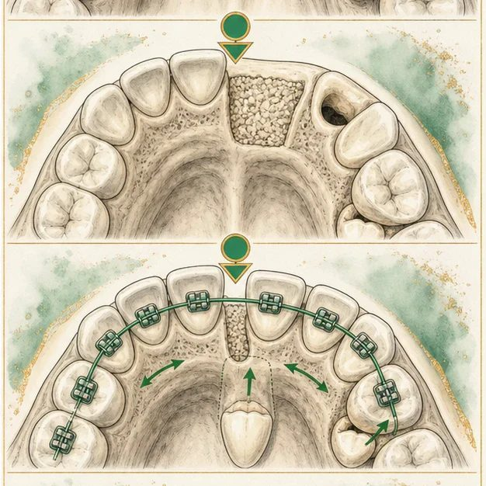
Biomedical teaching illustration: Sequence care through the tooth-bearing cleft
Analogy step | Biology step | How the relationship stays the same
Broken roadbed | Gap in the alveolar ridge | ________________________________
Rebuild foundation | Alveolar bone graft restores bone continuity | ________________________________
Align lanes | Orthodontics guides tooth position and bite | ________________________________

DISEASE LESSON 14 | CASE FILE AND DECISION
4. Use the case evidence

ID | Finding supplied in the case | Why it matters
D14-E1 | Mateo's cleft passes through the left tooth-bearing alveolar ridge. | Teeth and supporting bone near the cleft are at risk for predictable differences.
D14-E2 | One lateral incisor is missing and nearby teeth are rotated. | The dental pattern matches the location of the cleft.
D14-E3 | The permanent canine has not yet reached the usual graft-planning stage. | The team must monitor growth and eruption before choosing the next procedure.

5. Make the clinical decision
You are the orthodontist at today's team conference. The family asks whether all tooth and bone work should happen immediately.
A. Use preventive dental care now and coordinate later graft and orthodontic timing with eruption
B. Complete every procedure now
C. Ignore the missing tooth until adulthood
Decision. Choose the staged plan and identify what happens now versus what waits for a developmental marker.
________________________________________________________________________________
________________________________________________________________________________
Claim ceiling: You may outline the sequence. You may not set a surgery date without current imaging and eruption assessment.
Claim. State the choice you can defend.
________________________________________________________________________________
Evidence. Use these labeled IDs: D14-E1 + D14-E2 + D14-E3.
________________________________________________________________________________
Reasoning. Explain why the evidence supports the claim and stays inside the claim ceiling.
________________________________________________________________________________
________________________________________________________________________________

DISEASE LESSON 14 | REDUCE, REFLECT, AND PREPARE
6. Reduce the lesson to one lasting idea

Take-home. Dental and orthodontic care is staged because teeth, bone, and facial growth change on different schedules.
________________________________________________________________________________
________________________________________________________________________________
1. Why are tooth differences predictable near the cleft?
________________________________________________________________________________
2. Which developmental marker helps time later care?
________________________________________________________________________________

Glossary
Term | Plain-English definition
alveolus (alveolar ridge) | The bony ridge of the upper or lower jaw that holds the tooth sockets; a cleft can break this ridge near the front teeth.
hypodontia | A developmental condition in which one or a few teeth never form, leaving permanent gaps in the dental arch.
supernumerary tooth | An extra tooth beyond the normal count, which can appear near a cleft and crowd or block the regular teeth.
malocclusion | A misalignment of the upper and lower teeth so they do not meet properly when the jaws close.
alveolar bone grafting | A surgery that fills the bony gap in the upper gum of a cleft patient with bone, usually taken from the hip, so adult teeth can grow in.

Next lesson unlock
We answered why the cleft changes Mateo's teeth and bite and why dental care is staged. But now Mateo has a lot going on at once: surgeries, speech therapy, ear care, and dental visits. With all of that, how do we make sure the most basic thing is still on track, that he is actually growing and developing well overall?
The journal links on the lesson page are optional. Everything required for this guided-notes set is already supplied here and in the case file.

