DISEASE DOMAIN | LESSON 13 OF 20 | AUDIOLOGIST (CLEFT TEAM)

Protecting Mateo's Hearing
Why do children with a cleft palate get so many ear infections, and how does that threaten hearing?
CARRY FORWARD  Clear pressure sounds need the soft palate to move upward and seal the mouth from the nose. | 10-YEAR TAKEAWAY  Cleft-related middle-ear fluid can reduce hearing, so repeated hearing checks protect speech development.

Cells differentiate | Development sculpts | Cells move | Development can go wrong

1. Observe the analogy before naming the biology
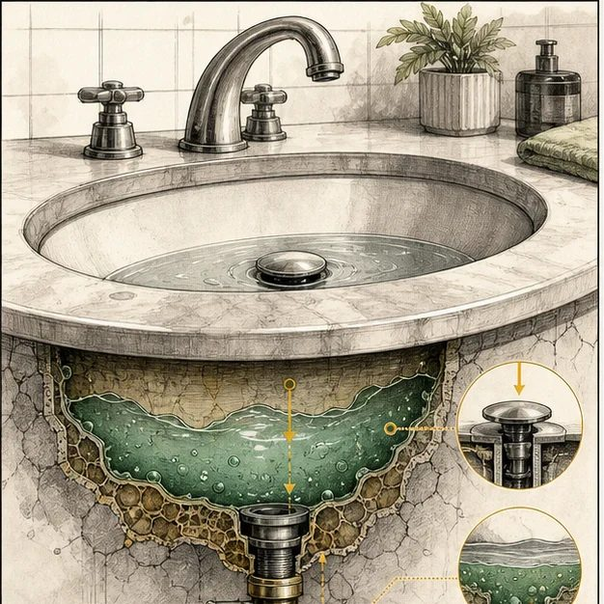
Illustration: A drain that does not open lets fluid collect
1. What happens when the drain stays closed?
________________________________________________________________________________
2. Why can the surface look fine while fluid collects behind it?
________________________________________________________________________________
3. How would you test whether flow is blocked?
________________________________________________________________________________

DISEASE LESSON 13 | RULES AND BIOLOGY MAPPING
2. Turn observations into rules

1. Rule 1: Poor drainage allows fluid to remain. Explain it in your own words.
________________________________________________________________________________
2. Rule 2: A hidden fluid problem can affect function before causing pain. Explain it in your own words.
________________________________________________________________________________
3. Rule 3: Repeated measurement catches changes over time. Explain it in your own words.
________________________________________________________________________________
Where the analogy stops: The Eustachian tube actively opens and the middle ear is not a sink. The analogy models drainage only.

3. Map the rules onto the biomedical example
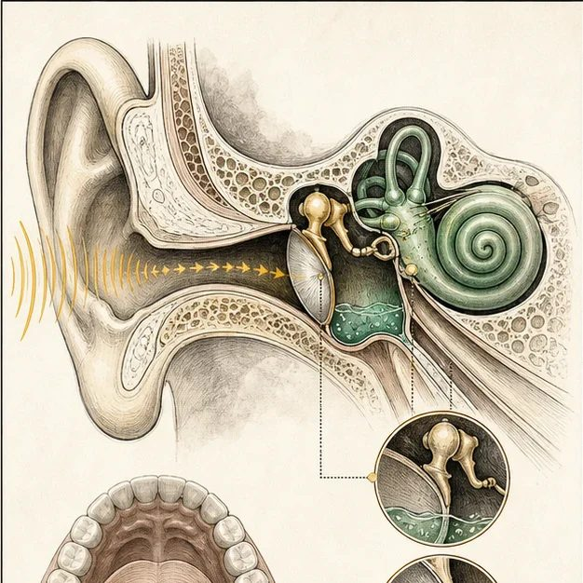
Biomedical teaching illustration: Connect palate muscles to middle-ear drainage
Analogy step | Biology step | How the relationship stays the same
Drain pathway | Eustachian tube connects middle ear to the throat | ________________________________
Drain does not open | Palate muscle differences reduce tube opening | ________________________________
Water remains | Middle-ear effusion causes conductive hearing loss | ________________________________

DISEASE LESSON 13 | CASE FILE AND DECISION
4. Use the case evidence

ID | Finding supplied in the case | Why it matters
D13-E1 | Mateo passed the newborn hearing screen. | Hearing was adequate at that moment, not guaranteed for all later months.
D13-E2 | At follow-up, both eardrums show reduced movement and middle-ear fluid. | Sound conduction may now be reduced.
D13-E3 | Mateo sometimes does not turn toward soft speech sounds. | The functional observation supports prompt audiology testing.

5. Make the clinical decision
You are the audiologist reviewing a passed newborn screen and new ear findings. The family asks whether the original pass means no further hearing checks are needed.
A. Complete age-appropriate hearing testing and coordinate ear management
B. Wait until Mateo fails a school hearing screen
C. Assume speech delay is unrelated to hearing
Decision. Choose the plan and explain why the newborn result does not cancel the new evidence.
________________________________________________________________________________
________________________________________________________________________________
Claim ceiling: You may say hearing is at risk and testing is needed. You may not state the degree of loss before audiology results.
Claim. State the choice you can defend.
________________________________________________________________________________
Evidence. Use these labeled IDs: D13-E1 + D13-E2 + D13-E3.
________________________________________________________________________________
Reasoning. Explain why the evidence supports the claim and stays inside the claim ceiling.
________________________________________________________________________________
________________________________________________________________________________

DISEASE LESSON 13 | REDUCE, REFLECT, AND PREPARE
6. Reduce the lesson to one lasting idea

Take-home. Cleft-related middle-ear fluid can reduce hearing, so repeated hearing checks protect speech development.
________________________________________________________________________________
________________________________________________________________________________
1. Why can hearing change after a passed newborn screen?
________________________________________________________________________________
2. How can middle-ear fluid affect speech development?
________________________________________________________________________________

Glossary
Term | Plain-English definition
Eustachian tube | A lesson term defined by the surrounding model and case evidence.
otitis media with effusion | Fluid trapped behind the eardrum without active infection, common in cleft palate, which can muffle a child's hearing.
conductive hearing loss | A lesson term defined by the surrounding model and case evidence.
tympanostomy tubes | Tiny tubes a surgeon places through the eardrum to drain fluid and prevent ear infections, common in children with cleft palate.
audiologist | A health professional who tests hearing and balance and manages hearing loss, an important team member for children with cleft palate.

Next lesson unlock
We answered why the cleft palate threatens hearing and how the team protects it. But Mateo's first teeth are coming in, and his parents notice some are crooked and one looks unusually small. How do we care for his teeth and his bite over the years ahead?
The journal links on the lesson page are optional. Everything required for this guided-notes set is already supplied here and in the case file.

