DISEASE DOMAIN | LESSON 12 OF 20 | SPEECH-LANGUAGE PATHOLOGIST (CLEFT TEAM)

How a Repaired Palate Lets Mateo Talk
How does the soft palate let us make clear speech sounds, and what goes wrong with speech when it cannot seal off the nose?
CARRY FORWARD  Lip repair restores form, while palate repair separates spaces and supports speech; different jobs require staged operations. | 10-YEAR TAKEAWAY  Clear pressure sounds need the soft palate to move upward and seal the mouth from the nose.

Cells differentiate | Development sculpts | Cells move | Development can go wrong

1. Observe the analogy before naming the biology
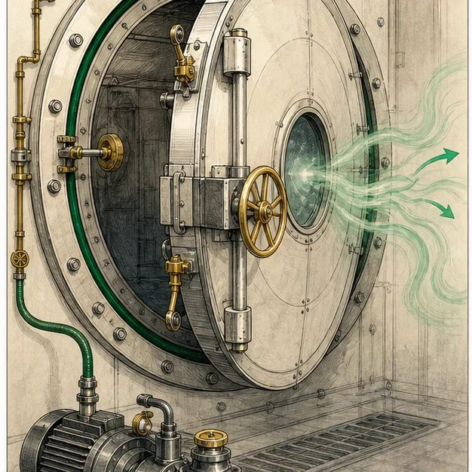
Illustration: A pressure door must close before the pump works
1. What happens if the door stays open?
________________________________________________________________________________
2. Which sounds would need pressure most?
________________________________________________________________________________
3. Is the problem the pump, the door, or both?
________________________________________________________________________________

DISEASE LESSON 12 | RULES AND BIOLOGY MAPPING
2. Turn observations into rules

1. Rule 1: Pressure builds only after a passage is sealed. Explain it in your own words.
________________________________________________________________________________
2. Rule 2: A moving valve must close at the right time. Explain it in your own words.
________________________________________________________________________________
3. Rule 3: Leaks create a predictable pattern of weak pressure. Explain it in your own words.
________________________________________________________________________________
Where the analogy stops: Speech involves airflow, sound, movement, and learned articulation. The door models only velopharyngeal closure.

3. Map the rules onto the biomedical example
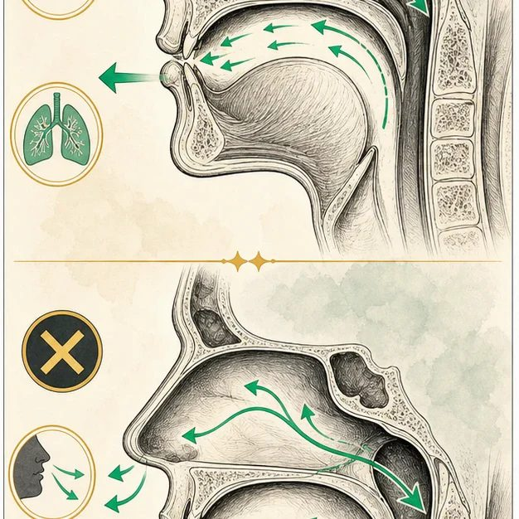
Biomedical teaching illustration: Watch the soft palate act as a moving seal
Analogy step | Biology step | How the relationship stays the same
Door lifts shut | Soft palate elevates toward the throat wall | ________________________________
Pump builds pressure | Lungs and oral cavity build pressure for consonants | ________________________________
Leak through opening | Nasal air escape and hypernasality with VPI | ________________________________

DISEASE LESSON 12 | CASE FILE AND DECISION
4. Use the case evidence

ID | Finding supplied in the case | Why it matters
D12-E1 | Mateo's voice sounds overly nasal during connected speech. | Resonance suggests air and sound are entering the nose at the wrong time.
D12-E2 | The consonants p, b, t, d, k, and g sound weak and nasal air is visible on a mirror. | Pressure consonants are affected by a seal problem.
D12-E3 | Vowels and low-pressure sounds are easier to produce. | The problem is patterned rather than random.

5. Make the clinical decision
You are Mateo's speech-language pathologist. You must decide whether today's pattern needs ordinary articulation practice alone or a full velopharyngeal evaluation.
A. Refer for velopharyngeal evaluation while continuing appropriate speech support
B. Practice p sounds only and ignore nasal escape
C. Assume hearing loss is the only cause
Decision. Choose the next step and use the pattern across the three evidence IDs.
________________________________________________________________________________
________________________________________________________________________________
Claim ceiling: You may identify a pattern consistent with VPI. You may not diagnose the exact structural cause without further evaluation.
Claim. State the choice you can defend.
________________________________________________________________________________
Evidence. Use these labeled IDs: D12-E1 + D12-E2 + D12-E3.
________________________________________________________________________________
Reasoning. Explain why the evidence supports the claim and stays inside the claim ceiling.
________________________________________________________________________________
________________________________________________________________________________

DISEASE LESSON 12 | REDUCE, REFLECT, AND PREPARE
6. Reduce the lesson to one lasting idea

Take-home. Clear pressure sounds need the soft palate to move upward and seal the mouth from the nose.
________________________________________________________________________________
________________________________________________________________________________
1. Why are p and b affected more than a relaxed vowel?
________________________________________________________________________________
2. What evidence makes this more than an ordinary articulation error?
________________________________________________________________________________

Glossary
Term | Plain-English definition
velopharyngeal closure | The sealing of the soft palate against the back of the throat that closes off the nose during speech and swallowing.
velopharyngeal insufficiency (VPI) | When the soft palate cannot fully close off the nose from the mouth during speech, letting air escape and making speech sound nasal.
hypernasality | A speech quality where too much air escapes through the nose, often when the soft palate cannot fully close off the nasal passage.
pressure consonants | Speech sounds like p, b, t, and s that need built-up air pressure in the mouth, which a cleft or leaky palate makes hard to produce.
speech-language pathologist | A specialist who evaluates and treats problems with speech, language, and feeding, key for children after cleft repair.

Next lesson unlock
We answered how the palate lets Mateo make clear speech and what VPI is. But the same little muscles near the palate do another job: they help drain the middle ear. Mateo keeps getting ear infections and does not always turn to soft sounds. How do we protect his hearing?
The journal links on the lesson page are optional. Everything required for this guided-notes set is already supplied here and in the case file.

