DISEASE DOMAIN | LESSON 11 OF 20 | PLASTIC SURGEON (CLEFT TEAM)

What the Surgeries Are Actually For
What clinical problem does each cleft surgery solve, and why is each one scheduled when it is?
CARRY FORWARD  Cleft care follows developmental windows, so the right action depends on what the child needs next. | 10-YEAR TAKEAWAY  Lip repair restores form, while palate repair separates spaces and supports speech; different jobs require staged operations.

Cells differentiate | Development sculpts | Cells move | Development can go wrong

1. Observe the analogy before naming the biology

Illustration: Repair the front door and the room divider for different reasons
1. Which repair changes the outside form?
________________________________________________________________________________
2. Which repair separates two spaces?
________________________________________________________________________________
3. Why would the jobs occur at different times?
________________________________________________________________________________

DISEASE LESSON 11 | RULES AND BIOLOGY MAPPING
2. Turn observations into rules

1. Rule 1: Name the function before choosing the repair. Explain it in your own words.
________________________________________________________________________________
2. Rule 2: Different structures can require different procedures. Explain it in your own words.
________________________________________________________________________________
3. Rule 3: Timing follows the problem each repair prevents. Explain it in your own words.
________________________________________________________________________________
Where the analogy stops: Surgery is not home repair. The analogy only separates structure, purpose, and timing.

3. Map the rules onto the biomedical example
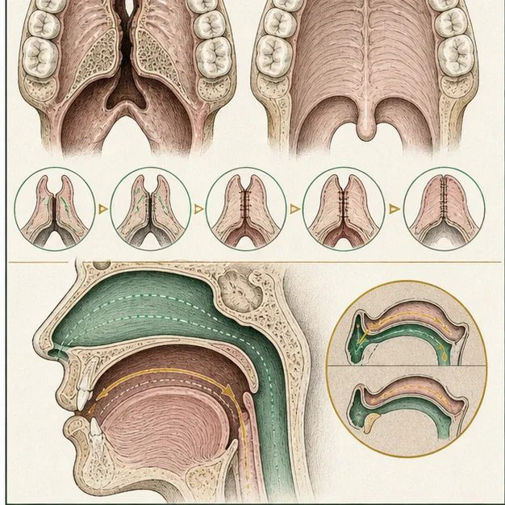
Biomedical teaching illustration: Match each operation to its clinical job
Analogy step | Biology step | How the relationship stays the same
Front-door form | Cheiloplasty restores continuity of the lip and improves nasal form | ________________________________
Room divider | Palatoplasty separates the mouth and nose | ________________________________
Use before damage | Palate repair is timed before major speech development | ________________________________

DISEASE LESSON 11 | CASE FILE AND DECISION
4. Use the case evidence

ID | Finding supplied in the case | Why it matters
D11-E1 | Mateo's parents want the lip and nose to have continuous form. | This concern maps to lip repair.
D11-E2 | The open palate connects the mouth and nose and cannot support normal oral pressure for speech. | This functional problem maps to palate repair.
D11-E3 | Speech sounds begin developing during the same period in which palate repair is commonly planned. | Timing protects a developmental window.

5. Make the clinical decision
You are the surgeon explaining the first two operations. The family asks why both problems cannot be fixed in one visit and forgotten.
A. Explain two structures, two jobs, and individualized timing
B. Describe both operations as cosmetic
C. Promise that surgery ends all future care
Decision. Choose the explanation and match each evidence ID to the operation it supports.
________________________________________________________________________________
________________________________________________________________________________
Claim ceiling: You may explain typical goals and timing. You may not promise a specific operation date or outcome.
Claim. State the choice you can defend.
________________________________________________________________________________
Evidence. Use these labeled IDs: D11-E1 + D11-E2 + D11-E3.
________________________________________________________________________________
Reasoning. Explain why the evidence supports the claim and stays inside the claim ceiling.
________________________________________________________________________________
________________________________________________________________________________

DISEASE LESSON 11 | REDUCE, REFLECT, AND PREPARE
6. Reduce the lesson to one lasting idea

Take-home. Lip repair restores form, while palate repair separates spaces and supports speech; different jobs require staged operations.
________________________________________________________________________________
________________________________________________________________________________
1. Which operation mainly restores form?
________________________________________________________________________________
2. Why is palate timing connected to speech?
________________________________________________________________________________

Glossary
Term | Plain-English definition
cheiloplasty | The surgical repair of a cleft lip, rejoining the separated lip tissue to restore a continuous lip and a more typical appearance.
palatoplasty | Surgery that closes a cleft in the roof of the mouth so the palate can separate the nose from the mouth and support speech.
staged care | A treatment plan delivered in planned steps across years, matching each procedure to the right point in a child's growth.
function before form | A care principle that fixing how a structure works, like feeding or speech, takes priority over how it looks.

Next lesson unlock
We answered why the palate is repaired early to protect speech. But that raises a new question: how exactly does a repaired palate let Mateo make clear speech sounds, and what happens if it still does not seal well?
The journal links on the lesson page are optional. Everything required for this guided-notes set is already supplied here and in the case file.

