DISEASE DOMAIN | LESSON 10 OF 20 | CLEFT TEAM COORDINATOR

The Plan for the Next 18 Years
What is the staged plan of care for a child like Mateo, from birth through the teen years, and why is each step timed when it is?
CARRY FORWARD  Most isolated clefts reflect many small genetic and environmental influences crossing a developmental threshold. | 10-YEAR TAKEAWAY  Cleft care follows developmental windows, so the right action depends on what the child needs next.

Cells differentiate | Development sculpts | Cells move | Development can go wrong

1. Observe the analogy before naming the biology

Illustration: A train schedule is built around connections
1. Why can one missed connection affect later steps?
________________________________________________________________________________
2. Which stops are fixed and which can vary?
________________________________________________________________________________
3. Who keeps the whole route visible?
________________________________________________________________________________

DISEASE LESSON 10 | RULES AND BIOLOGY MAPPING
2. Turn observations into rules

1. Rule 1: Sequence work around readiness and dependency. Explain it in your own words.
________________________________________________________________________________
2. Rule 2: Protect important windows without pretending every date is exact. Explain it in your own words.
________________________________________________________________________________
3. Rule 3: Assign someone to coordinate the whole route. Explain it in your own words.
________________________________________________________________________________
Where the analogy stops: Care is individualized and families are not trains. The analogy models sequence, timing, and coordination.

3. Map the rules onto the biomedical example
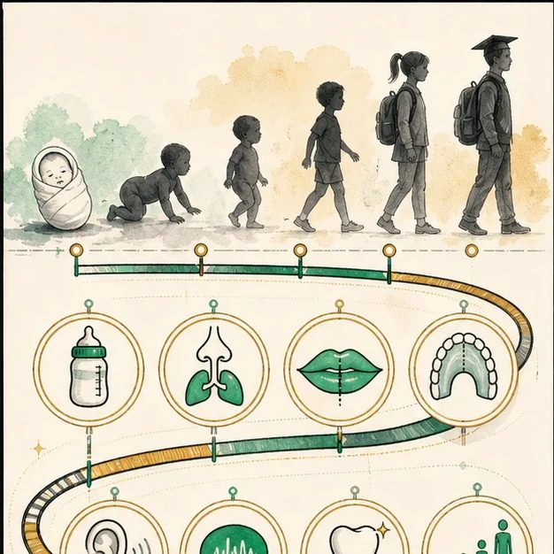
Biomedical teaching illustration: Build Mateo's care around developmental windows
Analogy step | Biology step | How the relationship stays the same
First station | Newborn feeding, airway, hearing, and family support | ________________________________
Timed connection | Palate repair before major speech development | ________________________________
Route coordinator | Cleft team coordinator and shared plan | ________________________________

DISEASE LESSON 10 | CASE FILE AND DECISION
4. Use the case evidence

ID | Finding supplied in the case | Why it matters
D10-E1 | Mateo needs feeding and growth follow-up now, before surgery. | Immediate needs come first in the sequence.
D10-E2 | Lip and palate operations are staged at different times for different purposes. | One operation cannot solve every problem.
D10-E3 | Hearing, speech, dental growth, psychosocial health, and facial growth require repeated checks over years. | The plan must extend beyond the first repair.

5. Make the clinical decision
You are Mateo's cleft team coordinator. The family wants a one-page plan that shows what happens now, in infancy, in childhood, and in adolescence.
A. Create a staged plan tied to developmental needs and review points
B. Promise one surgery will finish care
C. List specialists without timing or ownership
Decision. Choose the plan structure and place each evidence item in the correct time band.
________________________________________________________________________________
________________________________________________________________________________
Claim ceiling: You may provide typical windows and ownership. You may not promise exact dates before individual evaluation.
Claim. State the choice you can defend.
________________________________________________________________________________
Evidence. Use these labeled IDs: D10-E1 + D10-E2 + D10-E3.
________________________________________________________________________________
Reasoning. Explain why the evidence supports the claim and stays inside the claim ceiling.
________________________________________________________________________________
________________________________________________________________________________

DISEASE LESSON 10 | REDUCE, REFLECT, AND PREPARE
6. Reduce the lesson to one lasting idea

Take-home. Cleft care follows developmental windows, so the right action depends on what the child needs next.
________________________________________________________________________________
________________________________________________________________________________
1. Why is the plan organized by developmental windows?
________________________________________________________________________________
2. Which parts of the timeline need repeated checks rather than one visit?
________________________________________________________________________________

Glossary
Term | Plain-English definition
multidisciplinary care | Care provided by a team of different specialists who coordinate their treatment plans for one patient.
staged care | A treatment plan delivered in planned steps across years, matching each procedure to the right point in a child's growth.
care timeline | The planned sequence of treatments and check-ups a patient receives over months and years, with each step scheduled at the right age.
milestone | A key checkpoint or expected achievement reached by a set point, used to track a child's development or a project's progress.
developmental window | A limited period during growth when a tissue or organ is forming and is most sensitive to genes, signals, or disruptions.

Next lesson unlock
We have an 18-year care plan for Mateo, but what do the operations on that plan actually fix? What do the surgeries accomplish clinically?
The journal links on the lesson page are optional. Everything required for this guided-notes set is already supplied here and in the case file.

