DISEASE DOMAIN | LESSON 9 OF 20 | PEDIATRICIAN / GENETICIST (CLEFT TEAM)

What Caused Mateo's Cleft?
What caused Mateo's cleft: his genes, something in the pregnancy, or both?
CARRY FORWARD  Epidemiology describes patterns in groups; it does not identify the cause of one child's cleft. | 10-YEAR TAKEAWAY  Most isolated clefts reflect many small genetic and environmental influences crossing a developmental threshold.

Cells differentiate | Development sculpts | Cells move | Development can go wrong

1. Observe the analogy before naming the biology
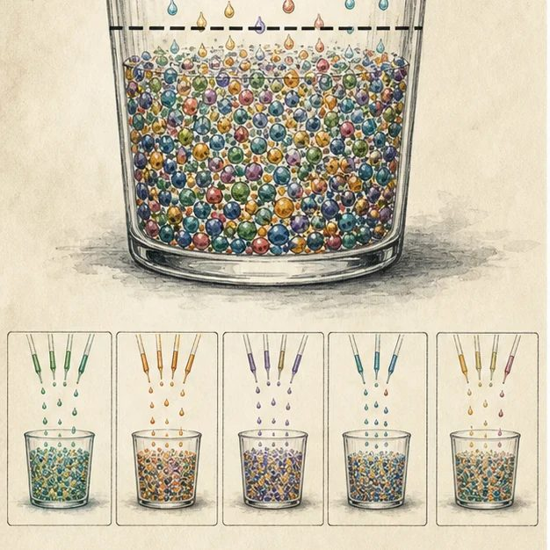
Illustration: Many small drops can fill a threshold cup
1. Does one drop fill the cup?
________________________________________________________________________________
2. Could different combinations reach the same line?
________________________________________________________________________________
3. Can you identify one guilty drop after the cup overflows?
________________________________________________________________________________

DISEASE LESSON 9 | RULES AND BIOLOGY MAPPING
2. Turn observations into rules

1. Rule 1: Many small influences can add together. Explain it in your own words.
________________________________________________________________________________
2. Rule 2: Different combinations can cross the same threshold. Explain it in your own words.
________________________________________________________________________________
3. Rule 3: Risk is not certainty and association is not blame. Explain it in your own words.
________________________________________________________________________________
Where the analogy stops: Biologic risk is not a literal liquid sum. The model simplifies interacting influences into a threshold idea.

3. Map the rules onto the biomedical example
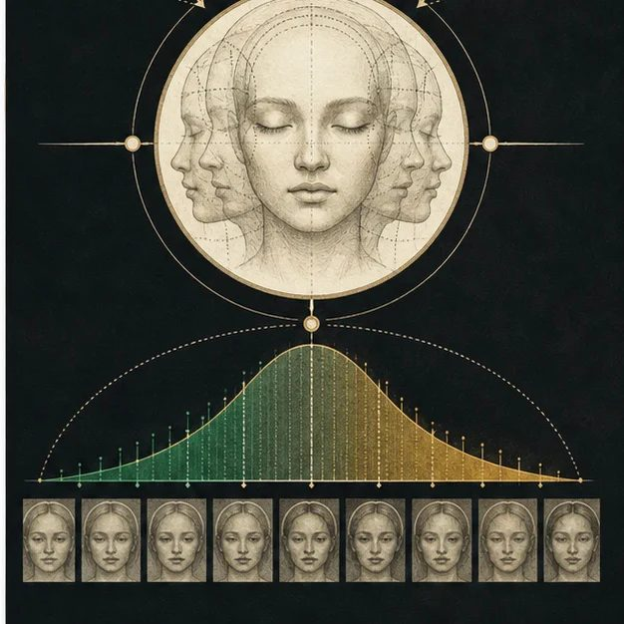
Biomedical teaching illustration: Use the threshold model for an isolated cleft
Analogy step | Biology step | How the relationship stays the same
Small drops | Small genetic variants and environmental exposures | ________________________________
Fill line | Developmental threshold for disrupted fusion | ________________________________
Overflow | A cleft forms during the developmental window | ________________________________

DISEASE LESSON 9 | CASE FILE AND DECISION
4. Use the case evidence

ID | Finding supplied in the case | Why it matters
D09-E1 | Mateo has no clear syndrome pattern or single-gene family pattern. | A simple one-gene explanation is not supported by the case.
D09-E2 | Research finds many genetic regions associated with common nonsyndromic clefts. | Multiple small genetic influences can contribute.
D09-E3 | Smoking and some other pregnancy exposures are associated with higher risk, but no exposure in Mateo's case proves causation. | Environmental factors change risk without assigning blame for an individual case.

5. Make the clinical decision
You are answering Mateo's parents when they ask, 'What did we do to cause this?' Your answer must be accurate, clear, and free of blame.
A. Explain multifactorial risk and that no single cause can be identified in this case
B. Name one exposure as the cause
C. Say genes always determine the outcome
Decision. Choose the explanation and use all three evidence IDs to set the limits of the claim.
________________________________________________________________________________
________________________________________________________________________________
Claim ceiling: You may explain multifactorial risk. You may not claim a specific exposure or variant caused Mateo's cleft.
Claim. State the choice you can defend.
________________________________________________________________________________
Evidence. Use these labeled IDs: D09-E1 + D09-E2 + D09-E3.
________________________________________________________________________________
Reasoning. Explain why the evidence supports the claim and stays inside the claim ceiling.
________________________________________________________________________________
________________________________________________________________________________

DISEASE LESSON 9 | REDUCE, REFLECT, AND PREPARE
6. Reduce the lesson to one lasting idea

Take-home. Most isolated clefts reflect many small genetic and environmental influences crossing a developmental threshold.
________________________________________________________________________________
________________________________________________________________________________
1. Why can two families reach the same outcome through different combinations?
________________________________________________________________________________
2. What is the difference between a risk factor and a cause?
________________________________________________________________________________

Glossary
Term | Plain-English definition
multifactorial | Caused by several genes acting together with environmental factors, not by a single gene alone.
twin concordance | How often both members of a twin pair share a trait, used to compare identical and fraternal twins and gauge genetic influence.
teratogen | An agent such as a drug, chemical, or infection that can disrupt development and cause birth differences if exposure happens during pregnancy.
risk factor | Anything that raises a person's chance of developing a disease, such as smoking, family history, or high blood pressure, without guaranteeing it.
odds ratio | A number comparing the odds of having a factor in affected versus unaffected people; above 1 suggests the factor is associated.
threshold model | The idea that a trait appears only when a person's combined liability from genes and environment crosses a set line.

Next lesson unlock
Mateo's cleft came from many small influences working together, not one fixable thing. So if no single cause can be removed, what is the actual plan for the next 18 years of his care?
The journal links on the lesson page are optional. Everything required for this guided-notes set is already supplied here and in the case file.

